Ex22andEx35Chp4
Exercise-22-Chapter 4
In Fig. 4-27, four stations, A, B, C, and D, are shown. Which of the last two stations do you think is closest to A and why?
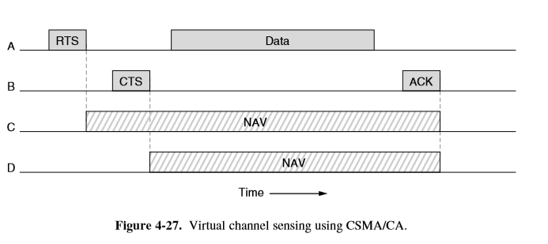
Exercise-35-Chapter 4
List some of the security concerns of an RFID system.

