Ex3andEx12Chp6
Exercise 3-Chapter 6
In the underlying model of Fig. 6-4, it is assumed that packets may be lost by the network layer and thus must be individually acknowledged. Suppose that the network layer is 100 percent reliable and never loses packets. What changes, if any, are needed to Fig. 6-4?

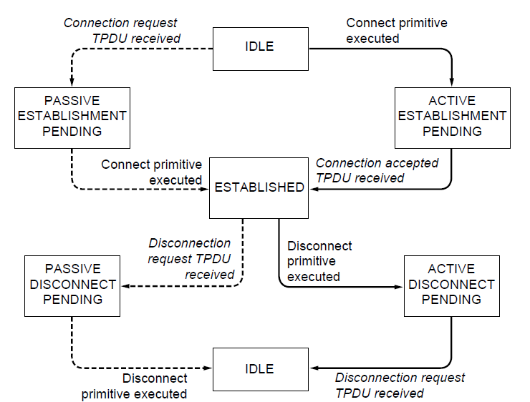
Figure 6-4. A state diagram for a simple connection management scheme. Transitions labeled in italics are caused by packet arrivals. The solid lines show the client’s state sequence. The dashed lines show the server’s state sequence

Exercise 12-Chapter 6
In Figure 6-20, suppose a new flow E is added that takes a path from R1 to R2 to R6. How does the max-min bandwidth allocation change for the five flows?

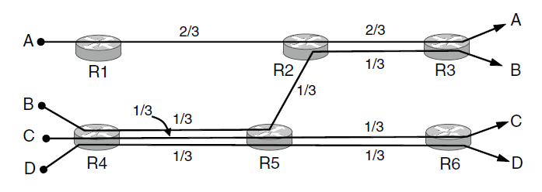
Figure 6-20. Max-min bandwidth allocation for four flows.

