Ex27Chp6andEx3Chp7
Exercise 27-Chapter 6
In Fig. 6-36 we saw that in addition to the 32-bit acknowledgement field, there is an ACK bit in the fourth word. Does this really add anything? Why or why not?
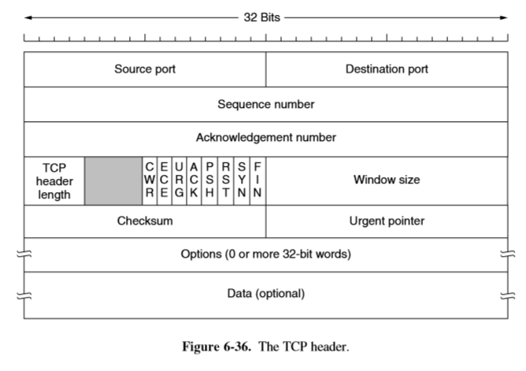

Exercise 3-Chapter 7
Consider a situation in which a cyberterrorist makes all the DNS servers in the world crash simultaneously. How does this change one’s ability to use the Internet?

