Grid Portal Assignment

User Registration and Basic Testing

Authors: UNC-C Grid course team
B. Wilkinson, Jeremy Villalobos, Jasper Land, and C. Ferner
December 29, 2009

This assignment is written to suit the systems and procedures at UNC-Charlotte/UNC-Wilmington.
Instructors - Alter document to suit your own procedures.

Overview

The purpose of this assignment is to establish your account on the course grid portal and computer systems used in course, and become familiar with the portal. This portal is based upon the Gridsphere portal, which is widely used in production grids. It provides web interface to the grid resources set up for this course and enable users to access grid resources with a single sign-on. Through the portal, users can handle their security credentials, run jobs on the various resources, transfer files between resources in a fast secure fashion, and perform other actions. The accessible resources currently consist of:

- UNC-C Computer Science departmental cluster dedicated to Grid computing:
- coit-grid01.uncc.edu – coit-grid04.uncc.edu
- Each dual 3.4 GHz dual Xeon processors (8 processors)
- coit-grid05.uncc.edu
- 4 quad-core 2.93 GHz Xeon processors (16 cores), 64GB memory, 1.6 TB disk

- UNC-W CS cluster called torvalds.cis.uncw.edu – a 40-processor system.

Access to the UNC-C cluster is generally through coit-grid01.uncc.edu.
coit-grid02.uncc.edu hosts the course portal and certificate authority and should not be used.

Although the portal provides a single sign-on, it is necessary for users to have accounts on all resources they wish to use. Each account will be set-up after the user has provided registration information. The Gridsphere portal comes with some standard “portlets” (windows within the portal). PURSe (Portal-based User Registration Service) has been added, which is a more friendly way of handling user credentials than provided in the basic Gridsphere portal.

User Registration on Portal

Go to the course portal URL http://coit-grid02.uncc.edu:8080/gridsphere as shown in Figure 1:

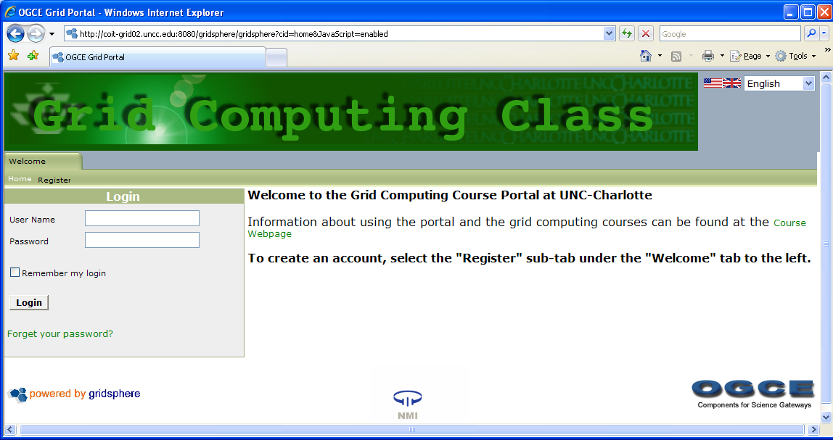
Figure 1 Main portal login page

Select the “Register” tab, which goes to the PURSe portlet, as shown in Figure 2:

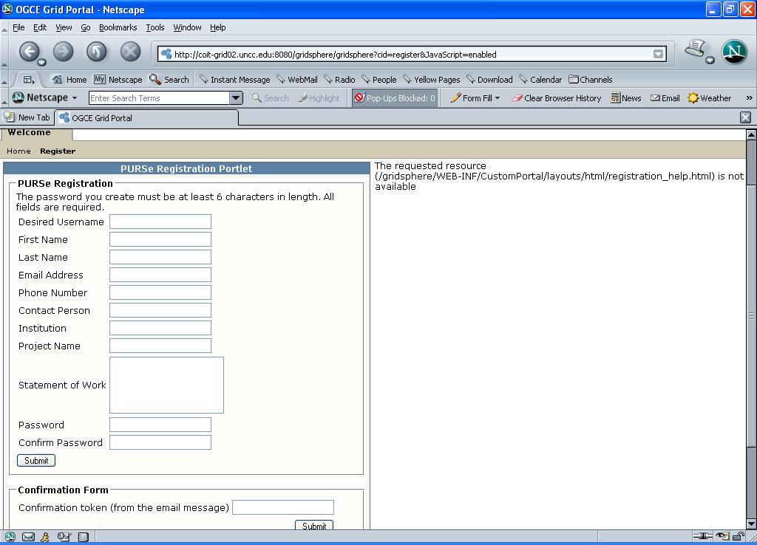
Figure 2 Registration portlet

Every field must have an entry or the registration portlet will not accept the form. Enter the information requested:

- Desired username Choose any username. This name will be used for you accounts on all grid resources
- First name First name as on university records
- Last name Last name as on university records
- Email address Address of your email that you read.
This email will be used to confirm the account and requires
a response from you.
- Phone number Put any number here. It will not be used
- Contact person Put the name of the instructor at your institution
- Institution Put the abbreviation for your institution,
e.g. UNCA, UNCC, UNCG, UNCW, NCAT, …
- Project name Put Grid course
- Statement of work Put your major and whether you are an undergraduate or graduate
- Password Choose a strong password that includes a mixture of upper case
and lower letters, and numerals, at least 8 characters long.
- Confirm password Retype password

After filling out all fields, click the "Submit" button (under confirm password). There is no need to fill out the "Confirmation Form" section. You should get the page shown in Figure 3:

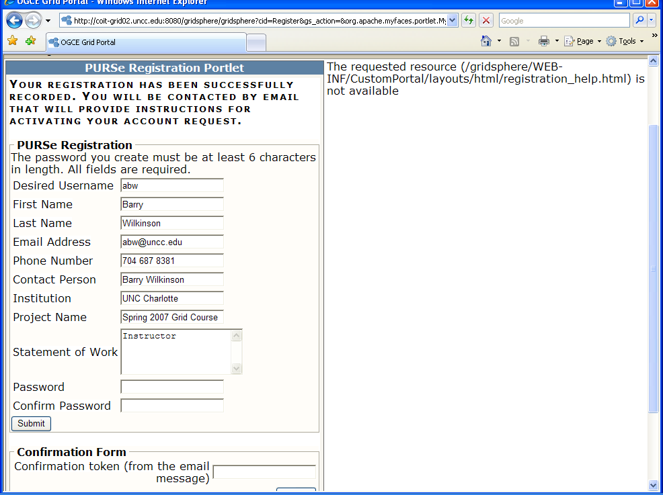
Figure 3 Initial response to entering registration information

You will also get an email reply such as:

Received a request for user account in Purse portal from this email address. Click on the following link to confirm request was made.
http://coit-grid02.uncc.edu:8080/gridsphere/gridsphere?cid=Register&rp_token=0000010f-9722-5636-00000cc1-e3f00adc5674
If the above link does not work for you, then go back to the page where you filled out the registration form. You'll find a confirmation form on that page, and you'll need to enter the following token into that form:
0000010f-9722-5636-00000cc1-e3f00adc5674
http://coit-grid02.uncc.edu:8080/purse-portlets/confirm.jsp

Clicking on the link should display Figure 4:

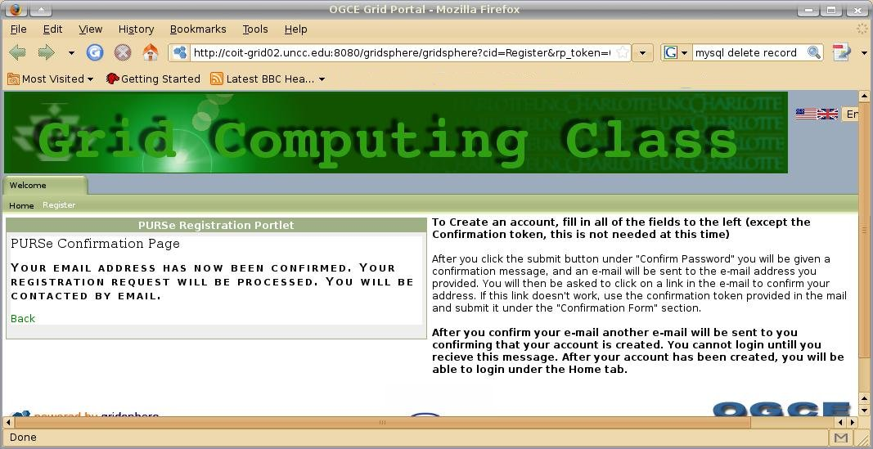
Figure 4 Email acknowledgment page

On the unlikely event you are unable to get this page, copy the token in the email message into confirmation form (Figure 2).

You will get an email:

Your request for an account with the Purse portal has been approved.

Within 2 days of registration, accounts will be set up and you will get a confirmation email that also includes your password for ssh login. This password is different to the password for the portal account, and should be changed once you login through ssh (see Assignment 2).

DO NOT FORGET YOUR PORTAL or SSH PASSWORDS.
WRITE THEM DOWN IN A SECURE PLACE.
WE MAY NOT BE ABLE TO RETRIEVE PASSWORDS FOR USERS.

Once your account is set up, you will be able to login to the portal from the main page and access requested resources.

Login and become familiar with Features

Log in to the portal. You will see the layout such as show in Figure 5 below:

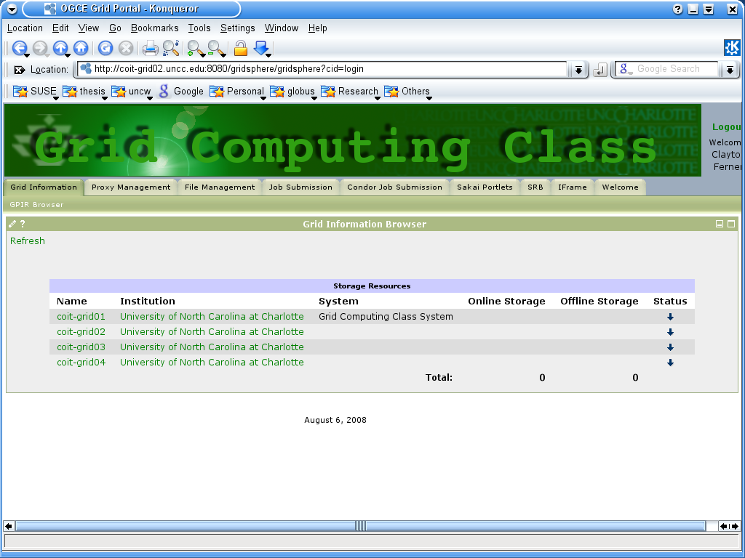
Tabs
Figure 5 Tabs after Login

From here you can click on the tab you wish to navigate to. Below is a list of the choices:

(a) Grid Information

Currently, the grid information browser (GPIR) is not setup.

(b) Proxy Management Tab

In order to use many services on the Portal, you are required to have a proxy. Proxies are part of the grid security infrastructure, which we will discuss later in the course. For now, it is sufficient to say that a proxy is an electronic document called a certificate that enables resources to be accessed on the user’s behalf. Usually PURSe automatically loads a proxy for you when you log in. Selecting the Proxy Management tab, you should get the display similar to Figure 6 (but with your proxy details:

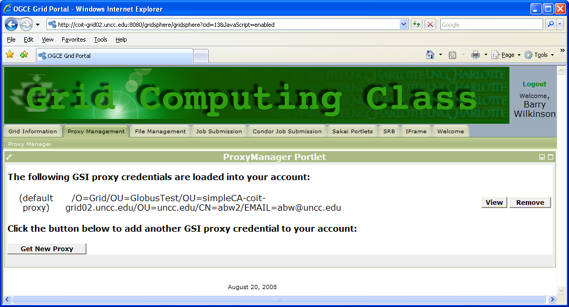
Figure 6 Proxy Management tab

The default lifetime of this proxy is 2 hours (proxies have limited lifetimes for security reasons). However, if you do not have a proxy or if you are running a job that takes longer than 2 hours to complete, you will need to create a proxy with a longer lifetime. You can click "Get New Proxy" to do this (see Figure 7):
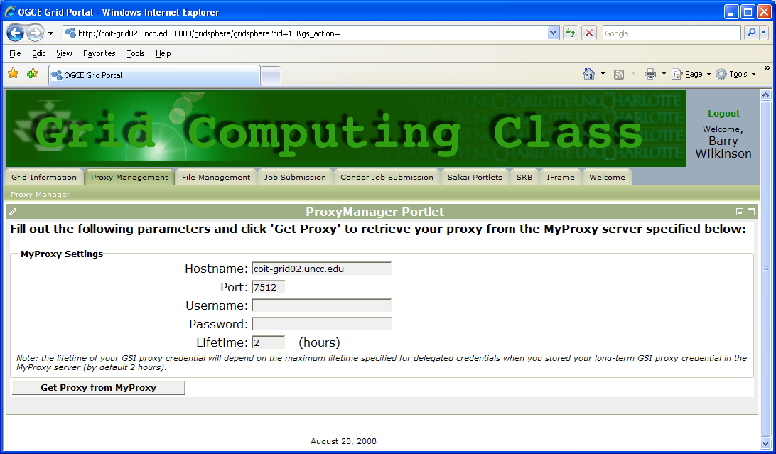
Figure 7 Proxy manager for creating new proxies

When filling out your MyProxy Settings, type in the hostname of the resource you want a proxy on, type in your username, and your proxy password. Change the lifetime of the proxy if a longer lifetime is desired, and click on "Get Proxy From MyProxy". If you login multiple times before your proxy expires you will have multiple proxies, which are not needed. If this happens you can click on the "Remove" button to the right of the desired proxy to be removed.

File Management Tab

Once you have your proxy, you can do grid related activities such as transfer files or submitting a job. To transfer files, go to the File Management Tab. There are two file managers, the GridPort “Comprehensive File Management” tool and the “GridFTP” tool. Both enable you to transfer files between resources. Explore them. Clicking on the Comprehensive File Management sub tab, and selecting a host that you have an account on to see your home directory on that system. Figure 8 shows a sample display.

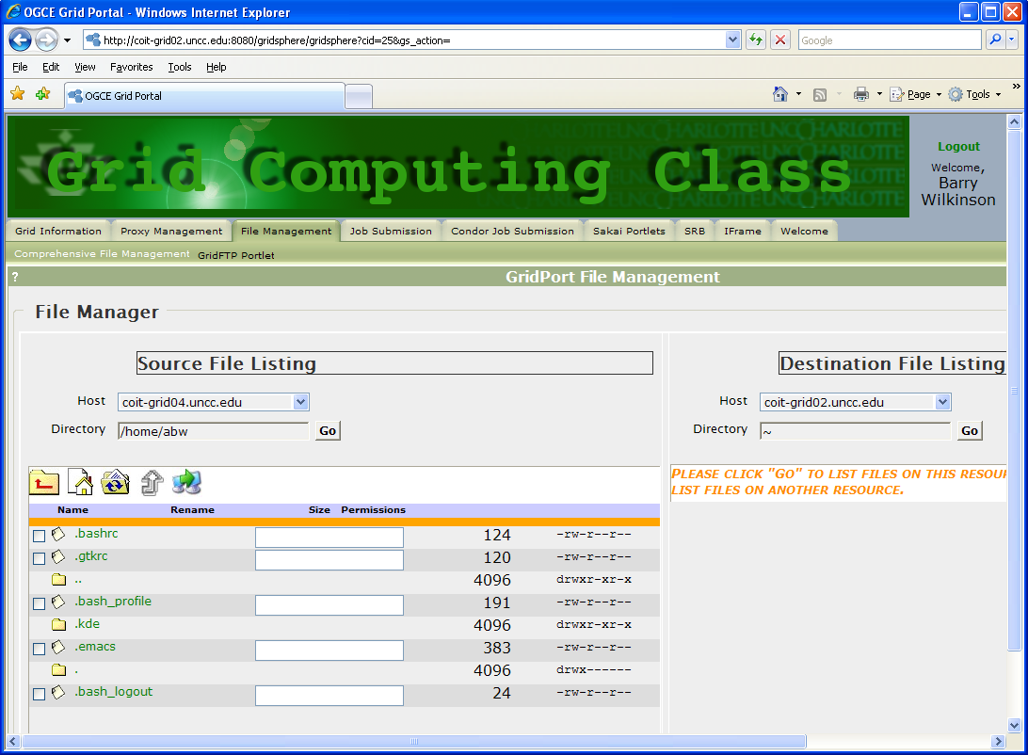
Figure 8 GridPort Comprehensive File Management Tool

You can also select torvalds.cis.uncw.edu to see the files on the machine at UNCW. Make sure that the Directory is “~” since your home directory is different on torvalds as it is on coit-grid0x. You will need to be patient when working with torvalds since the information needs to be transmitted from UNCW to UNCC before it is transmitted to your machine.
If you click the upload button ( ), then you will see the fields shown in Figure 9 at the bottom of the file listing, which will allow you to upload a file from your local machine to the server:

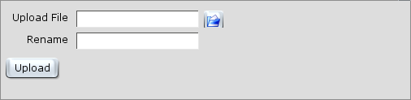
Figure 9 Comprehensive File Management Tool Upload File Option

Figure 10 shows the view when source and destination servers are selected. If you want to transfer a file from one server to another, obtain a file listing on the machine to which you want to transfer the file for the “Destination File Listing.” Select the file in the “Source File Listing”, then select the transfer file button ().

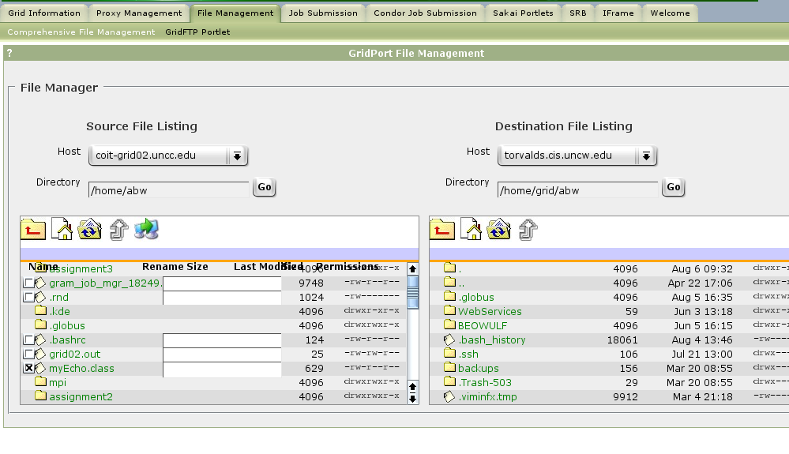
Figure 10 Comprehensive File Management tool Transferring a File

Click on the “GridFTP Portlet” sub-tab to get Figure 11:

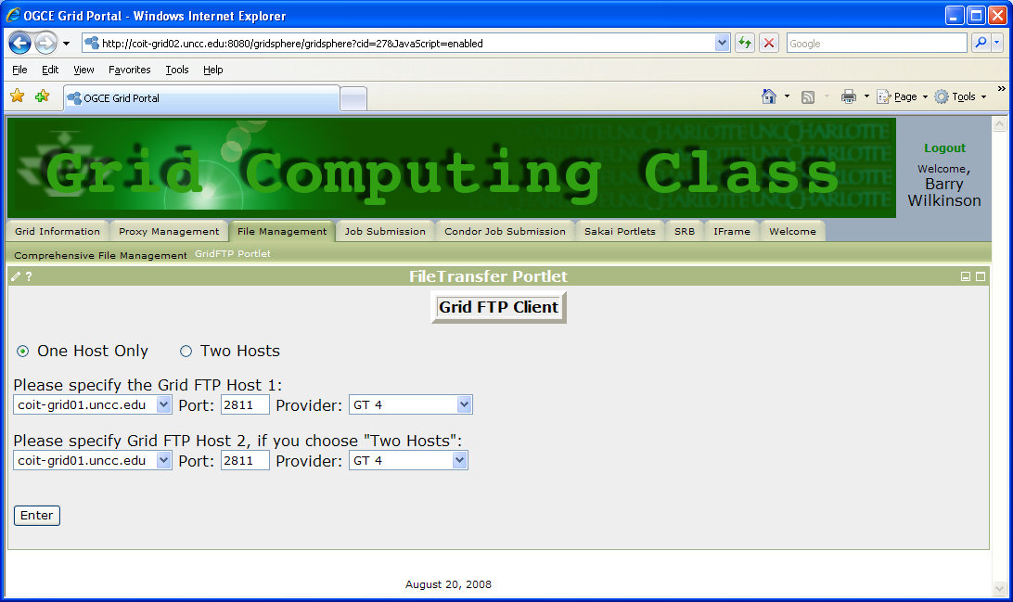
Figure 11 GridFTP potlet

In both file management systems, one has the option of uploading files from the system you are using to access the portal. For example in GridFTP, select file using the browse button after selecting the host, as shown in Figure 12:
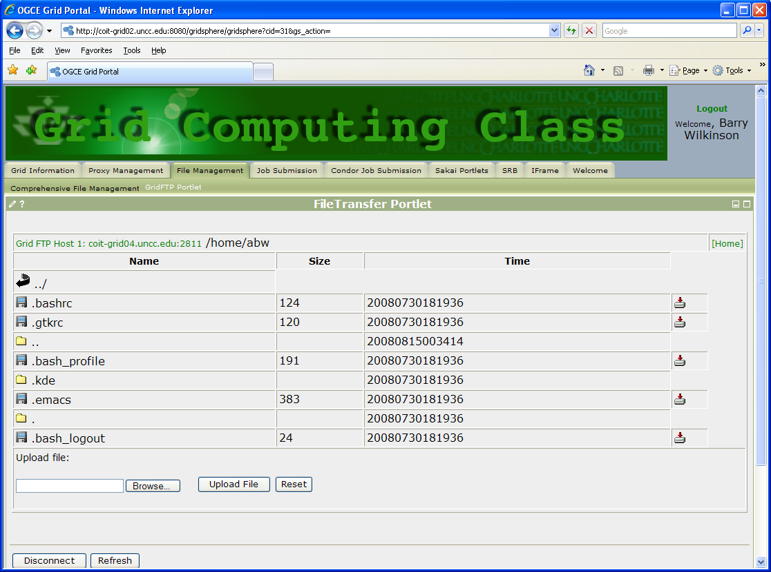
Figure 12 GridFTP File transfer portlet with one host

One can also bring up a display of two hosts to transfer from one host to another (between hosts enrolled into the system that you have access).

Job Submission Tab

To submit a job, go to the Job Submission portlet. There are two job submission portlets, batch and interactive. The batch job submission portlet is shown in Figure 13. The interactive job submission portlet is shown in Figure 14.

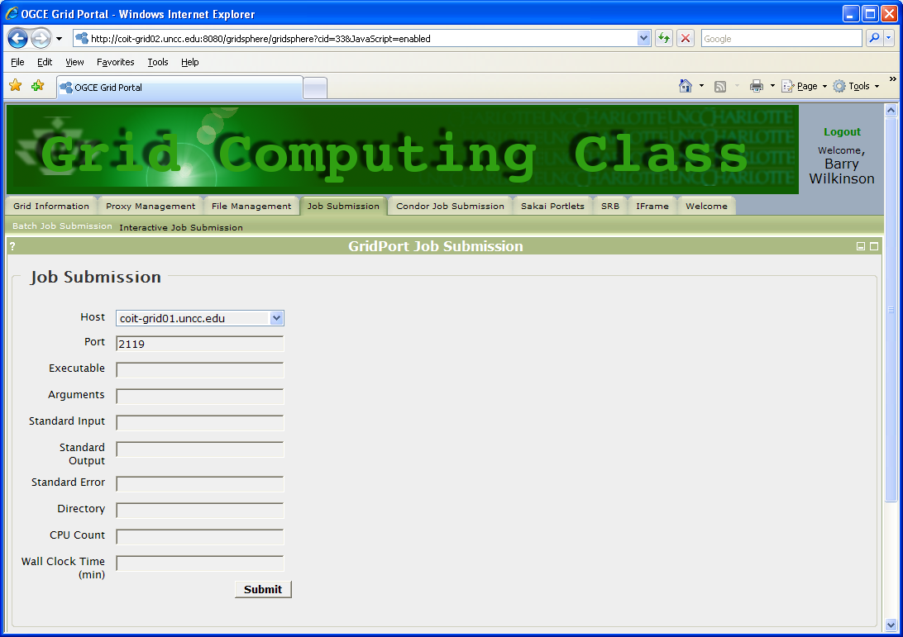
Figure 13 Batch Job Submission portlet

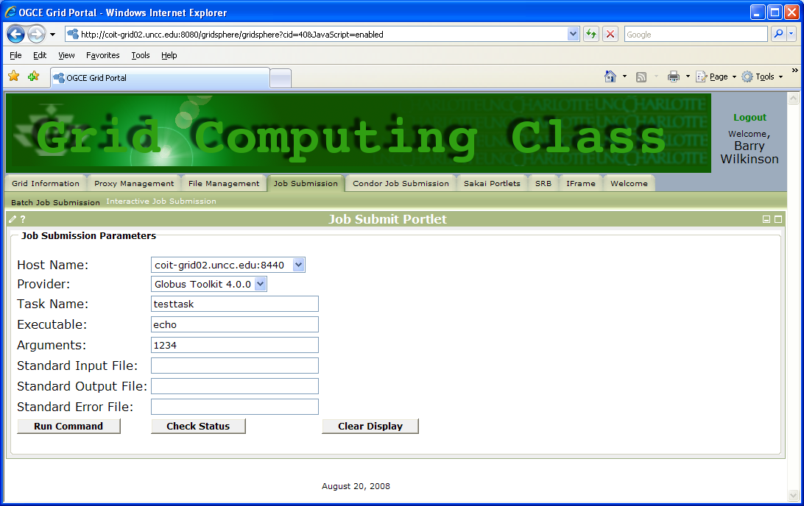
Figure 14 Interactive Job Submission portlet

You can experiment with simple Linux commands and executables and look in the file transfer portlet to see whether they were executed. Notice that standard output must be specified and output is redirect to the file specified.

Assignment Tasks

In this section, we will describe a number of simple tasks that you are to perform to complete this assignment.

Task 1

Execute the Linux command (program) echo with suitable arguments on the designated system from the (interactive) job submission portlet, redirecting standard output to a file called echo_output. Go to the file transfer portlet, and find this file. Download the file to your computer and take a screenshot of its contents.

Task 2

In this task, you are to execute your own program rather than a pre-existing program. It is possible to compile a program directly on a grid resource by specifying the compiler as the executable and the source file as its argument. However, we will compile a Java program remotely to obtain a platform-independent class file, which will be uploaded and executed on the grid resource with a Java Virtual Machine. We are also going to reuse this program in future assignments. We will eventually have two parts to solving a problem where one part is solved on one server and the other part is solved on another server. You will do the first part in this assignment.

Your goal is to compute the volume (in cubic feet) and cost of the mulch needed to cover a flower bed, given a function that gives the shape of the flower bed. In part one, you will approximate the square footage of the flower bed using an approximation of the integral of the function.

The shape of the flower bed is show in Figure 15. The curved part of the flower bed is approximately a sine curve. For x between 0 and 2, the curve is y = sin (x*π/2) + 2. For x between 2 and 5, the shape is y = 2. Although one can integrate these two functions mathematically, you will write a Java program that will perform numerical integration using the trapezoidal method. In this method, the area under the curve is divided into trapezoidal regions, as shown in Figure 16.

The area of under the curve between a and b is approximated using the following formula:

$$\begin{aligned}\text{Area=}\frac{δ\left(f(a)\text{+f}(\text{a+δ})\right)}{2}+\frac{δ\left(f(\text{a+δ})\text{+f}(\text{a+}\text{2δ})\right)}{2}…+\frac{δ\left(f(\text{a+}(n−1)δ)\text{+f}(b)\right)}{2} \\ \text{=δ}\left(\frac{f(a)}{2}\text{+f}(\text{a+δ})\text{+f}(\text{a+}\text{2δ})…f(\text{a+}(n−1)δ)+\frac{f(b)}{2}\right) \\ \end{aligned}$$

where there are n intervals each of width δ. The pseudo code to implement this method is shown below:

d = (b - a)/n;
area = 0.5 * (f(a) + f(b)); /* f returns the value of function */
for (x = a + d; x < b; x = x + d)
area = area + f(x);
area = area * d;

y=sin(x*π/2)+2 when 0<=x<=2
y=2 when 2<=x<= 5
0
1
2
3
4
5
0
1
2
3
4
5
Figure 15: Integration using the Trapezoidal Method

Figure 16: Integration using the Trapezoidal Method.

The more trapezoids there are, the better the approximation of the area under the curve. You should try using a large value for n to see what the effect is. You need to write a Java program that takes a and b from the command line, then computes the area under the curve f(x) between a and b. You should start with a simple function such as f(x) = x² + x³ + x⁴ + x⁵ to test your program. After you are confident it is working correctly, then change the method f() to return the values of the shape of the flower bed. Your program should report the area to stdout.

Upload the program (the .class file) and execute it on coit-grid03.uncc.edu. The executable is the java interpreter. The path to Java to java on all coit-grid machines should be /usr/local/java/bin/java. The arguments are the name of the Java class file (but without the .class) and the other arguments (a and b) to your program.

Useful Information

Processing command line arguments

The arguments given to your Java program on the command line are available to you through the array of strings args that is the parameter to the method main. Since this is an array, you can check the number of arguments given by the user using the args.length expression. Here is an example:

public static void main (String args[])
{
String arg1, arg2;

if (args.length < 2) {
return;
}

arg1 = args[0];
arg2 = args[1];
System.out.println (“arg1 = \”” + arg1 + “\””);
System.out.println (“arg2 = \”” + arg2 + “\””);
}

$ java myTest myarg1 myarg2 myarg3
arg1 = ”myarg1”
arg1 = ”myarg2”

Converting a String to a float or integer

String s1 = ..., s2 = ...;
int a;
float x;
...

a = Integer.parseInt(s1);
x = Float.parseFloat(s2);

Assignment Submission

Details regarding assignment submission are given in a separate document.

Software that signs certificates. See later in course for what a certificate authority does.
The Linux program echo simply sends it command line arguments to standard output. This program comes with the standard Linux distribution. It’s full path is /bin/echo.
Check if necessary using the Linux which command. which displays the full path to the file given as its argument. (which searches the user’s $PATH variable.)

