Portlet Development Assignment
Creating simple portlets
(Windows Version)

Authors: UNC-Charlotte Grid course team
Jeremy Villalobos, Jasper Land, and B. Wilkinson
Oct 5, 2009

1. Overview
The purpose of this assignment is to show how to create and test a portlet using the Gridsphere Portal. In the process of doing that, the student will also learn how to install Gridsphere and other required packages. This assignment is to be done on your own computer (either Windows, Mac or a Linux system). The instructions here are for Windows system. Other systems are essentially the same; simply download the appropriate packages.

A portal is a dynamic webpage that allows easy access with a friendly user interface to regular grid users. A portal deals with the task of managing users and access permission to portlets. It provides somewhat the same functionality as a window manager. A portlet is much like a window within a window GUI environment. It encapsulates all the actions that control one particular tool in the computer grid. Tomcat is an open source project that creates the software necessary to allow developers in creating and deploying web application. The package provides a Java API that simplifies development. Gridsphere is a web portal. It uses Tomcat API to work, it manages the users and groups and it also provides its own API to facilitate development of web services, tools to handle authentication, and it also wraps several technologies used to create web applications with Java. Ant is a project manager, it is controlled with an XML language. The program is used to set the necessary environment for compiling and deploying Java applications. Gridsphere provides an easy process to develop portlets through the use of ant scripts.

2. Installing Gridsphere and associated software

Installing Java (or checking Java's configuration)
If you have not already installed Java, download the Java 6 JDK Windows installer (if you are using Windows) from:

http://java.sun.com/javase/downloads/index.jsp

You may have to register (it’s free) in order to start the download. The file will launch an installation wizard. Follow the instruction on the wizard until the installation is finished. You can check this by opening a command line (start menu, programs, accessories, Command Prompt in Windows XP) and running the command:

java –version

Installing Ant
You should already have java installed from previous assignments. If not, get the Ant package from this link:

http://ant.apache.org

Select Download. The binary distribution is usually the most convenient if it matches the machine. (The source installation requires you to compile and install the distribution.)

In order to install ant you will need to set the JAVA_HOME environmental variable. This will be set to the directory where you installed java, in windows, usually in C:\Program Files\Java\jdk<version>. Set the environmental variable ANT_HOME pointing to the ant directory. Also add $ANT_HOME/bin to your path environmental variable:

set JAVA_HOME=C:\Program Files\Java\jdk1.5.0_09
set ANT_HOME=C: \apache-ant-1.7.0
set PATH=%PATH%;%ANT_HOME%\bin

Test the installation by typing the following on a command prompt:

ant -version

Installing tomcat
First download tomcat from http://tomcat.apache.org/

Choose Tomcat version 5.5. The assignment has been tested with Tomcat version 5.5.20.

DO NOT use version 6 as the directory structure has changed and the Gridsphere installation later in the assignment will give errors/fail.

The process of installing Tomcat is very similar to the previous package. Place the binary files in some path (e.g. C:\apache-tomcat-6.0.2). Then set the environmental variables: CATALINA_HOME should point to the path of the tomcat binaries (where you installed tomcat). JAVA_HOME should point to the path of the java jdk files (usually C:\Program Files\Java\jdk<version>). JRE_HOME should point to the Java JRE (usually C:\Program Files\Java\jre<version>). JAVA_HOME and ANT_HOME were done in the previous step leaving to do, for example:

set JRE_HOME=C:\Program Files\Java\jre1.5.0_09
set CATALINA_HOME=C:\apache-tomcat-5.5.20

Starting up and shutting down Tomcat server

Tomcat is started by running startup.bat in the %CATALINA_HOME%\bin directory. Tomcat is stopped by running the batch file shutdown.bat in the %CATALINA_HOME%\bin directory. It is very convenient to be able to startup and shutdown Tomcat from the desktop, so create two shortcuts (alaises), one for startup and one for shutdown and drag these shortcuts to the desktop.

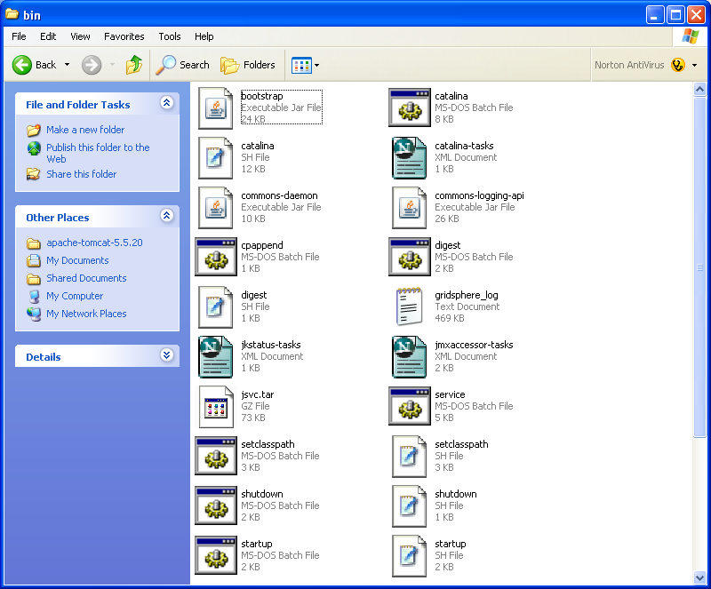

Start Tomcat by double clicking on the startup.bat shortcut. This should create some output letting you know the values of the environmental variables mention before. The final output should look something like:

Mar 10, 2007 2:09:03 PM org.apache.coyote.http11.Http11BaseProtocol start
INFO: Starting Coyote HTTP/1.1 on http-8080
Mar 10, 2007 2:09:03 PM org.apache.jk.common.ChannelSocket init
INFO: JK: ajp13 listening on /0.0.0.0:8009
Mar 10, 2007 2:09:03 PM org.apache.jk.server.JkMain start
INFO: Jk running ID=0 time=0/47 config=null
Mar 10, 2007 2:09:04 PM org.apache.catalina.storeconfig.StoreLoader load
INFO: Find registry server-registry.xml at classpath resource
Mar 10, 2007 2:09:04 PM org.apache.catalina.startup.Catalina start
INFO: Server startup in 11500 ms

Open an Internet browser, type http://localhost:8080/ on its address bar. You should see a welcome screen from the apache tomcat server:
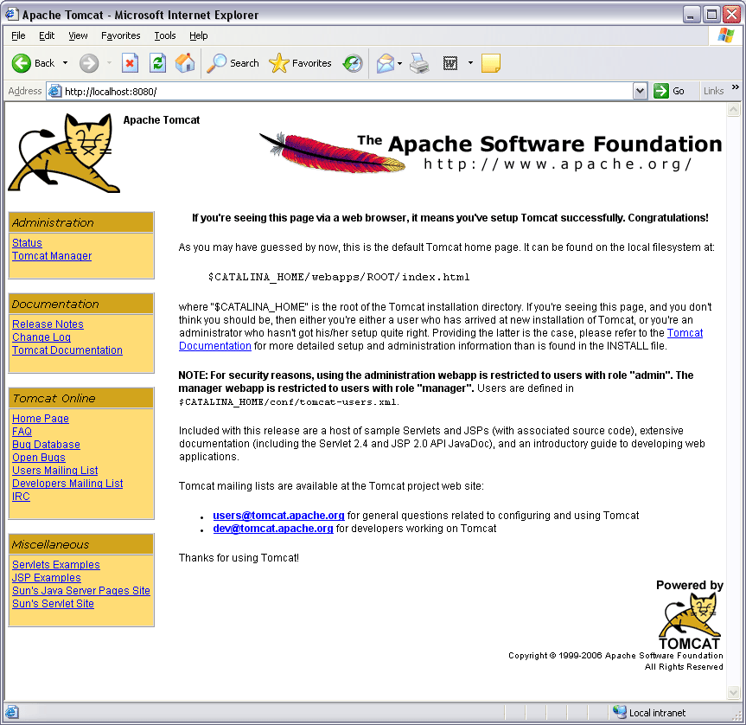

Installing Gridsphere
This installation is different than the previous installations. It uses Ant to deploy the portal. Get Gridsphere from:

http://www.gridsphere.org/gridsphere/gridsphere

Choose Gridsphere version 2.2 (not version 3). The assignment has been tested with GridSphere version 2.2.8.

Also get the xerces2 Java parser library from http://xerces.apache.org/xerces2-j. The assignment was tested with version 2.9.0. Unpack both of the source directories. Move the five .jar files from the xerces directory to %CATALINA_HOME%\shared\lib:
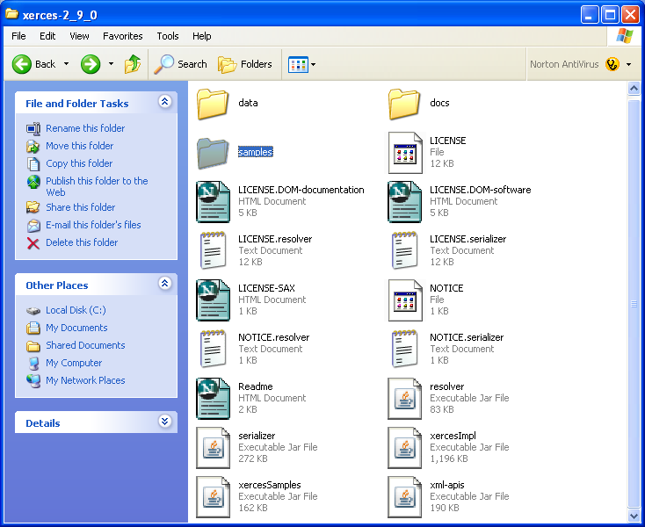

Make sure your tomcat server is still running before you continue with the installation.

“cd” into the Gridsphere directory from your command prompt and type:

ant install

This should start the installation process. After a lot of messages and 1000’s of file transfers, one should finally get:

[echo] GridSphere successfully installed.
[echo]
[echo] +--------------------------------------------------------------------------+
[echo] | Please start up your webserver and go to http://server:port/gridsphere/ |
[echo] +--------------------------------------------------------------------------+

BUILD SUCCESSFUL
Total time: 2 minutes 39 seconds
C:\gridsphere-2.2.8>

If there are no errors, restart the tomcat server by calling %CATALINA_HOME%\bin\shutdown.bat and then %CATALINA_HOME%\bin\startup.bat. Use shortcuts for convenience.

Open an Internet browser and type http://localhost:8080/gridsphere/. You should see a login screen or dialog asking you to set the administrators password.:

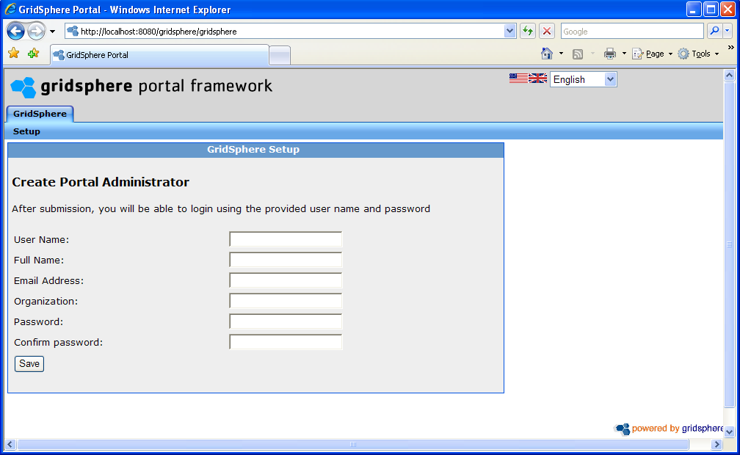

Set the administrator's password and you will get:

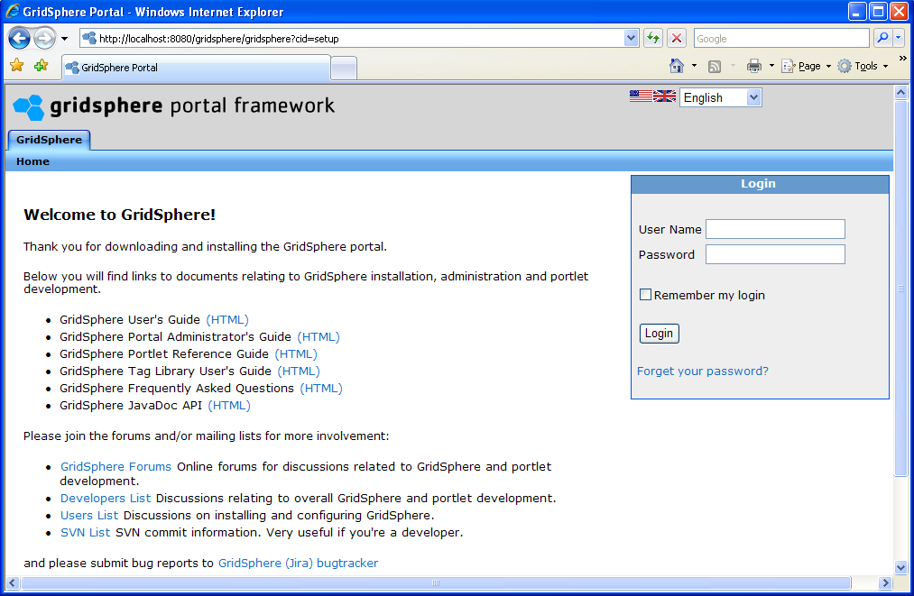

You are now (hopefully) done with the installation. If you have problems, make sure you set all of your environment variables.

3. Creating a portlet
Next, we will create a simple portlet who's job is to tell the user whether the inputed number is even or odd.

First, from the command prompt, cd into Gridsphere base directory and type:

ant new-project

The program will ask “ Please enter a Project Title e.g. Cool Portlets”, type:

Odd Even Portlet

The next question is “ Please enter a Project Name this will be used for your portlet web application, which should be lowercase:

oddevenportlet

The next question “Do you wish to develop GridSphere/WebSphere portlets or JSR 168 port
lets? Enter gs or jsr (gs, jsr)” type:

jsr

This creates a new directory inside of the projects directory called oddevenportlet.

cd into projects\oddevenportlet. You will see a directory structure:

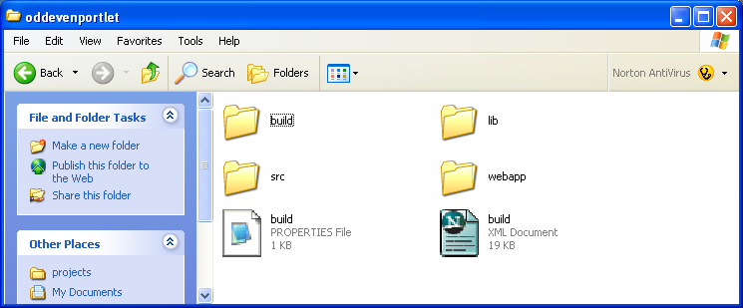
Holds directory structure leading to java source file
Holds deployment descriptor files

The two key directories are identified, src and webapp.

The structure is meant to organize your development process. Your Java source files should go in the folder “\src“. The folder structure inside the src folder should reflect the order of the classes in the package structure. For example, if you create a package edu.xxxx.username, you should have a directory username inside the directory xxxx which should be inside the directory edu.

The webapp folder contains files that describe the environment in which the portlet will work. This includes the jsp folder for jsp pages, the html folder for static html material and the WEB-INF folder that holds the files that specify the location of the java classes to the portlet loader. Because of the way the build.xml file is written for the Gridsphere project, the last folder of you package name should be named portlets. Otherwise your classes would not get included in the .jar file and this will create a ClassNotFound Exception at runtime.

Deployment Descriptor Files

There are three deployment descriptor files to create a portlet:

Portlet.xml JSR 168 standard, describing the portlet
Layout.xml Grdisphere file describing layout of portlet within page
Group.xml Gridsphere file describing a collection of portlets

(There are other deployment files that are generated automatically during deployment.) Deployment Files for our oddeven portlet are provided here:

portlet.xml
layout.xml
group.xml

and listed in the Appendix. Study the interrelationship of these files. Note that the group.xml file specifies the group as “demo.” The Portlet.xml file specifies the class files as edu.uncc.<username>.portlets.OddEven. The layout file specifies a portlet “tab” layout and specifies the class file. Edit these files to include your username where indicated.

Place the three files in the webapp\WEB-INF directory, replacing the existing sample files. Below the original files have been renamed for backup purposes

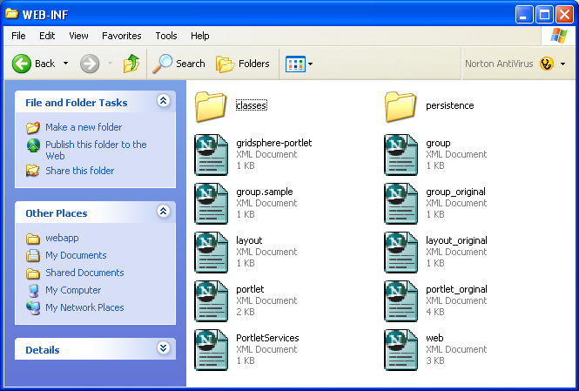

Java Portlet File

The java file provides the action to take place when the user interacts with the portlet. The file is provided here:

OddEven.java

and listed in the Appendix. Create the directory structure edu\uncc\username\portlets inside src directory (where username can be your university username). Move the file OddEven.java to src\edu\uncc\username\portlets\:

OddEven.java also uses a file called MainPage.jsp (JavaServer Pages, JSP) to dynamically generate an HTML page. This file can be found here:

MainPage.jsp

and listed in the Appendix. Move MainPage.jsp in the webapp\jsp directory:

Compile and deploy the portlet by running the ant install script inside of the gridsphere-2.2.8\Projects\oddevenportlet directory:

ant install

Restart Tomcat.

Go the http://localhost:8080/gridsphere/ and test the portlet. To do this, first login to Gridsphere with the username you setup. Configure your group membership by selecting the demo group (the group used with the OddEven portlet):
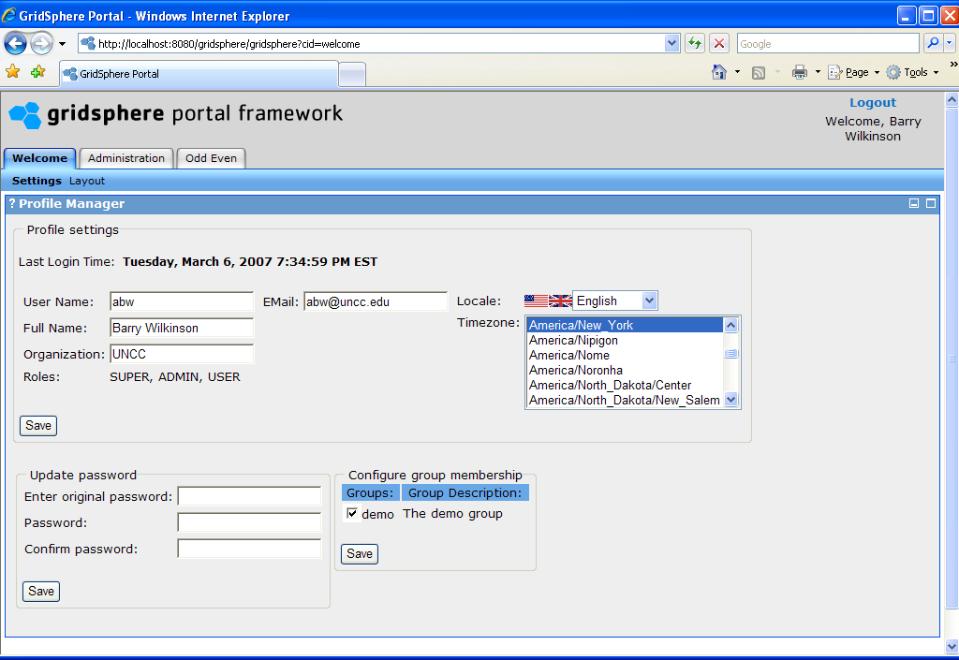

Then go to the Administration Tab, and next to the “Gridsphere” group name, select “Select Portlets”.

Check the box next to “Odd Even Portlet” at the bottom, and then click “Save”

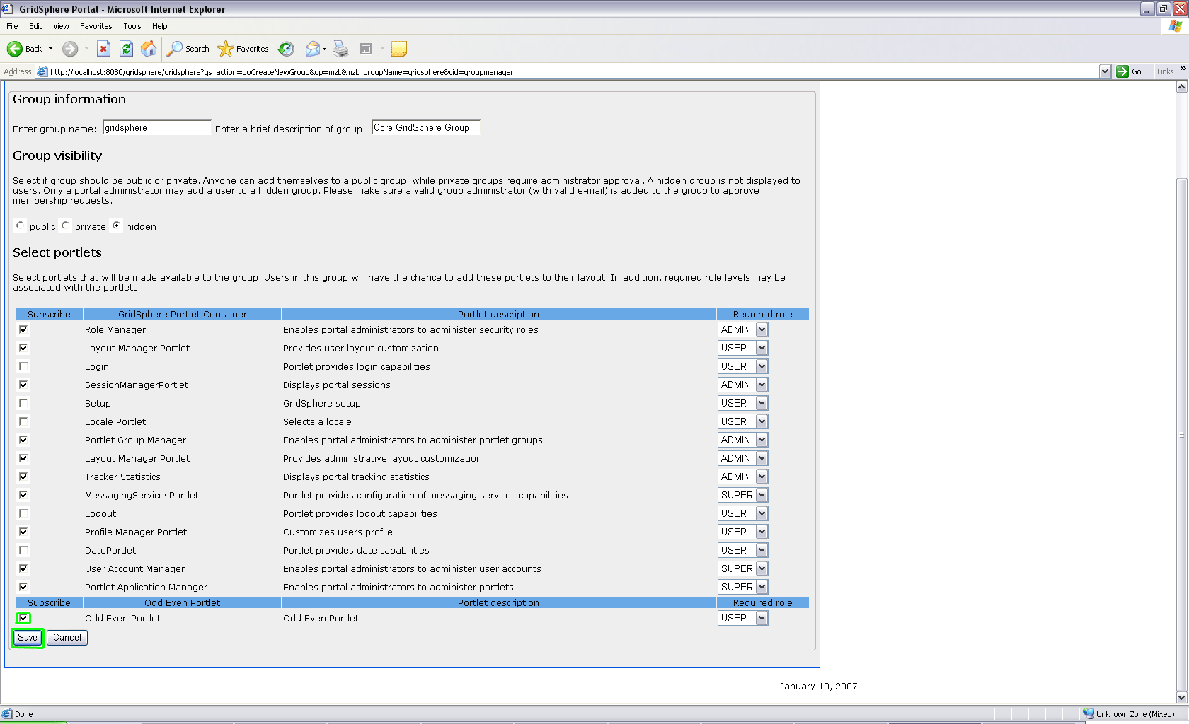

(Oddeven portlet is in the demo group.)

You should now see your portlet:

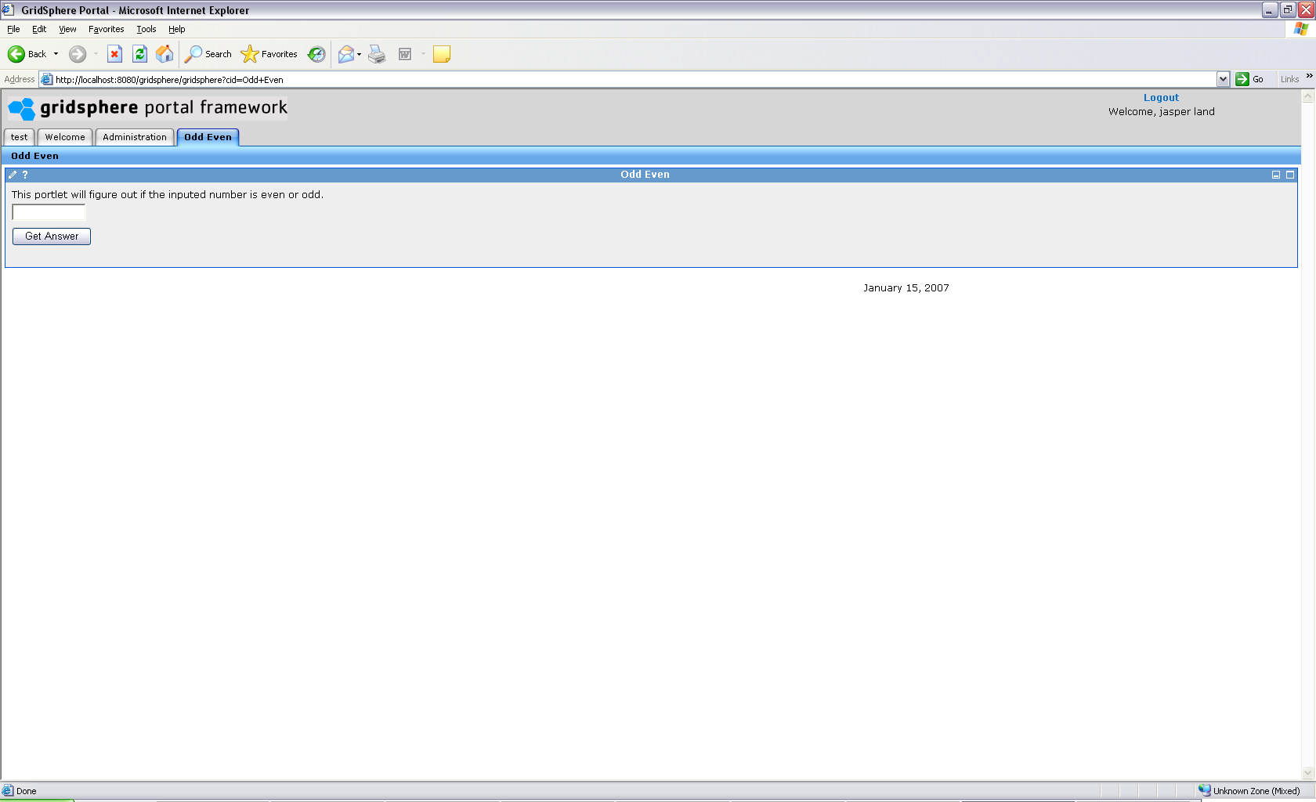

4. Developing your own portlet

Building on what you just learned, make a portlet that allows a user creates a portlet that can add, subtract, multiply and divide two numbers. An example is shown below:
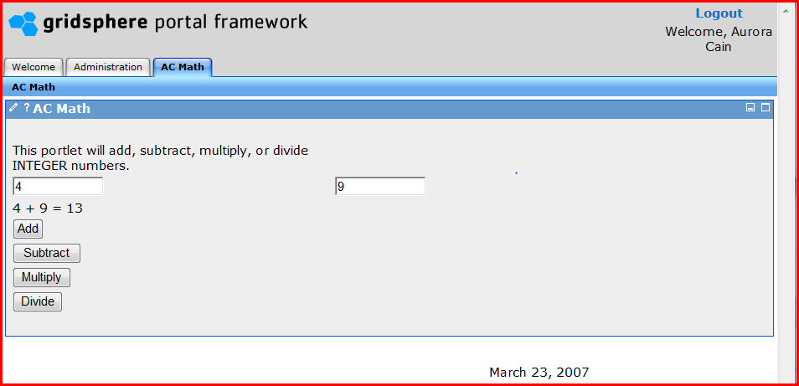

You should not to use the layout above. You should develop your own layout. Your layout could even be similar to a calculator with a single field that displays the input and accumulating answer, and buttons for the various functions.
5. Open-Ended Project

In this part, you are to bring together knowledge you have learned throughout the course to create a portlet interface for a distributed application or software component. The specific design is not specified but it must have the following components:

- A portlet that is hosted in Gridsphere and provides the user interface
- A local Java client program
- A Web service, ideally located elsewhere. This may be a service such as provided in previous assignments
There must be a purpose for the combined configuration.
Develop the code for your configuration and demonstrate that it functions according to your requirements. Graduate students are expected to demonstrate a more complex arrangement. Grading will depend upon the work done.
See also notes at end of assignment write-up.

6. Assignment Submission

Refer to the assignment submission document.

Appendix

Deployment descriptor files

Portlet.xml

<portlet-app xmlns="http://java.sun.com/xml/ns/portlet/portlet-app_1_0.xsd"
version="1.0"
xmlns:xsi="http://www.w3.org/2001/XMLSchema-instance"
xsi:schemaLocation="http://java.sun.com/xml/ns/portlet/portlet-app_1_0.xsd">
<portlet>
<description xml:lang="en">Odd Even Portlet</description>
<portlet-name>OddEven</portlet-name>
<display-name xml:lang="en">Odd Even Portlet</display-name>
<portlet-class>edu.uncc.username.portlets.OddEven</portlet-class>
<expiration-cache>60</expiration-cache>
<supports>
<mime-type>text/html</mime-type>
<portlet-mode>edit</portlet-mode>
<portlet-mode>help</portlet-mode>
</supports>
<supported-locale>en</supported-locale>
<portlet-info>
<title>Odd Even</title>
<short-title>Odd Even</short-title>
<keywords>odd even</keywords>
</portlet-info>
</portlet>
</portlet-app>
layout.xml

<portlet-tabbed-pane>
<portlet-tab label="Odd Even">
<title lang="en">Odd Even</title>
<portlet-tabbed-pane style="sub-menu">
<portlet-tab label="oddeventab">
<title lang="en">Odd Even</title>
<table-layout>
<row-layout>
<column-layout>
<portlet-frame label="Odd Even">
<portlet-class>edu.uncc.username.portlets.OddEven</portlet-class>
</portlet-frame>
</column-layout>
</row-layout>
</table-layout>
</portlet-tab>
</portlet-tabbed-pane>
</portlet-tab>
</portlet-tabbed-pane>
group.xml

<?xml version="1.0" encoding="UTF-8"?>
<portlet-group>
<group-name>demo</group-name>
<group-description>The demo group</group-description>
<group-visibility>PUBLIC</group-visibility>
<portlet-role-info>
<portlet-class>edu.uncc.username.portlets.OddEven</portlet-class>
<required-role>USER</required-role>
</portlet-role-info>
</portlet-group>
Java Portlet File

OddEven.java

package edu.uncc.username.portlets;
import org.gridlab.gridsphere.provider.portletui.beans.CheckBoxBean;
import org.gridlab.gridsphere.provider.portletui.beans.TextFieldBean;
import org.gridlab.gridsphere.provider.portletui.beans.TextBean;
import org.gridlab.gridsphere.provider.event.jsr.RenderFormEvent;
import org.gridlab.gridsphere.provider.event.jsr.ActionFormEvent;
import org.gridlab.gridsphere.provider.portlet.jsr.ActionPortlet;

import javax.servlet.UnavailableException;
import javax.portlet.PortletConfig;
import javax.portlet.PortletException;
import javax.portlet.PortletSession;

import javax.portlet.*;
import org.gridlab.gridsphere.provider.portlet.*;
import org.gridlab.gridsphere.provider.event.jsr.*;
import java.io.IOException;
import java.io.*;

public class OddEven extends ActionPortlet
{
private static final String DISPLAY_PAGE = "MainPage.jsp";

public void init(PortletConfig config) throws PortletException
{
super.init(config);
DEFAULT_VIEW_PAGE = "prepare";
}

public void action(ActionFormEvent event) throws PortletException
{
TextFieldBean value1 = event.getTextFieldBean("valueTF1");
TextBean answer = event.getTextBean("answer");

int val = Integer.parseInt( value1.getValue() );

if(value1.getValue() == null ){
answer.setValue("");
}
else{
if( isEven(val) ){
answer.setValue("The number: " + value1.getValue() + " is Even");
}else{
answer.setValue("The number: " + value1.getValue() + " is Odd");
}
}
setNextState(event.getActionRequest(), DISPLAY_PAGE);
}

public void prepare(RenderFormEvent event) throws PortletException
{
setNextState(event.getRenderRequest(), DISPLAY_PAGE);
}
public boolean isEven(int val){
return val % 2 == 0;
}

}

MainPage.jsp

<%@ taglib uri="/portletUI" prefix="ui" %>
<%@ taglib uri="http://java.sun.com/portlet" prefix="portlet" %>
<portlet:defineObjects/>
<ui:form>
<ui:table width="500">
<ui:tablerow>
<ui:tablecell>
This portlet will figure out if the inputed number is even or odd.
</ui:tablecell>
</ui:tablerow>
<ui:tablerow>
<ui:tablecell>
<ui:textfield size="10" beanId="valueTF1"/>
</ui:tablecell>
</ui:tablerow>
<ui:tablerow>
<ui:tablecell>
<ui:text beanId="answer"/>
</ui:tablecell>
</ui:tablerow>
<ui:tablerow>
<ui:tablecell>
<ui:actionsubmit action="action" value="Get Answer"/>
</ui:tablecell>
</ui:tablerow>
</ui:table>
</ui:form>

DEBUGGING NOTES

Tomcat and Gridsphere. Tomcat must be running first before starting Gridsphere.
Browser Caches: The contents of pages brought up by browsers are cached (as are portlets, see portlet.xml). Hence any changes you make may not be reflected in the displayed browser page. Update the page by pressing shift-control when selecting the URL to refresh the page from source.
__________________________________________________________________________________
For Section 5
Jeremy Villalobos
Nov 13, 2008

These are a few of the tricky steps that need to be done for Section 5. I recommend you first test that everything is ok by just plugging in the code from the Math Service Client that accesses Math Service “first” into a portlet that you have already tested for bugs and misconfiguration. A good choice would be the OddEvent portlet. Make sure you can run both assignemts (Math Service First and OddEvent without error. Then add the code from the Math Service Client to the portlet. Make sure to add the import statements, and to modify the Client code so that it can be used on the portlet. For example, the args[0] would need to be replaced with some other variable that you would create.

Before you compile the project with:

ant install

Add the highlighted code below to the Build.xml file in oddeven project folder. The code below just lets Ant know about the .jar's from Globus.
<if>
<equals arg1="${gridsphere.appserver}" arg2="tomcat"/>
<then>
<echo message="Installing for Tomcat"/>
<property name="appserver.home" value="${env.CATALINA_HOME}"/>
<path id="servletpath">
<fileset dir="${appserver.home}/common/lib/">
<include name="*.jar"/>
</fileset>
This should be the path to your Globus ws-core package, your %GLOBUS_LOCATION%
<fileset dir="/ws-core-4.0.8/lib/">
<include name="*.jar"/>
</fileset>

</path>
</then>
</if>

Make sure to catch any syntax error and resolve missing classes by adding import statements.

Before you restart tomcat. Add the .jar's from %GLOBUS_LOCATION%\lib to %CATALINA_HOME%\shared\lib (CATALINA_HOME is the location of the tomcat package)

Now you can restart tomcat and see if there are any remaining errors. If there are any remaining errors, you can use %CATALINA_HOME%\logs\catalina.out file in addition to what it is printed in the portlet to help you pinpoint the error.

NOTE: be aware that if you use a secure container (such as the ones in coit-grid and torvalds) you may need to add additional code to handle credentials. The Cog kit provides such API.

To set/edit an environment variable in Windows. Go to Start, right-click My Computer. Go down menu and click on Properties. Click on Advanced tab. Click on Environment variables tab. Click new, edit, or delete as appropriate.
In Windows, to create a shortcut, right-click of the file, and select Create Shortcut.

