Assignment Submission

This document is written to suit the systems and procedures at UNC-Charlotte/UNC-Wilmington.
Instructors - Alter document to suit your own procedures.

All assignments are to be submitted though UNC-C’s Moodle system at http://moodle.uncc.edu/ as shown below:

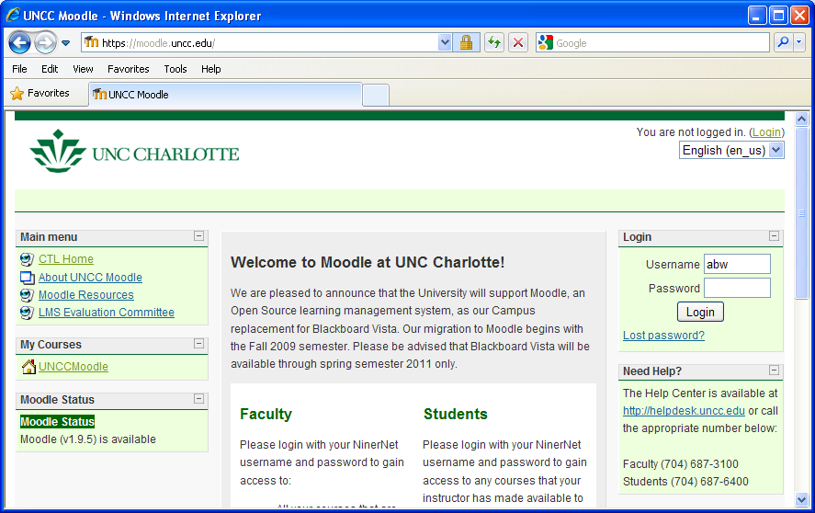
UNC-C Moodle login page

Log in and click on the UNC-C Grid computing course, ITCS 4146, listed under My Courses.

Assignment Report

Submit a single PDF document by the due date posted on the course home page, with the following aspects:

- Clearly show that you successfully followed the instructions and performed the tasks. Identify the tasks as given in assignment write-up.
- Include code listings where applicable, with comments and brief explanation of the code.
- Take screen shots displaying the output from various tasks and include them in the report. The number of screen shots is up to you but it should demonstrate your programs worked.
- Provide conclusions. For the record, state what programming skills and knowledge you used but already knew before doing this assignment (This information does not affect the grading, but may be helpful in subsequent course developments.)

DO NOT SUBMIT MULTIPLE FILES, A COMPRESSED FILE, OR A FILE IN ANY OTHER FORMAT THAN PDF. SUCH SUBMISSIONS WILL BE IGNORED. DO NOT SUBMIT BY EMAIL UNLESS REQUESTED TO DO SO.
abw/Oct 5, 2009

