SIGCSE 2010 - The 41st ACM Technical Symposium on Computer Science Education

March 10-13, 2010, Milwaukee, WI, USA

Workshop 20: Teaching a Hands-on Undergraduate Grid Computing Course

Session 2: Using a command line to execute jobs on a Grid platform

March 6, 2010

Note: This sesssion is based upon Using the Grid through a Command Line by Jasper Land, Jeremy Villalobos, B. Wilkinson, and Clayton Ferner, January 25, 2010, http://www.csc.uncw.edu/~cferner/ITCS4146S10/assign2S10.pdf, the second assignment in our Grid course. In the actual student assignment, not all the files are provided – students will need to write some themselves.

The purpose of this session is to understand how to submit jobs via the command line which can be compared to using portal.

I. Logging into the Grid

Step 1 Installing SSH client

For Windows, you will need an ssh client such as PuTTY to login to the servers. You can download PuTTY from http://www.chiark.greenend.org.uk/~sgtatham/putty/download.html.
Another client you can use instead is WinSCP. WinSCP may be used as an ssh client and has the advantage that it can also be used as a scp client to copy files to and from the client computer. WinSCP can be downloaded from http://winscp.net/eng/index.php.

Choose your preferred ssh client and install it.

Step 2. Log into the UNC-C grid server

Make an ssh connection to coit-grid01.uncc.edu using your ssh client and open a terminal. At this prompt type in the username we provided to you on registration. You should now have command line access to the grid as shown in Figure 1 (PuTTY).
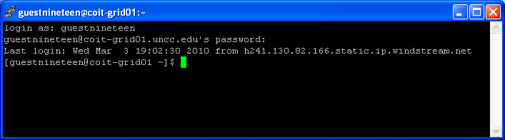
Figure 1: Logged in
Make sure you are in your home directory (~). In this directory, you will find several files that you will use for this workshop. Appendix A lists these files.

II. Setting up your credentials and getting a proxy

Before you can issue any grid commands, you will need a proxy to delegate your authority. As an expedient and convenience, we will use the myProxy server to obtain proxies just as in Session 1. (In the actual class assignment, students learn how to load their credentials into their accounts, see the class assignment write-up.)

Task: To obtain a proxy from the myProxy server, issue the command:

myproxy-logon -s coit-grid02.uncc.edu

You will be prompted for a password, which is the same as your portal password. You can check that you got a proxy with the command:

grid-proxy-info

which will show the proxy subject, issuer, and how much time is available.

III. Executing Jobs on the Grid Platform

Task 1 Getting Started – submitting a job as named executable to local host

We will use a Linux program/command called hostname that comes with the Linux distribution as our first job. Hostname simply returns the name of the host that runs the command. The simplest way is to specify the executable and arguments and let Globus create the job submission file and submit the job. The command to submit the echo job this way is:

globusrun-ws -submit -F localhost:8440 -s -c /bin/hostname

where:
-F localhost:8440 specifies the server and port that the job will run on. On our system, the globus container is running on port 8440. (Technically, it specifies ManagedJobFactory service and creates the Endpoint Reference, EPR, for it.)
-s (on its own) specifies streaming the output of the job back to the console. (To specific a file, use the additional flag –so outputfile)
-c flag causes globusrun-ws to generate the job description file with the subsequent named program and arguments.
-submit is a required flag and causes the job based upon the job description file to be submitted in one of three outputs modes, batch, interactive or interactive streaming . The mode here is the default interactive mode.

Submit the hostname job in the above fashion. You should get an output similar to Figure 2 (overleaf), with the exception that the “Job ID” line will be followed by a unique job name.

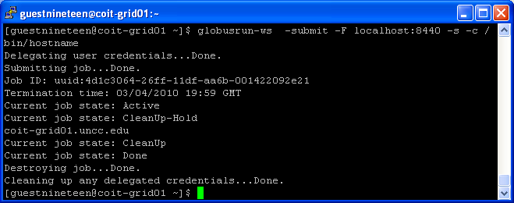
Figure 2 Running a local job

You should see the job progress through various states with the name of the server running the job among the output (It may take some time). The command can take some time to complete. Do not kill the command (ctrl-c) unless you have waited at least 2-3 minutes.

Task 2 Submitting a job as named executable to a remote server

Issue the command:

globusrun-ws -submit -F torvalds.cis.uncw.edu -s -c /bin/hostname

Notice that the name of the host is different as well as there is no port number given. That is because the globus container on torvalds is using the default port number of 8443, so it is not needed. You should see the job progress through various states with again the name of the server running the job among the output as shown in Figure 3. (It may take some time.)

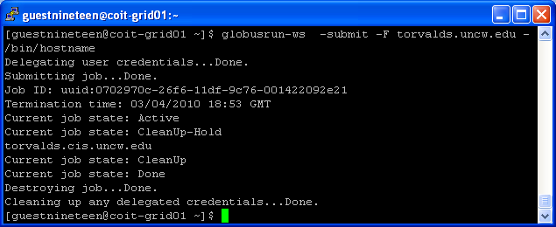
Figure 3 Running a remote job

Task 3 Submitting the Mulch programs

Now we are going to do the same computations as was done in Session 1 to compute the volume and cost of mulch to cover a flowerbed using the same two programs, one on the UNC-C system (myIntegral) and one on the UNC-W system (myMulch). You should already find these programs as class files on your accounts on these computers (myIntegral.class on coit-grid01.uncc.edu and myMulch.class on torvalds.cis.uncw.edu).

In addition, we will use more powerful and the normal way of submitting the job by specifying the job in a job description file. The job description files are written in a XML language and are provided as myIntegral.xml and myMulch.xml on coit-grid01.uncc.edu

Task 3a Examine the job description files, myIntegral.xml and myMulch.xml with the Linux cat (concatenate and print to stdout) command:

cat myIntegral.xml
and
cat myMulch.xml.

myIntegral.xml | myMulch.xml
<?xml version="1.0" encoding="UTF-8"?>  <job>  <executable>/usr/local/java/bin/java</executable>  <directory>${GLOBUS_USER_HOME}</directory>  <argument>myIntegral</argument>  <argument>0</argument>  <argument>5</argument>  <argument>10000</argument>  <stdout>${GLOBUS_USER_HOME}/area_output</stdout>  <stderr>${GLOBUS_USER_HOME}/area_error</stderr>  <count>1</count>  </job> | <?xml version="1.0" encoding="UTF-8"?>  <job>  <executable>/usr/local/java/bin/java</executable>  <directory>${GLOBUS_USER_HOME}</directory>  <argument>myMulch</argument>  <argument>area_output</argument>  <stdout>${GLOBUS_USER_HOME}/mulch_output</stdout>  <stderr>${GLOBUS_USER_HOME}/mulch_error</stderr>  <count>1</count>  </job>

File details:
<directory> specifies where the program execution is based on,
<executable> specifies the pathname of the file to be executed (in this case the echo command)
<stdout>/<stderr> specify where the output should be placed
<count> tells the program how many times the command should be executed.

Task 3b We now need to remove the output files created by programs from Session 1 so that we can confirm same programs worked from the command line.

On coit-grid01.uncc.edu, issue the command:

rm area_output

Maintain the ssh connection to coit-grid01 and open up a separate ssh connection (start another ssh client.) Log onto torvald.cis.uncw.edu and issue the command:

rm area_output mulch_output

Task 3c: Execute the myIntegral program on coit-grid01.uncc.edu using the globusrun-ws command:

globusrun-ws -submit -F localhost:8440 -f myIntegral.xml

Task 3d: Now you need to get the area_output to torvalds. The command to do this on coit-grid01 is:

globus-url-copy file:///nfs-home/<username>/area_output \
gsiftp://torvalds.cis.uncw.edu/home/grid/<username>/

Replace <username> with your user name (\ is the continuation symbol should you need to enter the command on multiple lines.)

Verify that the file was transferred successfully to torvalds.

Task 3e: Now run the myMulch program on torvalds using the globusrun-ws command on coit-grid01 with the myMulch.xml job description file.:

globusrun-ws -submit -F torvalds.uncw.edu -f myMulch.xml

Go to the torvalds command window and verify that above worked successfully looking to see if a file stdout was created and has the expected output. If the command didn't work correctly, be sure to check the standard error file for any errors.

Task 4 Using File Staging (if there is time)

We can move the area_output file in Task 3d to torvalds automatically by specifying input file staging in the myMulch job description file that is executed on torvalds. We can also specify that the final output is moved back to coit-coit01 (output staging). Finally we can specify that intermediate area file is deleted (clean-up). We provide the complete job description file as mulch2.xml in your coit-grid01.uncc.edu home directory and shown below:

<?xml version="1.0" encoding="UTF-8"?>
<job>

<executable>/usr/local/java/bin/java</executable>
<directory>${GLOBUS_USER_HOME}</directory>
<argument>myMulch</argument>
<argument>area_output</argument>
<stdout>${GLOBUS_USER_HOME}/mulch_output</stdout>
<stderr>${GLOBUS_USER_HOME}/mulch_error</stderr>
<count>1</count>

<fileStageIn>
<transfer>
<sourceUrl>gsiftp://coit-grid01.uncc.edu:2811/nfs- home/<username>/area_output</sourceUrl>
<destinationUrl>file:///home/grid/<username>/</destinationUrl>
</transfer>
</fileStageIn>

<fileStageOut>
<transfer>
<sourceUrl>file:///home/grid/<username>/mulch_output</sourceUrl>
<destinationUrl>gsiftp://coit-grid01.uncc.edu:2811/nfs-home/<username>/</destinationUrl>
</transfer>
</fileStageOut>

<fileCleanUp>
<deletion>
<file>file:///home/grid/<username>/area_output</file>
</deletion>
<deletion>
<file>file:///home/grid/<username>/mulch_output</file>
</deletion>
<deletion>
<file>file:///home/grid/<username>/mulch_error</file>
</deletion>
</fileCleanUp>

</job>

At this point, we have already run the myIntegral program and will only add file staging to the myMulch program.

Task 4a: Modify the job description file mulch2.xml replacing <username> everywhere with your user name. The easiest way to do this using nano is to use the control-\ “search and replace” nano command throughout (select “all” after search and replace).

Task 4b: Run this job description file using the globusrun-ws using the command on coit-grid01.uncc.edu:

globusrun-ws -submit -S -F torvalds.cis.uncw.edu -f mulch2.xml

Notice the addition of the -S option. This tells the globusrun-ws command to delegate your credentials to the remote machine. You should get output such as shown in Figure 4
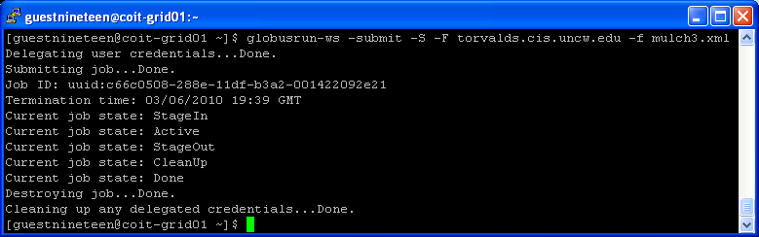
Figure 4 Running the MyMulch job with file staging and cleanup

Notice the extra StageIn and StageOut stages that the job goes through in Figure 4.

Verify the results and see that the final results are now written to mulch_output on coit-grid01.

Task 5 End your grid session

You can destroy your proxy by issuing the command grid-proxy-destroy. Since the proxy has a limited lifetime, it is not essential to destroy it. It will soon become useless anyway. When you have completed all of the steps above you should logoff of both servers.

Appendix A Provided files used for Session 2

coit-grid01.uncc.edu

myIntegral.class Java class file for the myIntegral.java program that computes the area of the flowerbed. The instructions call for the output to be redirected to a file called area_output.

myIntegral.xml Job description file to execute myIntegral.class.

myMulch.xml Job description file to execute myMulch.class.

mulch2.xml Generic job description file to execute myMulch.class with input and output file staging on torvalds.cis.uncw.edu, and file clean-up.

torvalds.cis.uncw.edu

myMulch.class Java class file for the myMulch.java program that computes the volume and cost of the mulch over the flowerbed, given the area of the flowerbed given in the file named as the first and only argument (area_output)

