SIGCSE 2010 - The 41st ACM Technical Symposium on Computer Science Education

March 10-13, 2010, Milwaukee, WI, USA

Workshop 20: Teaching a Hands-on Undergraduate Grid Computing Course

Session 1: Accessing Grid Portal to Execute Jobs

March 6, 2010

Note: This session is based upon “Grid Portal Assignment: User Registration and Basic Testing” by B. Wilkinson, Jeremy Villalobos, Jasper Land, and C. Ferner, Dec. 29, 2009, http://www.csc.uncw.edu/~cferner/ITCS4146S10/assign1S10.pdf, the first assignment in our Grid course and set on the first day of class. In the actual student assignment, not all the files are provided – students will need to write some themselves.

Overview

The purpose of this session is to become familiar with a Grid portal. This portal is based upon the Gridsphere portal, which is widely used in production grids. It provides web interface to the grid resources set up for this course and enable users to access grid resources with a single sign-on. Through the portal, users can handle their security credentials, run jobs on the various resources, transfer files between resources in a fast secure fashion, and perform other actions. The accessible resources currently consist of:

- UNC-C Computer Science departmental cluster dedicated to Grid computing:
- coit-grid01.uncc.edu – coit-grid04.uncc.edu (Each dual 3.4 GHz dual Xeon processors)
- coit-grid05.uncc.edu (Four quad-core 2.93 GHz Xeon processors)

- UNC-W CS cluster called torvalds.cis.uncw.edu (or torvalds.uncw.edu).

Access to the UNC-C cluster is generally through coit-grid01.uncc.edu.
coit-grid02.uncc.edu hosts the course portal and certificate authority and should not be used.

The Portal

Although the portal provides a single sign-on, it is necessary for users to have credentials and accounts on all resources they wish to use. As an expedient for this workshop, these have already been set up for each participant. Details of provided separately. Several accounts are needed for the course:

- User account on the Portal
- User ssh accounts of each computer system to be used (UNC-C and UNC-W)

You have TWO passwords. The password for the portal is also used for the proxy credentials that are established on the myProxy server. A different password is used for the ssh connection.

Login to Portal

Go to the URL http://coit-grid02.uncc.edu:8080/gridsphere on a browser as shown in Figure 1:

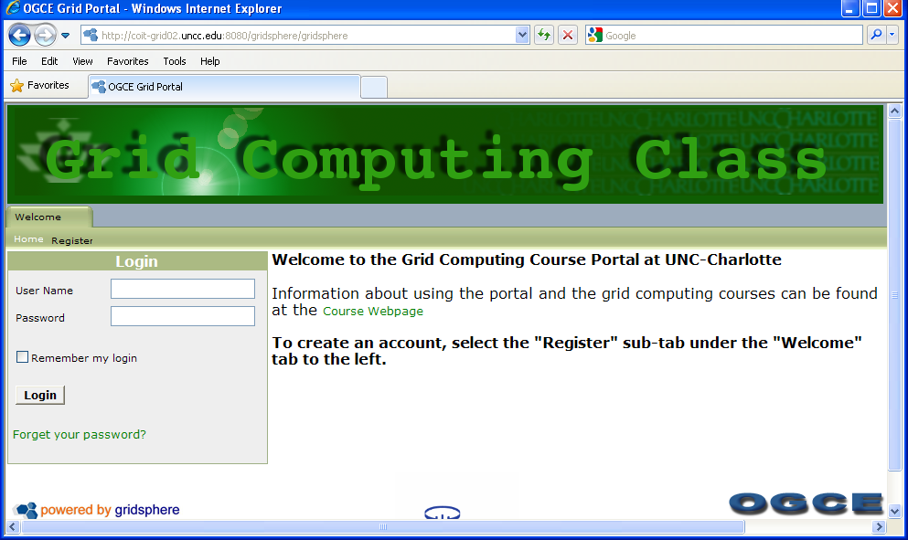
Figure 1 Portal login page

And log in to the portal. You will see the layout such as show in Figure 2 below:

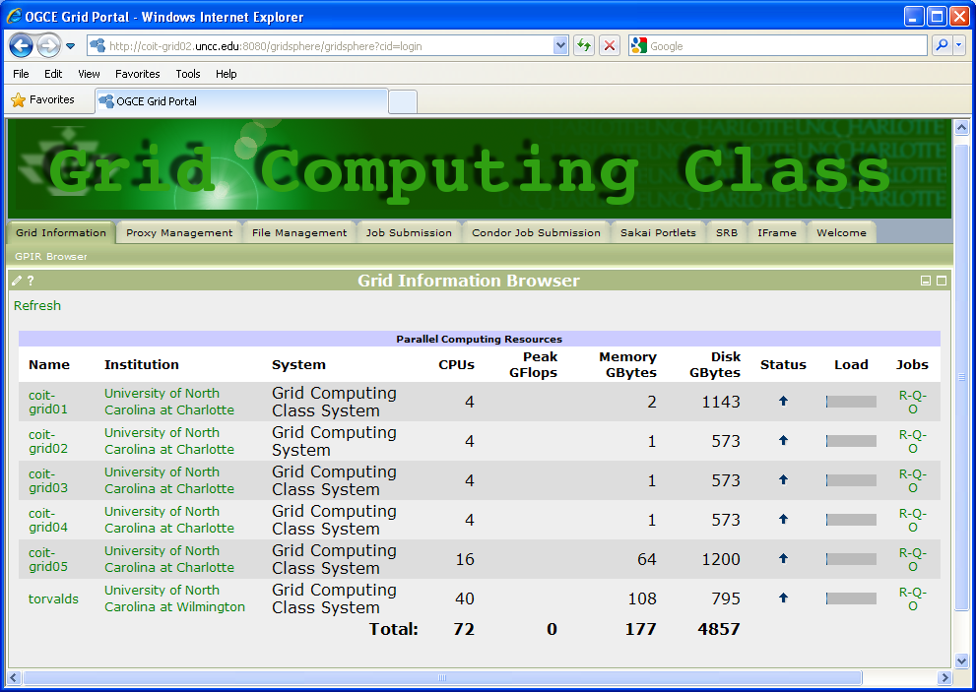
Figure 2 Grid Information page

From here you can click on the tab you wish to navigate to. Overleaf is a list of the choices:

(a) Grid Information

Select the Grid information tab and see the computer system available and their status (Figure 2).

(b) Proxy Management Tab

Selecting the Proxy Management tab, you should get the display similar to Figure 3 (but with your proxy details):

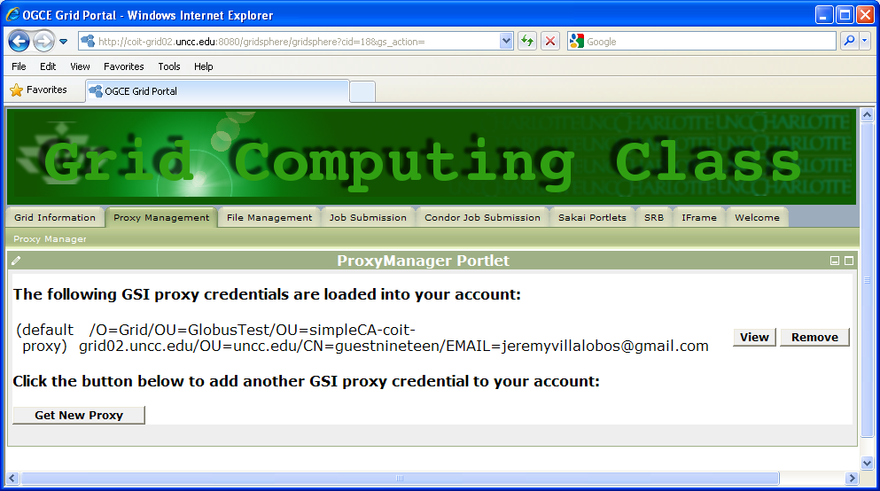
Figure 3 Proxy Management tab

Usually a proxy is loaded for you when you log in. The default lifetime of this proxy is 2 hours (proxies have limited lifetimes for security reasons). Every time you log in you will get a new proxy in addition to any unexpired proxies from previous logins. If you login multiple times before your proxy expires you will have multiple proxies, which are not needed.

MAKE SURE YOU HAVE A VALID PROXY SET AS DEFAULT. You cannot do any grid activities with a valid proxy.

File Management Tab

There are two file managers to transfer files between systems, the GridPort “Comprehensive File Management” tool and the “GridFTP” tool. We will use the (GridPort) Comprehensive File Management tool. Figure 4 shows a sample display with coit-grid01.uncc.edu selected as source and torvalds.cis.uncw.edu as destination.
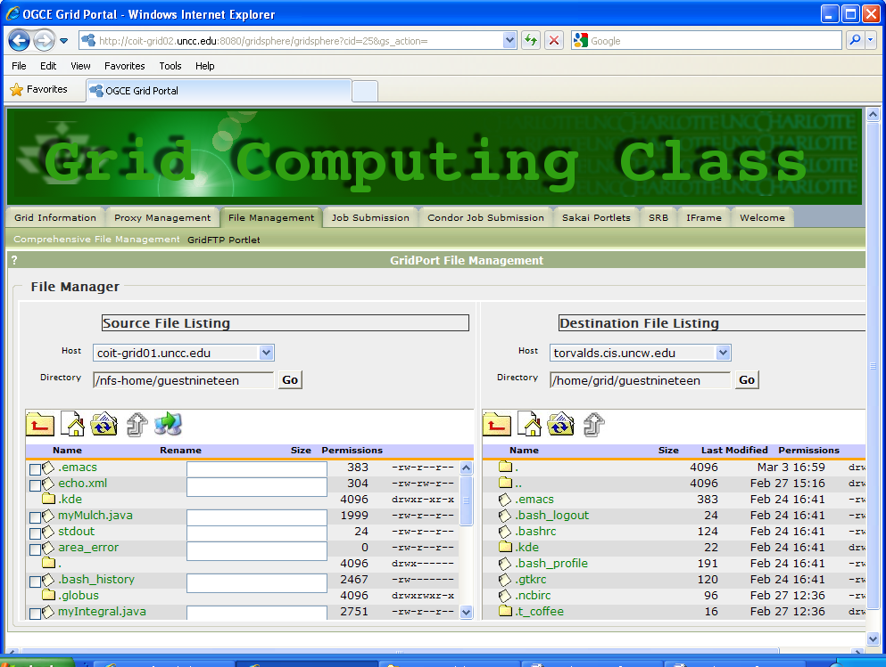
Figure 4 GridPort Comprehensive File Management Tool

Make sure that the Directory is “~” since your home directory is different on torvalds as it is on coit-grid0x. You will need to be patient when working with torvalds since the information needs to be transmitted from UNCW to UNCC before it is transmitted to your machine.

Upload File button: To transfer files from your computer to a server

Transfer Files button:  To transfer files between servers:

Download files to your computer: – click on file

Job Submission Tab

To submit a job, go to the Job Submission portlet. There are two job submission portlets, batch and interactive. We will use interactive job submission portlet shown in Figure 5.
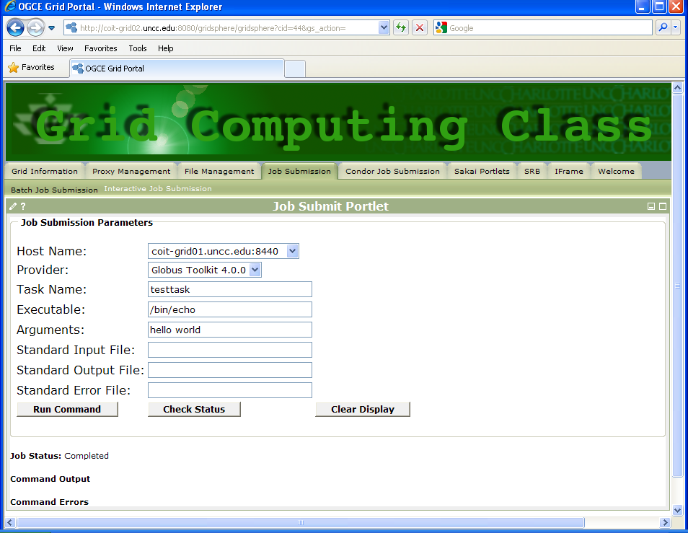
Figure 5 Interactive Job Submission portlet

Tasks

The task is to use the grid portal for a demonstration computation that uses both the UNC-C servers and the UNC-W cluster.This computation will be done again later using the command line and using a GUI workflow editor. The programs are written in Java, compiled locally and uploaded onto the servers for execution with a Java Virtual Machine.

The Computation: Compute the mulch to cover a flowerbed in Figure 6 to a depth of 4 inches.

Add 4 inches of mulch
Figure 6 Flowerbed

Two programs will be used:
1. myIntegral, a program to compute the area of the flowerbed, which will be executed on coit-grid01.uncc.edu, with the output redirected to a file called area_output, and
2. myMulch, a program to compute the volume of mulch and cost, given the area of the flowerbed held in the file area_output from myIntegral, to be executed on torvalds.uncw.edu.
As illustrated in Figure 7, it will be necessary to transfer the area_output file from coit-grid01.uncc.edu to torvalds.cis.uncw.edu. We can also copy the final result back to coit-grid01.uncc.edu if needed.

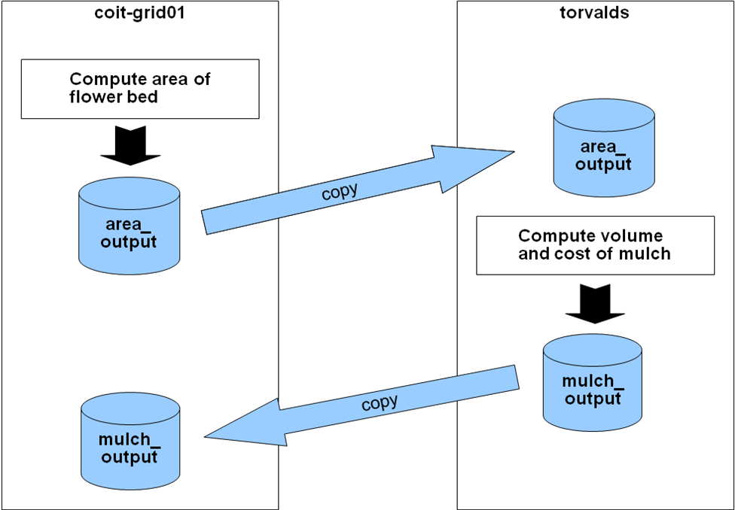

Figure 7. Complete computation including manual file movement

Step 1: Compute the area of the flowerbed on coit-grid01.uncc.edu

The first program computes the area of the flowerbed by numerically integrating the function describing the flowerbed. The Java code is given in Appendix A. As an expedient, this program has been compiled and already placed in your home directory on coit-grid01.uncc.edu as myIntegral.class. The program requires three arguments, the start and end of the flowerbed and the number of intervals. We shall use 0, 5 and 10000 as the three arguments. It reports the area to stdout.

Step 1a Check file myIntegral.class exists in your home directory using the file management portlet.

Step 1b Execute program myIntegral.class on coit-grid01.uncc.edu using the Interactive Job Submission portlet. Several entries are needed:

Hostname: coit-grid01.uncc.edu
Provider: Globus Toolkit 4.0.0
Task name: Any name
Executable: /usr/local/java/bin/java (The executable is the Java interpreter.)
Arguments: myIntegral 0 5 10000 (The name of Java class file, without .class extension,
and other arguments, a, b, and n, to program)
Std. Output File: area_output (Stdout must be specified. Output is redirect to file specified.)
Std. Error File: area_error

The entries should look as shown in Figure 8 (overleaf)
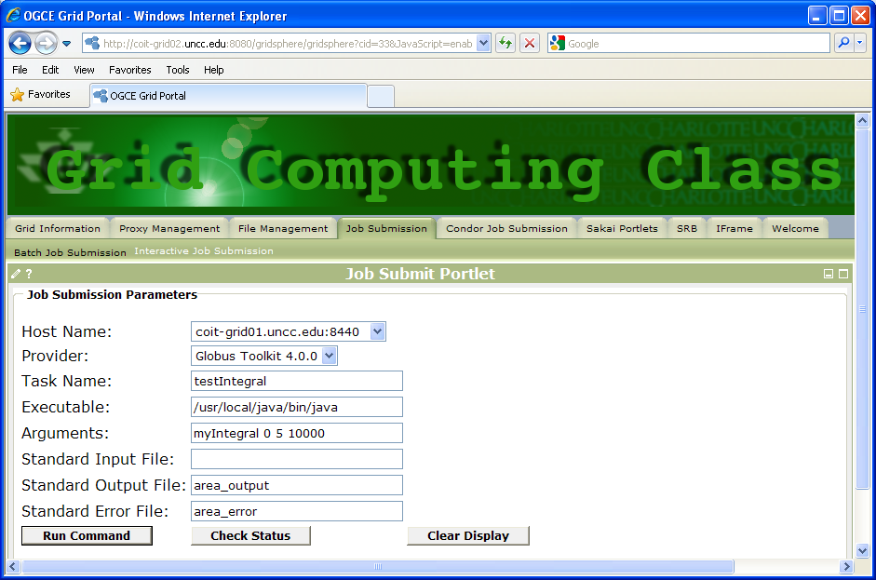

Figure 8 myIntegral job submission.

Step 1 c Check status shortly after selecting run. When complete, check the area_output file contains the correct answer (11.274239479285436 sq ft) by going to the file management portlet and clicking on the output file.

Step 2 Transfer the area_output file to torvalds

Transfer the area_output file to torvalds.uncw.edu using the File Management tab of the portal.

Step 3 Given area, compute the volume and cost of the mulch on torvalds

The compiled program to compute the volume and cost of mulch given the area of the flowerbed is provided in your home directory on torvalds as myMulch.class.

Step 3a Check file myMulch.class exists in your home directory on torvalds using the file management portlet.

Step 3b Execute myMulch.class the program using the Job Submission tab of the portal. The executable is again java interpreter. The path to Java to java on all torvalds should be /usr/local/java/bin/java. The arguments are the name of the Java class file (but without the .class) and the other arguments (the name of the input file) to your program. Redirect standard output to a file called mulch_output. The entries should look as shown in Figure 9 (overleaf).

Step 3c After the job has finished, go to the file transfer portlet and find the mulch_output file and check the answer is correct (vol = 4.0, cost = $10.6). (Although the status might report “Status is null” the program may still have run.)

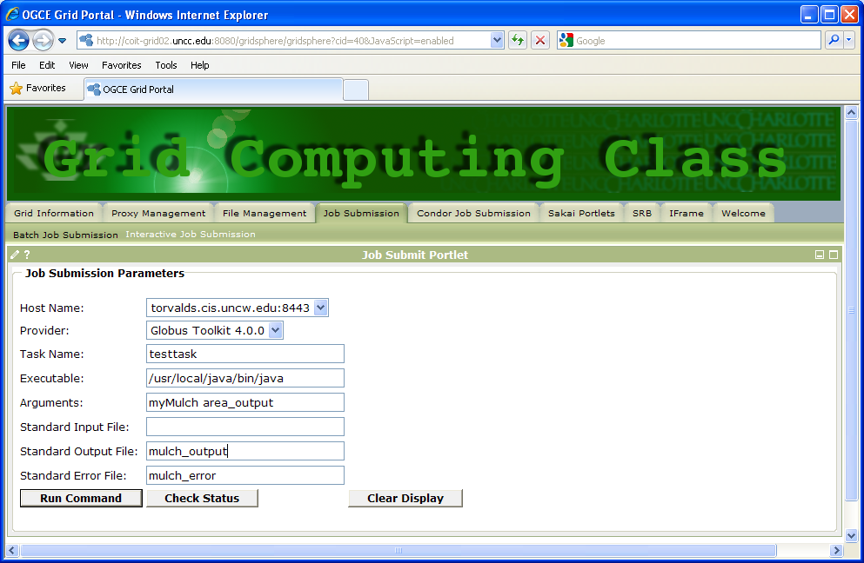

Figure 9 myMulch job submission.

Step 4 Copy myMulch_output back to coit-grid01.uncc.edu (optional)

Appendix A
Programs to compute area of flowerbed and volume and cost of mulch

A. Flowerbed Area (myIntegral.java)

The first program computes the area of the flowerbed by numerically integrating the function describing the flowerbed The shape of the flower bed is show in Figure 9.
0
1
2
3
4
5
0
1
2
3
4
5
y =sin(x*π/2)+2 when 0<=x<=2
Y = 2 when 2<=x<= 5
Figure 9 Flowerbed viewed from above

Although one can integrate these two functions mathematically, we will use a Java program that will perform numerical integration using the trapezoidal method where there are n intervals each of width δ. The program requires three arguments, the start and end of the flowerbed and the number of intervals. We shall use 0, 5 and 10000 as the three arguments. It reports the area (11.274239479285436 with 10000 intervals) to the stdout.

The volume and cost of the mulch will be computed, given the area of the flowerbed. assuming the mulch will be spread 4 inches (1/3 of a foot) thick. Since mulch must be a whole number of cubic feet, this value is rounded up to the nearest integer (i.e. ceiling). Then the value of the mulch is calculated using the rate $2.90/cubic feet (also a constant). The program is provided in your home directory as myMulch.java (and here: myMulch.java) The program reports the cubic feet and cost to stdout. This program has been compiled and also provided in your home directory as myMulch.class.

B. Volume and cost of mulch, given area -- myMulch.java

The volume and cost of the mulch will be computed, given the area of the flowerbed. assuming the mulch will be spread 4 inches (1/3 of a foot) thick. Since mulch must be a whole number of cubic feet, this value is rounded up to the nearest integer (i.e. ceiling). Then the value of the mulch is calculated using the rate $2.90/cubic feet (also a constant). The program reports the cubic feet and cost to stdout.

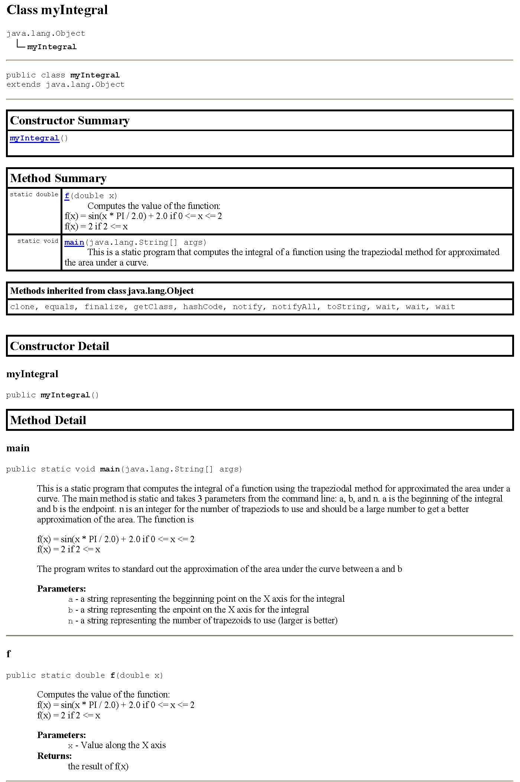
Java code

myIntegral.java

public class myIntegral
{

/**
* This is a static program that computes the integral of a function using
* the trapeziodal method for approximated the area under a curve. The main
* method is static and takes 3 parameters from the command line: a, b, and n.
* a is the beginning of the integral and b is the endpoint. n is an integer
* for the number of trapeziods to use and should be a large number to get
* a better approximation of the area. The function is <p>
* f(x) = sin(x * PI / 2.0) + 2.0 if 0 <= x <= 2 <br>
* f(x) = 2 if 2 <= x <br>
* <p> The program writes to standard out the approximation of the area under
* the curve between a and b
*
* @author Clayton S. Ferner
* @date 1/29/2010
* @param a a string representing the begginning point on the X axis for the integral
* @param b a string representing the enpoint on the X axis for the integral
* @param n a string representing the number of trapezoids to use (larger is better)
*/

public static void main(String args[])
{
if(args.length < 3) {
System.out.println("Usage: java myIntegral a b n");
return;
}

double a = Double.parseDouble(args[0]); // Converts the first parameter to a Double
double b = Double.parseDouble(args[1]); // Converts the second parameter to a Double
long n = Long.parseLong(args[2]); // Converts the third parameter to a Long
double area;

/*
The algorithm is
Area = d * [ f(a)/2 + f(a + d) + f(a + 2d) + ... + f(a + (n-1)d) + f(b)/2 ]
*/

double d = (b - a) / n; // The width of each trapezoid
area = 0.5 * (f(a) + f(b)); // Compute the f(a)/2 + f(b)/2)

for(double x = a + d; x < b; x += d) // Now add all the intermediate points
area += f(x);

area *= d; // And finally multiply by d
System.out.println(area);
}

/**
* Computes the value of the function:<br>
* f(x) = sin(x * PI / 2.0) + 2.0 if 0 <= x <= 2 <br>
* f(x) = 2 if 2 <= x
*
* @author Clayton S. Ferner
* @date 1/29/2010
* @param x Value along the X axis
* @return the result of f(x)
*/
public static double f(double x)
{
if(x >= 0.0 && x < 2.0)
return Math.sin(x * Math.PI / 2.0) + 2.0;

/* sin (x * PI/2) + 2 = 2 when x == 2
However, computing sin(2 * PI/2) + 2 will likely result in a value
that is not quite 2 because of roundoff. So if x == 2, just return 2.
*/
else if (x >= 2.0)
return 2.0;

// This line should never be reached.
else return 0.0;
}
}

myMulch.java

import java.io.*;

public class myMulch
{
public static float price = 2.9F;
public static float thickness = 0.333333F;

/**
* This is a static program that computes the volume and cost of mulch to
* cover a flower bed given the square footage of the flower bed.
* The main method is static and takes as a parameters from the command line
* the path of a file containing the area. The file should contain a single
* floating point value that represents the area in square feet. This
* program computes the volume of mulch needed to cover the flower bed
* 4 inches (1/3 of a foot) deep <i> rounded up to the next integer value</i>.
* It also computes the the cost of that mulch at the rate of $2.90/ft^3. <p>
* This program writes the volume (ft^3) rounded up to the next integer needed to
* cover the area 4 inches thick and the cost of the mulch at the rate $2.90/ft^3
* to standard out.
*
* @author Clayton S. Ferner
* @date 1/29/2010
* @param filename a string containing the full path of a file that contains the area
*/

public static void main(String args[])
{
String inputLine = null;

if(args.length < 1) {
System.err.println
("Input must be in a file given as the first argument ");
return;
}

try {
BufferedReader bufferedreader = new BufferedReader(
new FileReader(new File(args[0])));
inputLine = bufferedreader.readLine();
bufferedreader.close();
}
catch(Exception exception)
{
System.err.println("Unable to read file " + args[0]);
}
float area = Float.parseFloat(inputLine);
float cubicFeet = area * thickness;
cubicFeet = (float)Math.ceil(cubicFeet);
float dollars = cubicFeet * price;
System.out.println("area = " + area);
System.out.println(cubicFeet + " cubic feet of mulch = $" + dollars);
}
}

