"Workshop 31: Developing a Hands-on Undergraduate Parallel Programming Course with Pattern Programming," Barry Wilkinson and Clayton Ferner
SIGCSE 2013, Denver, USA, March 9, 2013

Seeds Framework

Session 1

Compiling and executing Monte Carlo π code through Eclipse

Modification date: March 2, 2013

Preliminaries

These notes describe how to set up and execute the Seeds framework on a single computer (Windows or Mac), and run a simple workpool application (Monte Carlo π calculation) using Eclipse IDE. Running other applications follow the same procedure.

Seeds Framework Versions

There are three versions of the Java-based Seeds framework currently implemented:

- Full JXTA P2P networking version suitable for a fully distributed network of computers and requiring an Internet connection even in just running on a single computer
- A simplified JXTA P2P version called the “NoNetwork” version for running on a single computer and not requiring an Internet connection, and finally
- Multicore version implemented with threads for more efficient execution on single multicore computer or shared memory multiprocessor system and does not require an Internet connection.

The two JXTA versions can use the same application module source code and bootstrap run module code, and run in the same fashion with similar logging output. The multicore version also uses the same application module source code but the bootstrap run module code is slightly different. Here we will explore all three versions. In each version of the framework, only one Seeds library is different - seeds.jar, seedsNoNetwork.jar, and seedsMulticore.jar.

Software provided on Flash drives

As a convenience all required software except Java JDK is provided on flash drives, although the software is intended to be transfer to the computer hard drive to run, for faster execution speed.

Java. The session has been tested with JDK 1.7.0 on Windows XP and 7 computers, and JDK 1.6.0 on Mac OS X 10.6.8. To determine whether you have Java and if so, its version, type:

java –d64 –version

at the command line. –d64 will establish whether you are running 32-bit Java or a 64 bit Java.

32-bit and 64-bit OS. You will need to also determine whether you are running a 32-bit OS or a 64 bit OS. A 32-bit OS will require a 32-bit Java.

If you do not already have Java JDK installed, obtain it from:

http://www.oracle.com/technetwork/java/javase/downloads/index.html

The flash drive has two folders:

WorkshopWindows
WorkshopMac

one for each platform. (The only difference is actually the Eclipse executable.) Within each of the directories "WorkshopWindows" and "WorkshopMac":

Eclipse (32-bit version that only works with 32-bit Java)
Eclipse (64-bit version that requires 64-bit OS)

If you do not have Eclipse already installed, you can copy the appropriate version (or obtain it from http://www.eclipse.org/downloads/ . Eclipse can be placed anywhere for execution.

Within the directory "Workshop", there are three workspace directories:

"workspace" (Full JXTA P2P version requiring an Internet connection)
"workspaceNoNetwork" (Version not needing an external network)
"workspaceMulticore" (Multicore version for operation on a single computer)

The following projects and libraries are within each workspace:

Monte Carlo pi ("PiApprox"")
MatrixAddition ("MatrixAdd")
Matrix Multiplication ("MatrixMult")
Numerical Integration ("NumIntegration")
SeedsTemplate ("SeedsTemplate" for code development)
Seeds libraries ("seeds", "seedsNoNetwork", or "seedsMulticore")

Copy the workshop directory from the flash drive to your computer. The Windows version is configured to run from C: (i.e. C:/Workshop/). The Mac version is configured to run from the root directory (i.e. /Workshop/). If all the workshop workspaces are moved to another location, see later and notes on "Moving Workshop Files" on how to re-configure the project library paths.

The directory structure and important files to know are given below.

… --->Eclipse //wherever Eclipse is located
…
eclipse.exe //click on to start Eclipse

--->Workshop
--->workspace // used to hold Seeds projects
--->seeds // Seeds framework (sometimes called pgaf)
--->lib // Seeds libraries
--->Availableservers.txt // holds names and other information
… // of computers used, to be edited

--->PiApprox // Monte Carlo pi project for session 1
--->bin> edu>uncc>grid>example>workpool> // Class files, empty until code compiled
---> src>edu>uncc>grid>example>workpool> // Java source files
MonteCarloPiModule.java
RunMonteCarloPiModule.java
--->MatrixAdd // Matrix add project
…
--->MatrixMult // Matrix multiply project
…
--->NumericalIntegration // Numerical Integration project
…
--->SeedsTemplate // For code development
…
--->workspaceNoNetork // used to hold noNetwork Seeds projects
…
--->workspaceMulticore // used to hold multicore Seeds projects
…

Software directory structure

Monte Carlo π Code

The Monte Carlo algorithm for computing π is well known and given in many parallel programming texts. It is a so-called embarrassingly parallel application particularly amenable to parallel implementation but used more for demonstration purposes than as a good way to compute π. (It can lead to more important Monte Carlo applications.) A circle is formed within a square. The circle has unit radius and the square has sides 2 x 2. The ratio of the area of the circle to the area of the square is given by π(12)/(2 x 2) = π/4. Points within the square are chosen randomly and a score is kept of how many points happen to lie within the circle. The fraction of points within the circle will be π/4, given a sufficient number of randomly selected samples. Implementing the pattern in the framework requires two classes. A module Java class implements a pattern interface. It is used to define the flow of information through the pattern. The second class is the boot-strapping class. It is used to define the environment where the application will run.

In the workpool approach, the master process will send a different random number to each of the slaves. Each slave uses that number as the starting seed for their random number generator. The Java Random class nextDouble method returns a number uniformly distributed between 0 and 1.0 (excluding 0 and 1). Each slave then gets the next two random numbers as the coordinates of a point (x,y) using nextDouble. If the point is within the circle (i.e. x² + y² <= 1), it increments a counter that is counting the number of points within the circle. This is repeated for 1000 points. Each slave returns its accumulated count. The gatherData method performed by the master accumulates the slave results. A separate method, getPi, executed within the bootstrap module, computes the final approximation for π using the accumulated total.

MonteCarloPiModule.java. MonteCarloPiModule.java implements the interface for the workpool

package edu.uncc.grid.example.workpool;
import java.util.Random;
import java.util.logging.Level;
import edu.uncc.grid.pgaf.datamodules.Data;
import edu.uncc.grid.pgaf.datamodules.DataMap;
import edu.uncc.grid.pgaf.interfaces.basic.Workpool;
import edu.uncc.grid.pgaf.p2p.Node;

public class MonteCarloPiModule extends Workpool {
private static final long serialVersionUID = 1L;
private static final int DoubleDataSize = 1000;
double total;
int random_samples;
Random R;
public MonteCarloPiModule() {
R = new Random();
}
@Override
public void initializeModule(String[] args) {
total = 0;
Node.getLog().setLevel(Level.WARNING); // reduce verbosity for logging
random_samples = 3000; // set number of random samples
}
public Data Compute (Data data) {
DataMap<String, Object> input = (DataMap<String,Object>)data; //input gets data produced by DiffuseData()
DataMap<String, Object> output = new DataMap<String, Object>(); // output will emit partial answers by method
Long seed = (Long) input.get("seed"); // get random seed
Random r = new Random();
r.setSeed(seed);
Long inside = 0L;
for (int i = 0; i < DoubleDataSize ; i++) {
double x = r.nextDouble();
double y = r.nextDouble();
double dist = x * x + y * y;
if (dist <= 1.0) {
++inside;
}
}
output.put("inside", inside); // store partial answer to return to GatherData()
return output;
}
public Data DiffuseData (int segment) {
DataMap<String, Object> d =new DataMap<String, Object>();
d.put("seed", R.nextLong());
return d; // returns a random seed for each job unit
}
public void GatherData (int segment, Data dat) {
DataMap<String,Object> out = (DataMap<String,Object>) dat;
Long inside = (Long) out.get("inside");
total += inside; // aggregate answer from all the worker nodes.
}
public double getPi() { // returns value of pi based on the job done by all the workers
double pi = (total / (random_samples * DoubleDataSize)) * 4;
return pi;
}
public int getDataCount() {
return random_samples;
}
}
MonteCarloPiModule.java

In MonteCarloPiModule.java, two important classes are imported called Data and DataMap. Data is used to pass data between the master and slaves and is used with input parameters of the Compute and GatherData methods. DataMap is used within DiffuseData, Compute Data, and GatherData methods for specifying the data being passed and uses two parameters, a string and an object (generic typing). The first parameter can be any programmer chosen string and used to identify the second stored item. DiffuseData method (executed by the master) creates a DataMap object and returns it with random seed for each job. The Compute method (executed by slaves) picks up the data from DiffuseData and creates a DataMap object for holding its partial results

MULTICORE VERSION OF SEEDS FRAMEWORK

We will first execute the Monte Carlo program with the multicore version, which does not requires an Internet connection.

RunMonteCarloPiModule.java. RunMonteCarloPiModule.java deploys the Seeds pattern and runs the workpool. Below is the code for the multicore version of the framework

package edu.uncc.grid.example.workpool;

import java.io.IOException;

import net.jxta.pipe.PipeID;
import edu.uncc.grid.pgaf.Anchor;
import edu.uncc.grid.pgaf.Operand;
import edu.uncc.grid.pgaf.Seeds;
import edu.uncc.grid.pgaf.p2p.Types;

public class RunMonteCarloPiModule {
public static void main(String[] args) {
try {
MonteCarloPiModule pi = new MonteCarloPiModule();
Thread id = Seeds.startPatternMulticore( new Operand( (String[])null, new Anchor( args[0],
Types.DataFlowRole.SINK_SOURCE), pi ), 4 );
id.join();
System.out.println( "The result is: " + pi.getPi() ) ;
} catch (SecurityException e) {
e.printStackTrace();
} catch (IOException e) {
e.printStackTrace();
} catch (Exception e) {
e.printStackTrace();
}
}
}

RunMonteCarloPiModule.java –Thread-based multicore version

Several classes are imported, PipeID, seeds-specific Anthor, Operand, Seeds, and Types. An instance of MonteCarloPiModule is first created. The Thread object is the thread managing
the source and sink threads for the pattern. The programmer can monitor when the pattern is
done computing by checking id.isAlive() or can just wait for the pattern to complete using id.join(). Args[0] should be the local host name.

The Seeds method startPattern starts the workpool pattern on the computers. It requires as a single argument an Operand object. Creating an Object object requires three arguments. The first is a String list of argument that will be submitted to the host. The second is an Anchor object specifying the nodes that should have source and sink nodes (the master in this case) which in this provided as the string argument of main (first command line argument, args[0]). The third argument is an instance of MonteCarloPiModule previously created. As mentioned above, to run this code, we will need to provide one command line argument, the name of the local host.

Executing the Monte Carlo π program. The program can be executed on the command line or through an IDE. We choose here to use Eclipse.

Step 1. Open Eclipse Start Eclipse by double clicking the Eclipse executable found in the Eclipse folder. It is convenient to create a shortcut of the Eclipse executable on the desktop. Starting the Eclipse executable will generally ask if you want to use the default location for the workspace. Enter the location of the multicore workspace, such as shown below:

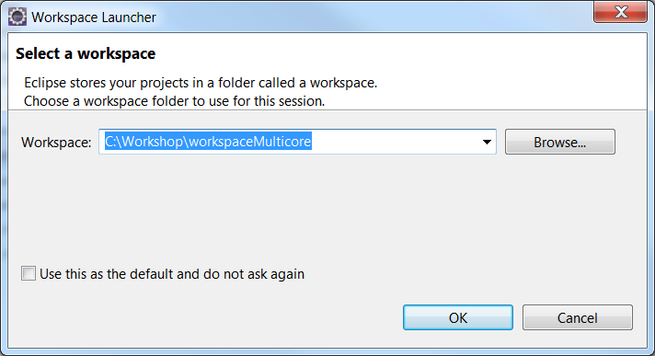

Once Eclipse opens, you should see the Monte Carlo π project and other projects already loaded. If you do not, import the projects with File->Import->General->Existing Projects into Workspace in order to see it. You may also have to click on the Workspace” icon at the right

Step 2 Build paths. If all the workshop workspaces are moved to location other than the default location C:Workshop for Windows computer or /Workshop on a Mac, you will need to update the paths to the Seeds libraries. Refer to the notes on "Moving Workshop Files" on how to re-configure to remove build errors.

Step 3 Command Line Arguments Before you can run the program, you will need to provide a command line argument that is read by the bootstrap class RunMonteCarloPiModule. Go to Run -> Run Configurations …
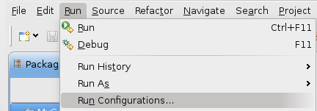
A Java Application configuration for each project should already be present, otherwise create a named configuration by clicking on the leftmost icon “New launch configuration” at the top of Run Configurations to create a new configuration.

Click the tab named (x)=Arguments. For the multicore version of Seeds, the bootstrap class is written to accept one argument, the name of your computer.
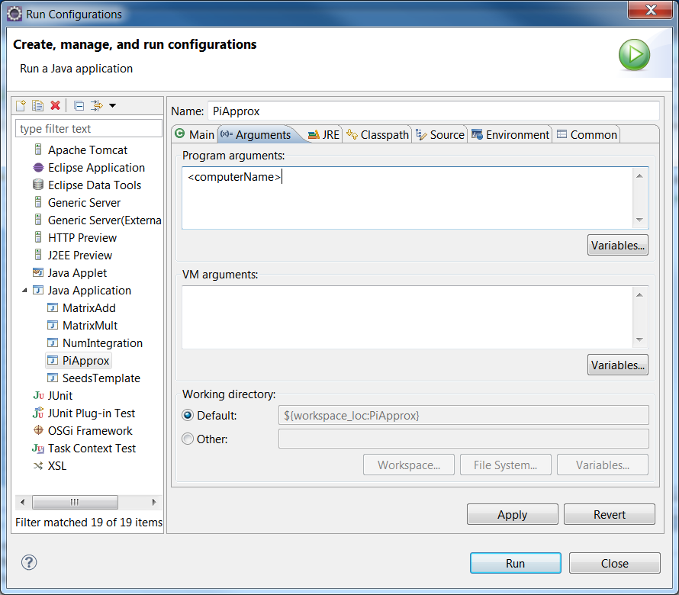

The name of your computer can be found by typing hostname on the command line.

Do NOT use the computer name that you will see from "View system information" or similar, which can have additional characters added to the name. You MUST use the name returned by the hostname command.

You will need this name again so create a text file say with Notepad on a Windows system or TextEdit (under Applications) on a Mac and paste the name into the file. Save and keep the file open to add additional information later.

Replace <computerName> with the name of the computer. Includes double quotes to make a string if there are one or more spaces in the name.

Step 4 Run program

Click “Run” to run the project. You should see the project run immediately with output in the console window:

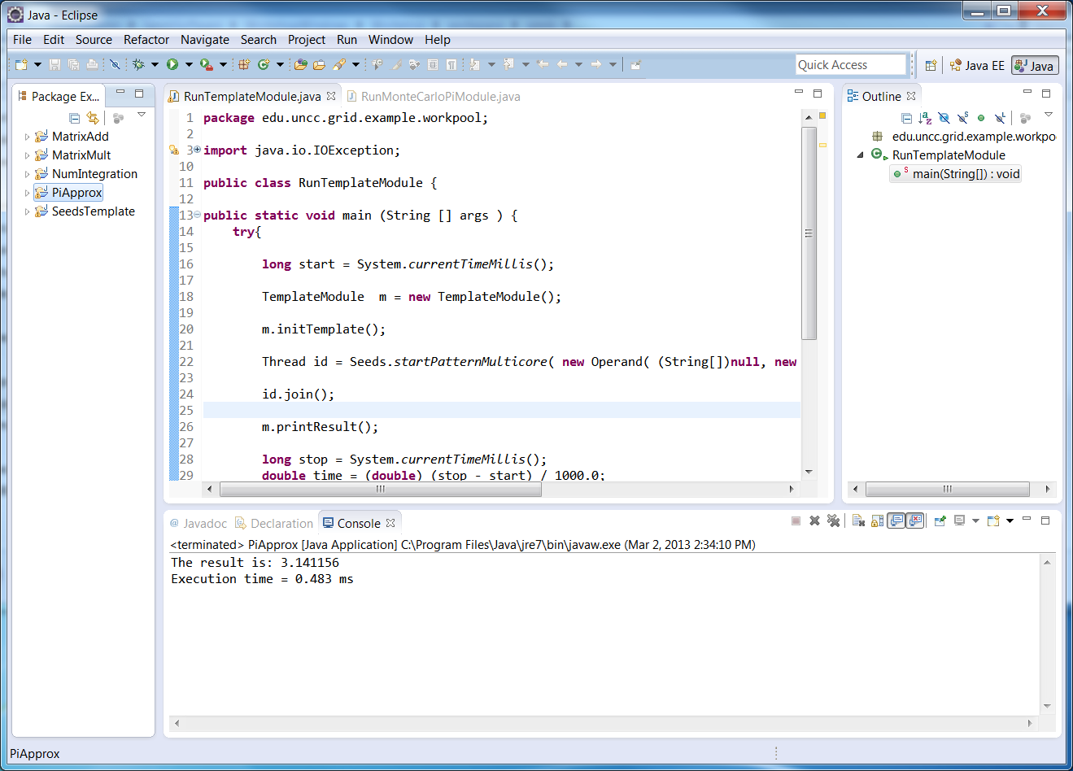

Issues running program: If you do not get the expected output, see posted FAQs at
http://coitweb.uncc.edu/~abw/SIGCSE2013Workshop/SeedsSoftware/SeedsFAQs.html
for known issues.

How many random numbers were tried by the π approximation program?

NETWORK VERSION OF SEEDS FRAMEWORK

The full network version requires an Internet connection. If you do not have an Internet connection, use the “NoNetwork” version, which is a similar JXTA P2P implementation but runs on a single computer without an Internet connection. In that case, choose "workspaceNoNetwork" workspace rather than “workspace” workspace in the following.

It is now necessary to specify the servers, even though in this case we will only use a single computer.

Specifying the computers to use

The AvailableServers.txt file found inside the seeds folder within the workspace folder needs to hold the name of the computers being used and other information can be included. For this session, we will only use a local computer and just need to provide its name of the computer. Lines starting with a # are commented out lines. Modify the one uncommented line:

<computerName> local - - - 1 10 GridTwo

replacing <computerName> (or whatever name is there) with the name of your computer and set the number of processors from 1 to however many processors you have (normally just one) and set the number of cores from 10 to the number of cores in each processor on your computer.

The name of your computer can be found by typing hostname on the command line.

Do NOT use the computer name that you will see from "View system information" or similar, which can have additional characters added to the name. You MUST use the name returned by the hostname command.

RunMonteCarloPiModule.java. RunMonteCarloPiModule.java deploys the Seeds pattern and runs the workpool. Below is the code for the network version of the framework:

package edu.uncc.grid.example.workpool;

import java.io.IOException;

import net.jxta.pipe.PipeID;
import edu.uncc.grid.pgaf.Anchor;
import edu.uncc.grid.pgaf.Operand;
import edu.uncc.grid.pgaf.Seeds;
import edu.uncc.grid.pgaf.p2p.Types;

public class RunMonteCarloPiModule {

public static void main(String[] args) {
try {
MonteCarloPiModule pi = new MonteCarloPiModule();
Seeds.start( args[0] , false);

PipeID id = Seeds.startPattern(
new Operand( (String[])null, new Anchor( args[1] , Types.DataFlowRoll.SINK_SOURCE), pi ) );
System.out.println(id.toString() );
Seeds.waitOnPattern(id);
System.out.println( "The result is: " + pi.getPi() ) ;

Seeds.stop();

} catch (SecurityException e) {
e.printStackTrace();
} catch (IOException e) {
e.printStackTrace();
} catch (Exception e) {
e.printStackTrace();
}
}
}

RunMonteCarloPiModule.java – Network version

Several classes are imported, PipeID, seeds-specific Anthor, Operand, Seeds, and Types. An instance of MonteCarloPiModule is first created. Seeds is started and deployed on the list servers using the Seeds method start, which takes as its first argument the path to the seeds folder on the local computer. In the code given, the path is provided as the string argument of main (first command line argument, args[0]). The Seeds method startPattern starts the workpool pattern on the computers. It requires as a single argument an Operand object. Creating an Object object requires three arguments. The first is a String list of argument that will be submitted to the remote hosts. The second is an Anchor object specifying the nodes that should have source and sink nodes (the master in this case) which in this provided as the string argument of main (second command line argument, args[1]). The third argument is an instance of MonteCarloPiModule previously created. The Seeds method waitOn Pattern waits for the pattern to complete, after which the results are obtained using the getPi method in MonteCarloPiModule.java. Seeds is stopped using the method stop.

As mentioned above, to run this code, we will need to provide two command line arguments, the local path to the Seeds folder and the name of the local host. Both could have been hardcoded.

Executing the Monte Carlo π program.

Step 1. Open Eclipse and select the workspace:

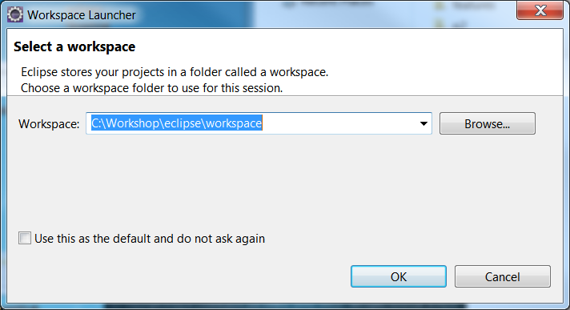

Step 2 Build paths. If all the workshop workspaces are moved to location other than the default location C:Workshop for Windows computer or /Workshop on a Mac, you will need to update the paths to the Seeds libraries. Refer to the notes on "Moving Workshop Files" on how to re-configure to remove build errors.

Step 3 Command Line Arguments

For the full network version and “NoNetwork version of Seeds, the bootstrap class is written to accept two arguments:

1st argument: Path to where AvailableServers.txt is located
2nd argument: Name of your computer

Enter the two arguments. Includes double quotes to make a string if there are one or more spaces in the path. The name of your computer should be the same as you put in AvailableServers.txt.

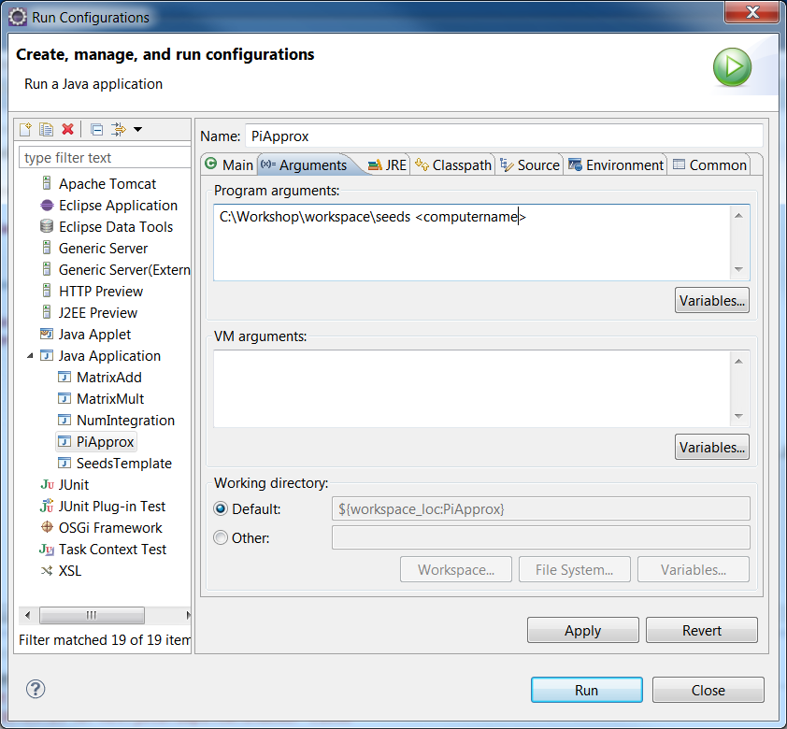

Step 4 Run program

Click “Run” to run the project. The console output will begin with logging messages such as:

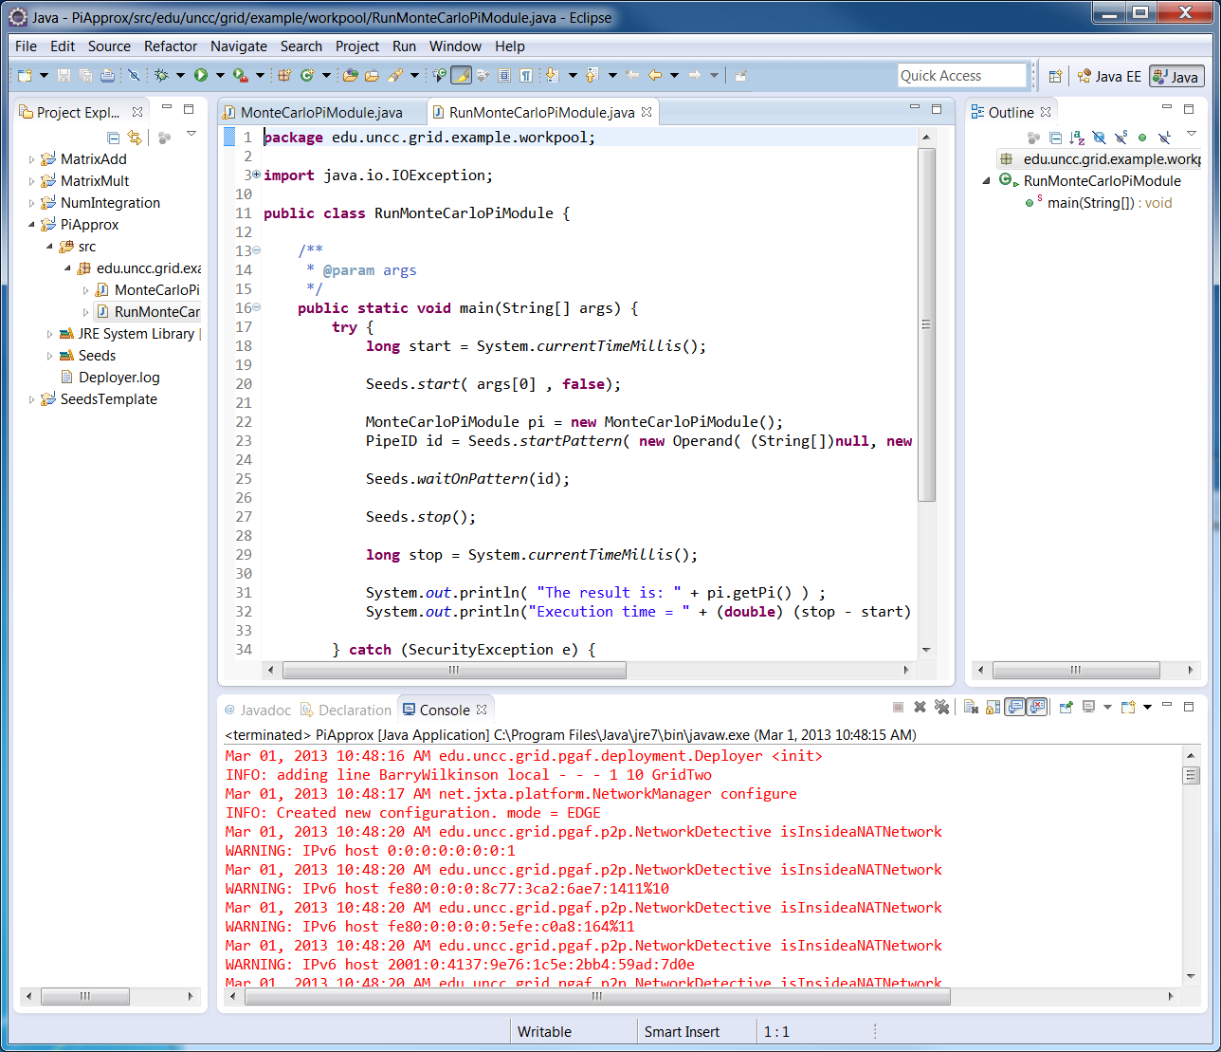

with the final result in black at the end:

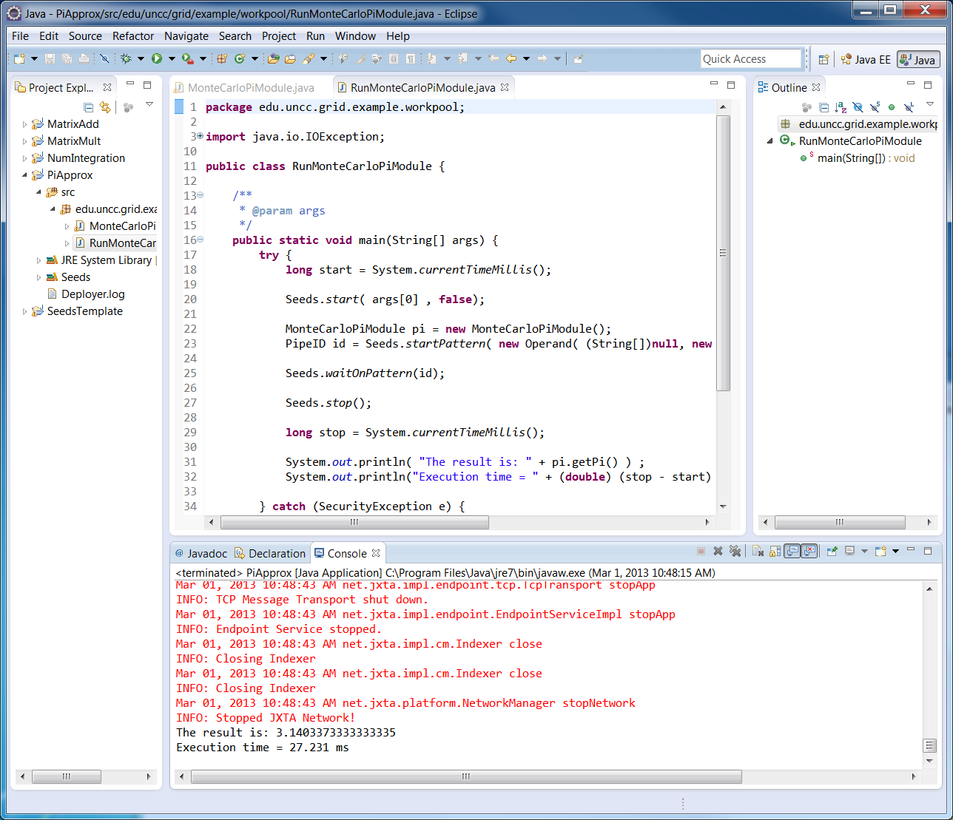

Issues running program: If you do not get the expected output, see posted FAQs at
http://coitweb.uncc.edu/~abw/SIGCSE2013Workshop/SeedsSoftware/SeedsFAQs.html
for known issues.

A Windows command line console window can be started with Win+R, enter cmd, and press Enter. On a mac, a command line console window can be started from Applications > Utilities > Terminal.
Windows system: Start > right click (My) Computer > Properties. If you do not see x64 Edition, under system, it is a 32-bit OS. Mac: Apple Menu> About This Mac. All Mac OS X => 10.5 are 64 bit OS’s.
DataMap extends Java HashMap.

