"Workshop 31: Developing a Hands-on Undergraduate Parallel Programming Course with Pattern Programming," Barry Wilkinson and Clayton Ferner
SIGCSE 2013, Denver, USA, March 9, 2013

Session 2

Seeds Framework

Workpool pattern

Matrix Addition and Multiplication

Modification date: March 4, 2013.

Software

Refer to Session 1 notes for installing the software. For Session 2, we will be using Eclipse projects MatrixAdd and MatrixMult, both found in each workspace.

Matrix Addition

Matrix addition, C = A + B, adds corresponding elements of each matrix to form elements of result matrix. Given elements of A as a_{i,j} and elements of B as b_{i,j}, each element of C computed as c_{i,j} = a_{i,j} + b_{i,j} (0 <= i < n, 0 <= j < m for n x m matrices).

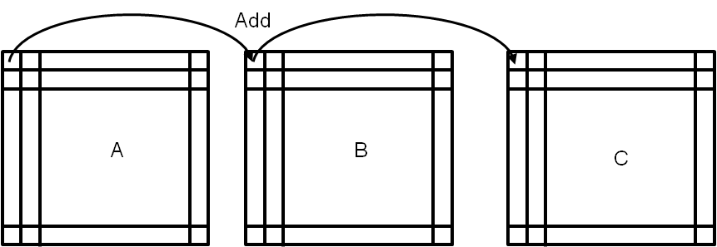

Workpool Implementation

Each slave adds one row of A with one row of B to create one row of C (rather than each slave adding single elements):

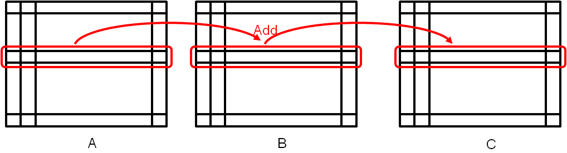

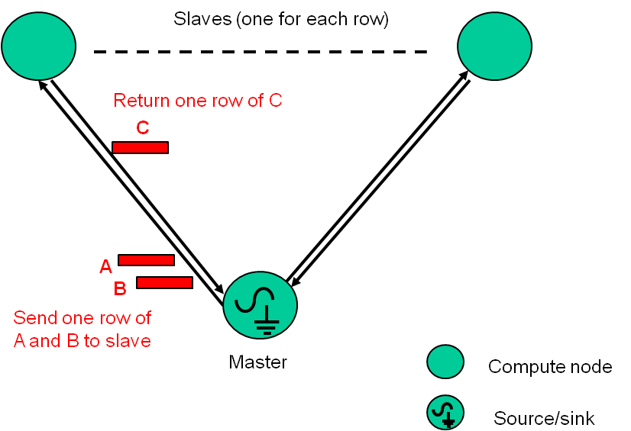

Matrix addition workpool

There are two Java source programs:

- MatrixAddModule.java – the module class that implements the interface for the workpool
- RunMatrixAddModule.java – the bootstrap class to deploy the framework and run the code.

MatrixAddModule.java. This code uses 3 x 3 matrices and 3 slaves and is given below:

package edu.uncc.grid.example.workpool;
import java.util.Random;
import java.util.logging.Level;
import edu.uncc.grid.pgaf.datamodules.Data;
import edu.uncc.grid.pgaf.datamodules.DataMap;
import edu.uncc.grid.pgaf.interfaces.basic.Workpool;
import edu.uncc.grid.pgaf.p2p.Node;
public class MatrixAddModule extends Workpool {
private static final long serialVersionUID = 1L;
int[][] matrixA;
int[][] matrixB;
int[][] matrixC;
public MatrixAddModule() {
matrixC = new int[3][3];
}

public void initMatrices(){
matrixA = new int[][]{{2,5,8},{3,4,9},{1,5,2}};
matrixB = new int[][]{{2,5,8},{3,4,9},{1,5,2}};
}
public int getDataCount() {
return 3;
}
public void initializeModule(String[] args) {
Node.getLog().setLevel(Level.WARNING);
}

public Data DiffuseData(int segment) {

int[] rowA = new int[3];
int[] rowB = new int[3];

DataMap<String, int[]> d =new DataMap<String, int[]>();

int k = segment;
for (int i=0;i<3;i++) {
rowA[i] = matrixA[k][i];
rowB[i] = matrixB[k][i];
}
d.put("rowA",rowA);
d.put("rowB",rowB);
return d;
}

public Data Compute(Data data) {

int[] rowC = new int[3];
DataMap<String, int[]> input = (DataMap<String,int[]>)data;
DataMap<String, int[]> output = new DataMap<String, int[]>();

int[] rowA = (int[]) input.get("rowA");
int[] rowB = (int[]) input.get("rowB");

for (int i=0;i<3;i++) {
rowC[i] = rowA[i] + rowB[i];
}

output.put("rowC",rowC);
return output;
}

public void GatherData(int segment, Data dat) {

DataMap<String,int[]> out = (DataMap<String,int[]>) dat;

int[] rowC = (int[]) out.get("rowC");

for (int i=0;i<3;i++) {
matrixC[segment][i]= rowC[i];
}

}

public void printResult() {

for (int i=0;i<3;i++) {
System.out.println();
for (int j=0;j<3;j++) {
System.out.print(matrixC[i][j] + " ");
}
}

}

} // end of MatrixAddModule

MatrixAddModule.java

As in other workpool framework projects, two important classes are imported, called Data and DataMap. Data is used to pass data between the master and slaves and is used with input parameters of the Compute and GatherData methods. DataMap is used within DiffuseData, Compute Data, and GatherData methods for specifying the data being passed and uses two parameters, a string and an object (generic typing). The first parameter can be any programmer chosen string and used to identify the second stored item. DiffuseData method (executed by the master) creates a DataMap object and returns it with random seed for each job. The Compute method (executed by slaves) picks up the data from DiffuseData and creates a DataMap object for holding its partial results.

RunMatrixAddModule.java. RunMatrixAddModule.java deploys the Seeds pattern and runs the workpool:

package edu.uncc.grid.example.workpool;

import java.io.IOException;

import net.jxta.pipe.PipeID;
import edu.uncc.grid.pgaf.Anchor;
import edu.uncc.grid.pgaf.Operand;
import edu.uncc.grid.pgaf.Seeds;
import edu.uncc.grid.pgaf.p2p.Types;

public class RunMatrixAddModule {
public static void main (String [] args ) {
try {
long start = System.currentTimeMillis();
Seeds.start( args[0] ,false);
MatrixAddModule m = new MatrixAddModule();
m.initMatrices();
PipeID id = Seeds.startPattern(new Operand ((String[])null,new Anchor (args[1], Types.DataFlowRoll.SINK_SOURCE),m));
Seeds.waitOnPattern(id);
m.printResult();
Seeds.stop();
long stop = System.currentTimeMillis();
double time = (double) (stop - start) / 1000.0;
System.out.println("Execution time = " + time);
} catch (SecurityException e) {
e.printStackTrace();
} catch (IOException e) {
e.printStackTrace();
} catch (Exception e) {
e.printStackTrace();
}
}
}

RunMatrixAddModule.java

Several classes are imported, PipeID, seeds-specific Anthor, Operand, Seeds, and Types. An instance of MonteCarloPiModule is first created. Seeds is started and deployed on the list servers using the Seeds method start, which takes as its first argument the path to the seeds folder on the local computer. In the code given, the path is provided as the string argument of main (first command line argument, args[0]). The Seeds method startPattern starts the workpool pattern on the computers. It requires as a single argument an Operand object. Creating an Object object requires three arguments. The first is a String list of argument that will be submitted to the remote hosts. The second is an Anchor object specifying the nodes that should have source and sink nodes (the master in this case) which in this provided as the string argument of main (second command line argument, args[1]). The third argument is an instance of MonteCarloPiModule previously created. The Seeds method waitOn Pattern waits for the pattern to complete, after which the results are obtained using the getPi method in MonteCarloPiModule.java. Seeds is stopped using the method stop. As mentioned above, to run this code, we will need to provide two command line arguments, the local path to the Seeds folder and the name of the local host. Both could be hardcoded.

Executing the matrix addition program. Refer to Session 1 for how to run the code through Eclipse.

Matrix Multiplication, C = A * B

Multiplication of two matrices, A and B, produces matrix C whose elements, c_{i,j} (0 <= i < n, 0 <= j < m), computed as follows:
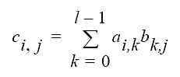
where A is an n x l matrix and B is an l x m matrix.

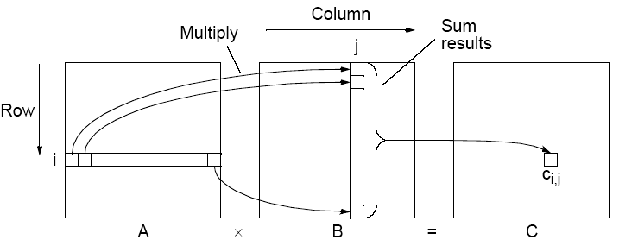

Parallelizing Matrix Multiplication
Assume throughout that matrices square (n x n matrices).
Sequential code to compute A x B could simply be:

for (i = 0; i < n; i++) // for each row of A
for (j = 0; j < n; j++) { // for each column of B
c[i][j] = 0;
for (k = 0; k < n; k++)
c[i][j] = c[i][j] + a[i][k] * b[k][j];
}

which requires n³ multiplications and n³ additions. The sequential time complexity is O(n³). It is very easy to parallelize as each result independent

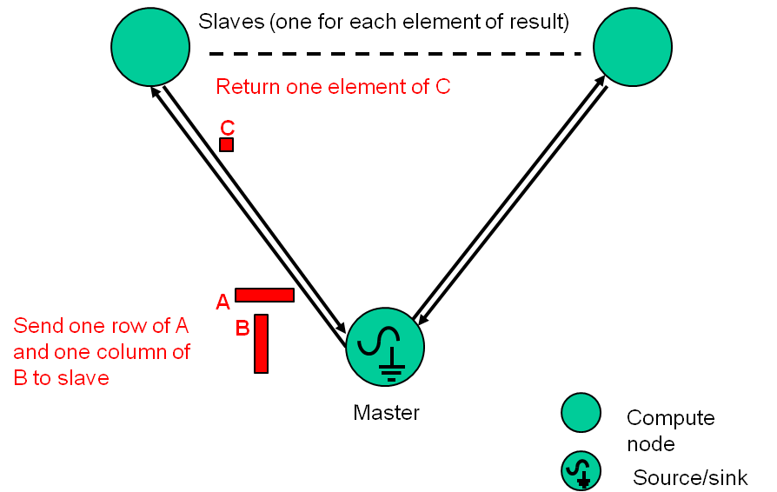

Matrix multiplication workpool

There are two Java source programs:

- MatrixMultModule.java – the module class that implements the interface for the workpool
- RunMatrixMultModule.java – the bootstrap class to deploy the framework and run the code.

MatrixAddModule.java. This code uses 3 x 3 matrices and 9 slaves and is given below:

package edu.uncc.grid.example.workpool;
import java.util.logging.Level;
import edu.uncc.grid.pgaf.datamodules.Data;
import edu.uncc.grid.pgaf.datamodules.DataMap;
import edu.uncc.grid.pgaf.interfaces.basic.Workpool;
import edu.uncc.grid.pgaf.p2p.Node;

public class MatrixMultModule extends Workpool {

private static final long serialVersionUID = 1L;

int[][] matrixA;
int[][] matrixB;
int[][] matrixC;

public MatrixMultModule() {
matrixC = new int[3][3];
}

public void initMatrices(){
matrixA = new int[][]{ {3,6,7},
{7,4,9},
{9,5,7}};
matrixB = new int[][]{ {3,6,7},
{7,4,9},
{9,5,7}};
}
public int getDataCount() {
return 9;
}

public void initializeModule(String[] args) {

Node.getLog().setLevel(Level.WARNING);
}

public Data DiffuseData(int segment) {

int[] rowA = new int[3];
int[] colB = new int[3];

DataMap<String, int[]> d =new DataMap<String, int[]>();

int a=segment/3, b = segment%3;
for (int i=0;i<3;i++){ //Copy one row of A and one column of B into d
rowA[i] = matrixA[a][i];
colB[i] = matrixA[i][b];
}

d.put("rowA",rowA);
d.put("colB",colB);

return d;
}

public Data Compute(Data data) {

DataMap<String, int[]> input = (DataMap<String,int[]>)data;
DataMap<String, Integer> output = new DataMap<String, Integer>();

int[] rowA = (int[]) input.get("rowA");
int[] colB = (int[]) input.get("colB");

int out = 0; //computation
for (int i=0;i<3;i++) {
out += rowA[i] * colB[i];
}

output.put("out",out);

return output;
}

public void GatherData(int segment, Data dat) {

DataMap<String,Integer> out = (DataMap<String,Integer>) dat;

int answer = out.get("out");
int a=segment/3, b=segment%3;
matrixC[a][b]= answer;

}

public void printResult(){

for (int i=0;i<3;i++){
System.out.println();
for(int j=0;j<3;j++){
System.out.print(matrixC[i][j] + " ");
}
}
System.out.println();
}

} // end of MatrixMultiplyModule
MatrixMultModule.java

RunMatrixMultModule.java. RunMatrixMultModule.java deploys the Seeds pattern and runs the workpool and is similar to the other Bootstrap class. Just the name of the module class in the code is changed to suit.

Executing the matrix multiplication program. Refer to Session 1 for how to run the code through Eclipse.

Extensions

Write the code to perform matrix transpose and test.

DataMap extends Java HashMap.

