Team 21’s 2023 Toiletries Case

User’s Manual

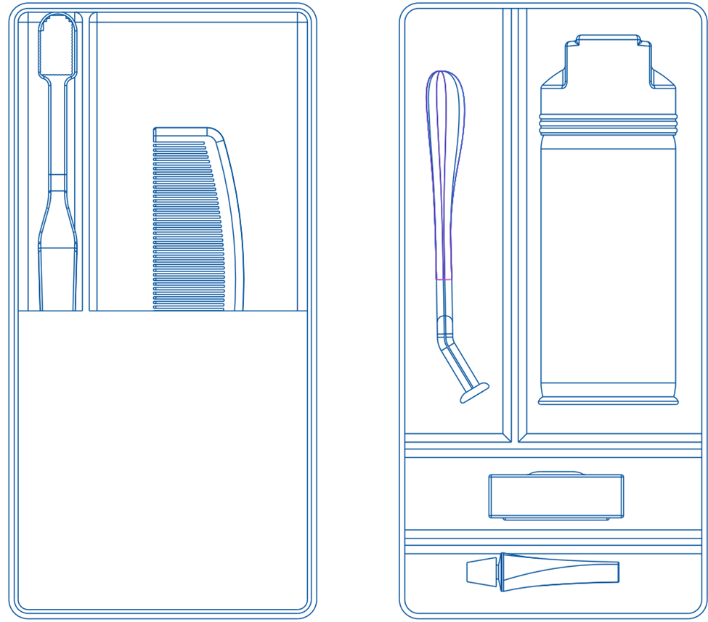

Table of Contents
User’s Manual 1
ASSEMBLY 3
SETUP 4
MAINTENANCE 5
SAFETY INFORMATION 6
WARRANTY INFORMATION 7
SERVICE CENTER 8
REPLACEMENT PARTS 9

ASSEMBLY
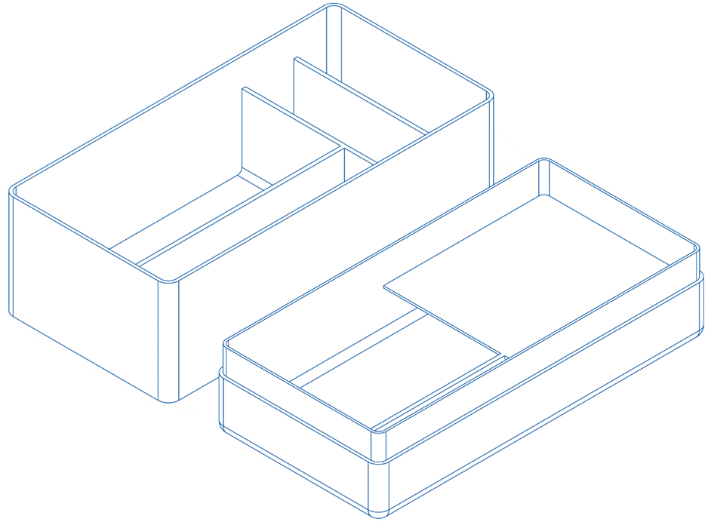
After opening the case from the packaging, ensure all parts of the toiletries case are accounted for, there should be 2 parts of the case.
Bottom Piece
Top Piece
How to Close
To close the case, turn the top piece with the inside facing each other. Fit the top piece on the bottom piece.
How to Open
To open the case, grip the top piece and lift it off slowly.

SETUP
Stand Mode
To use on a flat surface, such as a counter, position the case pieces' insides facing up. Using the bottom piece, toiletries can be stood up for immediate use.

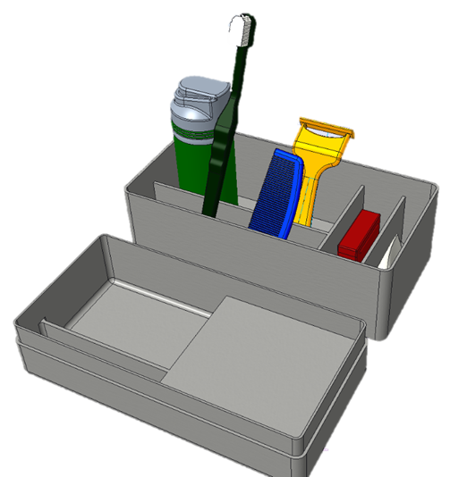

MAINTENANCE
Water resistance
This product is required to have the sides of the toiletries case cleaned when putting the lid on the case to ensure the water resistance rating. The case has to be in tack for the water resistance rating to uphold, meaning no creaks or heavy drops.
Cleaning
The case is made of a hard plastic shell that is made of two pieces, therefore it can be easily cleaned with water. Due to the case being hard plastic, it would not be safe to keep washing it in the dishwasher. Over time the case could start deforming causing it not to be able to keep water and moisture out of the case. When cleaning make sure to not leave water inside the case, when the case is closed there is no way for moisture to escape. This could lead to buildup and mold forming if not taken care of properly.
Structure integrity
The design of the toiletries case is firm and stiff and therefore not easy to break and is durable. Making sure that the ribs of the bottom case are not damaged is important to the structural integrity of the case. If the top or bottom of the case are dropped from low heights then the shell will be undamaged. Though if dropped from a great height the shell will creak after much distress.
The case is made of a hard plastic shell that is made of two pieces, therefore not much more maintenance is required due to the fact that it's designed specially in order to be easy to maintain.

SAFETY INFORMATION
- To ensure proper use it is advised to clean the Toiletries case on a regular basis
- Avoid using harsh chemicals for cleaning
- Do not leave it in open sunlight
- Do not leave it outside
- Do not leave the case exposed to moist or humid environments for extended periods
- Store in dry, temperature-controlled areas

WARRANTY INFORMATION
This product has a high water resistance rating for its lifetime. However, the product can not be submerged in water for more than a couple of hours. The warranty also extends to if the water resistance top or lid no longer does its job without human error it will be replaced. The warranty is voided if the user breaks the toiletry case carelessly.

SERVICE CENTER
LOCATION: 9201 University City Blvd, Charlotte, NC 28223
PHONE 1-800-UNC-CT21
Team 21 Members
Ashley Okpara | aokpara@uncc.edu
Sam Sinigur | ssinigur@uncc.edu
Alex Smith | asmit674@uncc.edu
Christian Stremlau | cstremla@uncc.edu

REPLACEMENT PARTS
For Replacement parts, please contact our service center at 1-800-UNC-CT21. If replacement parts are unavailable and the case is still under warranty, a replacement case will be sent and paid for. If the warranty is voided then replacement parts can still be purchased.

