Dudes were originally old rags, and a dudesman a scarecrow. In the latter half of the nineteenth century, "dude became synonymous with dandy a term used to designate a sharp dresser in the western territories [of the United States]" (321).
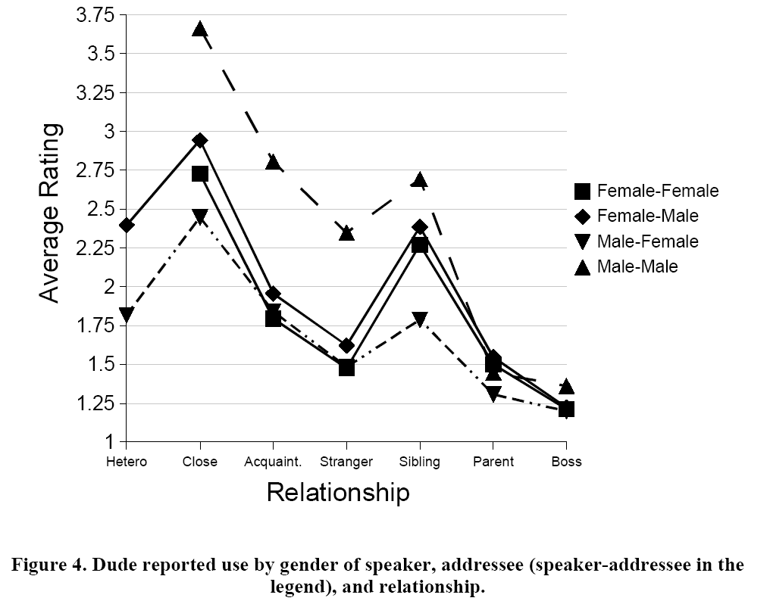
There was for a time a female version of the word, but it fell out of use. According to Hill, the use of dude as an address term developed in the 1930s and 1940s from groups of men, "Urban Mexican-American pachuchos and African-American zoot-suiters" (323), known for their clothes consciousness. These groups began to use it as an in-group term, and it soon was used as a general form of address among men. It seems that dude followed a well-worn linguistic path from stigmatized groups such as urban African-Americans and Mexicans to whites through African American music culture (much as cool and groovy did). Finally, in the 1980s, "[y]oung people began to use dude as an exclamation of delight and/or affection." (Hill 1994:325) Hill predicts that dude may follow fuck and its derivatives as being able to function in any grammatical slot (or as a single-word utterance that can mean anything in the right context).
