Network-assisted Language Learning

Directed by Dr. Ye-ling Chang
English Department, National Kaoshiung Normal University
cangyl2003@yahoo.com.tw
http://140.127.60.124/engstu/students.htm

Spring Semester, 2007
March 5, 2007

Syllabus
- Purposes:
- To identify multimedia and network resources which help improve the understanding of content or discipline of language arts.
- To be aware of the changes in teaching patterns, learning patterns, instructional sources and resources, instructional methods, media and technology, and curriculum design.
- To find the possibility of the use of multimedia in learning, teaching and research.
- To share findings, experiences and models with others in the collaborative academy.
- To assess courseware and learning resources by some criteria.

- Contents:
- Multimedia and network resources in language teaching.
- Changes in teaching patterns, learning patterns, instructional sources and resources, instructional methods, media and technology, and curriculum design.
- To compose web-pages, on-line tests, forums and reading clubs for virtual language instruction.
- Development of network literacy, cross-cultural communication, collaborative learning, learning resources, and presentation modes
- Assessments of courseware and learning resources

- Performance:
- To read assigned articles in hard copies and on the website.
- To give an individual reports to one self-selected article.
- To participate in class-discussions, To composes Powerpoint slides (for web-delivery), web-pages, on-line tests, forums and reading clubs for virtual language instruction. (Practice makes perfect.)
- To participate in a mid-term project on “A Cross-Cultural Intergenerational Lesson" (CCIL) with UNCC students by doing e-mail exchanges, on-line chats (http://www.nicenet.org.), and net-meetings
(http://163.32.83.90/vc/index.html). Then write a mid-term paper and an on-line questionnaire.
According to Dr. Boyd Davis (2007), intergenerational refers to the interaction of people from a younger generation with elders. The younger generation could be young children with grandparents, or high school youth or college students.
- To do a final project on by “Comparison of two English Courseware Designs”. Then write a final report.

- Assessment:
Grades are judged by class discussion, multimedia composing, two term projects, and individual reports.

- Reading Materials:
- Chang, Y-L. (1997). A reading package of network-assisted language learning.
- Warschauer, M. & Kern, R. (2004). Network-based language teaching: Concepts and practice. Cambridge: Cambridge University Press.
2. Selected on-line resources:
Resource | Website | Account &  Password
1. STORYBOARDS | http://www.english.uncc.edu/bdavis/LHA07.htm | Not required
2. Elder Partnerships | http://www.mrs.umn.edu/academic/sl/elderpartnerships.html | Not required
3. Examples of lessons designed for high school and college students | http://education.uncc.edu/more/StartResources/Galleries.htm | Not required
4. Project MORE materials | http://education.uncc.edu/more & http://www.nicenet.org. | Required  (34H84DA49)
5. An Anonymous form | http://education.uncc.edu/more/Evaluation.htm | Not required

- References
Tomalin, B. (1990). Video, TV & radio in the English class. Hong Kong: Macmillan Publishers Lit.
Liou, H-C. (1994). Multimedia English material development: theories and implementation. Taipei: The Crane Publishing Co. Ltd.
Liou, H-C. (1994). Multimedia English material development: theories and implementation. Taipei: The Crane Publishing Co. Ltd.
The proceeding of the sixth international conference on multimedia language education.. Taipei: The Crane Publishing Co..
The proceeding of the seventh international conference on multimedia language education. Taipei: The Crane Publishing Co..
Sharan, Y. & Sharan, S. (1992). Expanding cooperative learning through group investigation. New York : Teachers College Press.
Sperling, D. (1998). The Internet guide. New Jesery: Prentice Hall Regents.
Vygotsky, L. (1986). Thought and language. A Kozulin (Trans. and Ed.) Cambridge, MA: MIT Press.

V. Schedule
Week | Date | Subjects | Activities
1 | Feb. 28 | Memorial Day (No class meeting)
2 | March 7 | - Introduction to the course  - Intergeneration | Email or Chat with UNCC Ss: discuss photonovellas and CHAPTER 6
3 | March 14 | - Intergeneration  - Multimedia and network resources | Email or Chat with UNCC Ss: Use ProjectMORE to outline proposed  Intergenerational lessons (groups)
4 | March 21 | - Intergeneration  - Synchronous v.s. Asynchronous  Responses  - General v.s. Peer responses  - Traditional v.s. virtual learning space | Email, Chat, or do a net-meeting with UNCC Ss: Draft of intergenerational lessons (groups), evaluate usability (indiv; form)
5 | March 28 | - Changes in teaching patterns, learning patterns  - Individual Report 1: Ch. 2 Socio-collaborative language learning | T. material development 1: Composing PowerPoint slides on Intergeneration
6 | April 4 | - Changes in instructional methods and technology  - Individual Report 2: Ch. 3  On-line learning | T. material development 2: Composing one-frame homepages on Intergeneration
7 | April 11 | - Changes in curriculum design.  - Individual Report 3: Ch. 4  - Negotiation in cyberspace | T. material development 3: Composing two-frame homepages on Intergeneration
8 | April 18 | - Changes in curriculum design.  2. Individual Report 4: Ch. 5  Writing into change | T. material development 4: Composing a courseware on Intergeneration on the NKNU platform
9 | April 25 | - Changes in computer literacy  - Responses to the CCIL project | Writing an evaluation form and a mid-term report for the CCIL project
10 | May 2 | Mid-term Reports
11 | May 9 | - Individual Report 5: Ch. 6  Computers and collaborative writing  2. Problem-solving | Composing and applying problem-solving homepages in language instruction
12 | May 16 | - Individual Report 6: Ch. 9  Task-based language learning  2. Applying forums & blogs in literacy instruction | Composing and applying problem-solving homepages in language instruction
13 | May 23 | - On-line reading clubs  - Recognizable & productive tests | Composing and applying on-line tests in language instruction
14 | May 30 | - Individual Reports 7 & 8  - Recognizable & productive tests | Composing and applying on-line tests in language instruction
15 | June 6 | - Individual Reports 9 & 10  - Recognizable & productive tests | Composing and applying on-line tests in language instruction
16 | June 13 | - Individual Reports 11 & 12  - Support groups for net generation | Composing and applying on-line tests in language instruction
17 | June 20 | Courseware Assessments | Making comments & suggestions for courseware assessments
18 | June 27 | Final Reports

Network-assisted Language Learning

A Sample Page for the NALL-4 Class
http://140.127.60.124/engstu/nall-4/nall-4-home.htm
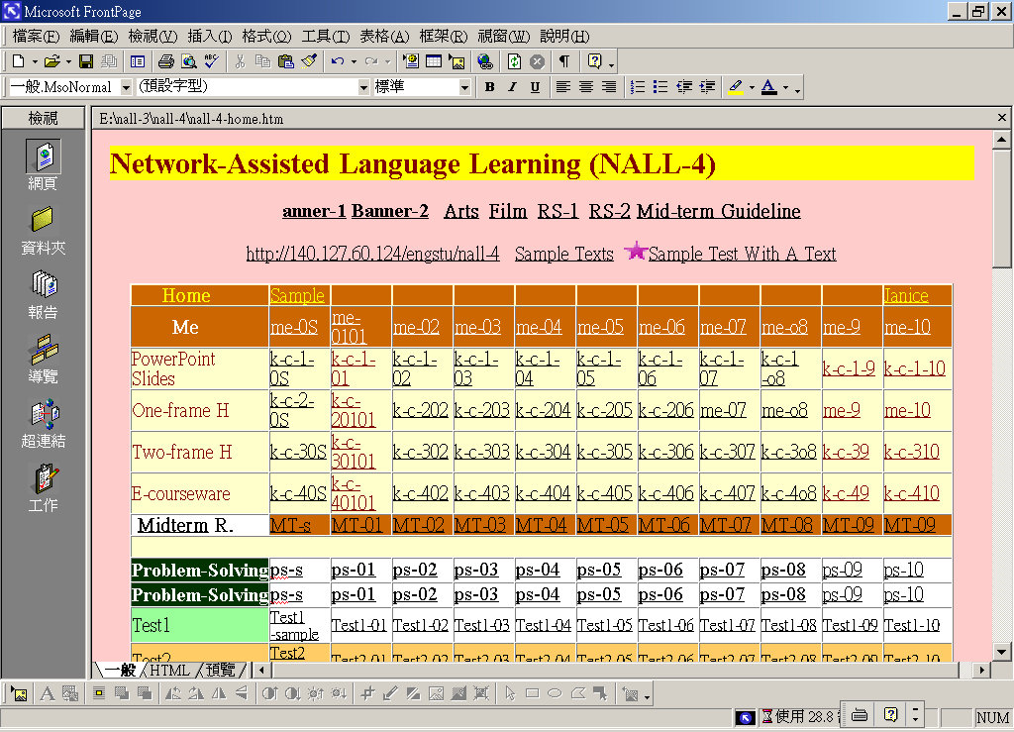

A Sample Page for the Mid-term Project
“Creating A Cross-Cultural Intergenerational Lesson" (CCIL)
http://www.nicenet.org.
