The Amazing Skimmer™

from

Awesome Pools©

**User Manual**

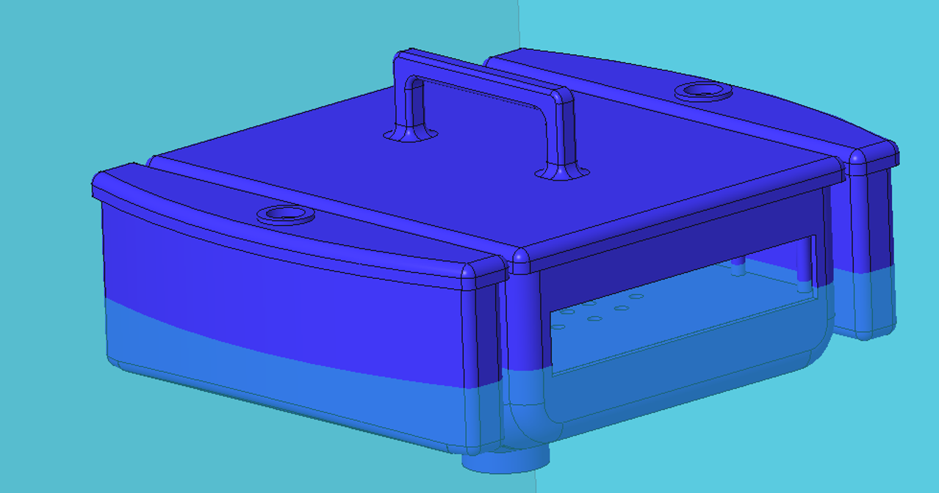

PLEASE READ THE FOLLOWING MANUAL BEFORE OPERATING THE AMAZING SKIMMER™

**Awesome Pool’s© Amazing Skimmer™**

**Table of Contents**

Assembly.............................................................3

Initial Setup and Use................................................4

Maintenance..........................................................6

Safety Information...................................................9

Warranty Information................................................10

Service Center......................................................11

Replacement Parts...................................................12

**Assembly**

The Awesome Pools© Amazing Skimmer™ is comprised of six (6) individual pieces, which are all assembled in our factory for your convenience.

If disassembly is needed, refer to the graphic below, which pictures how our product is assembled.

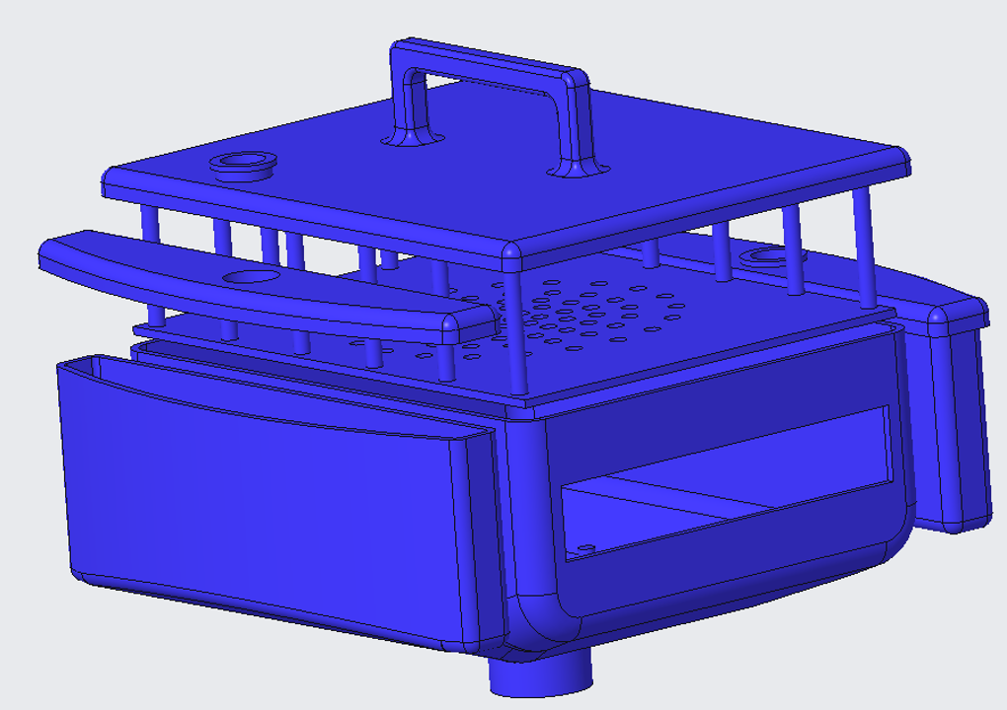

Every Amazing Skimmer™ comes with one (1) removeable tray, one (1) skimmer body, two (2) float lids, and two (2) water adjustment caps.

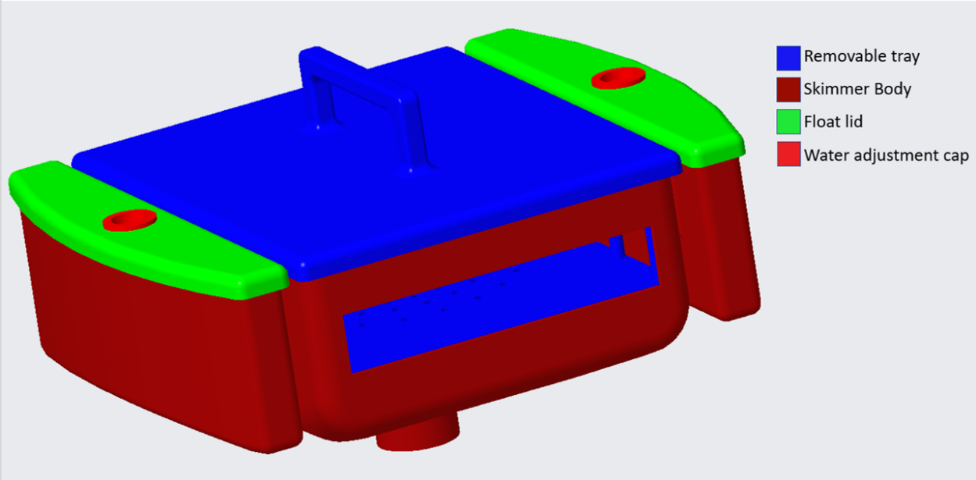

**Initial Setup and Use**

Before using your new skimmer, ensure that the pump is in working condition and can pull water through the vacuum hose. Once the pump has been checked and is working properly, connect the vacuum hose to the male connector on the bottom of the skimmer. The skimmer can now be placed in the pool with the help of the handle and the hose on the bottom.

To ensure that the skimmer will perform to its highest potential in your pool, use the buoys on both sides of the skimmer to customize the skimmer to your pool density. Simply remove the Water Adjustment Caps (refer to the “Assembly” section for more information) and fill them with water until the pool water line reaches the height indicated on the model below. Then simply place the caps back on the buoys.

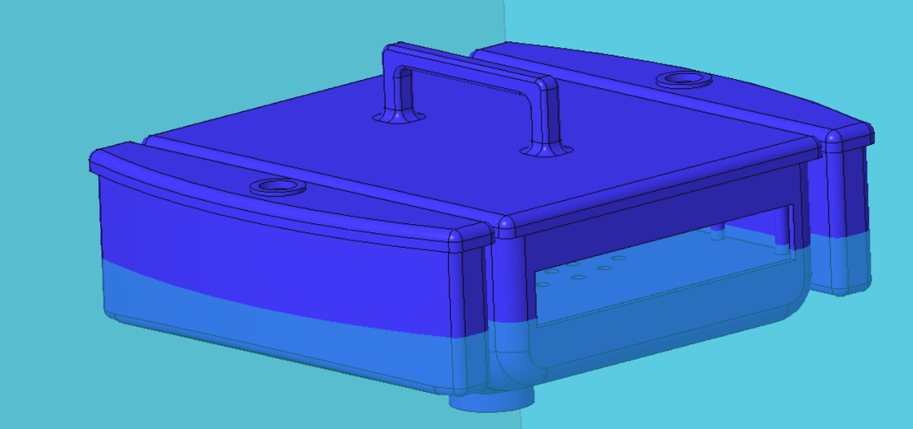

After ensuring the buoys are adequately filled and the correct water height has been reached, your Amazing Skimmer™ is ready to use! Simply connect the vacuum hose to the male connector found on the bottom of the skimmer, place the skimmer in the pool, and turn on the pump! With Awesome Pool’s© advanced technology, you can sit back and relax as the Amazing Skimmer™ will move throughout your pool!

**Maintenance**

**Emptying skimmer**

The skimmer will need to be frequently emptied, as the more debris it collects, the weaker the vacuum pull will be. The frequency of this necessity will depend on factors such as the cleanliness and size of your pool, the power of your pump, and other related factors. However, Awesome Pools© recommends cleaning your skimmer once a day to ensure the product maintains peak performance.

NOTE: The Amazing Skimmer™ can be left in the water or taken out during the following section.

To empty your skimmer, simply grab the handle placed on top of the skimmer unit and pull directly upward. This will detach the Removeable Tray (refer to the “Assembly” section for more information). There are many ways the tray can be cleaned, but Awesome Pools© recommends several ways: 1) Take a cloth and, reaching in from the front, start at the back and wipe the debris out the front of the tray, 2) Take a hose and spray the tray from the back, washing the debris out the front of the tray, or 3) Tilting the tray so the front is facing the ground, gently shake the tray, allowing the debris to fall out the front of the tray and into a garbage container. After the tray has been cleaned, the tray can be held by the handle and pushed vertically down until it is securely fitted in the Skimmer Body.

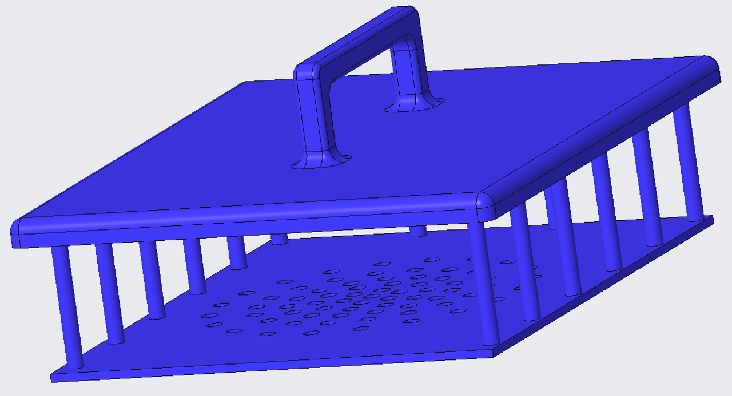

**Replacing chlorine tablets**

IF YOUR POOL DOES NOT USE CHLORINE, PLEASE DISREGARD THIS SECTION.

The Amazing Skimmer™ comes with the option to chlorinate your pool with the skimmer as well. Placing chlorine tablets in the skimmer is beneficial if you are looking to chlorinate the pool quickly.

Make sure to wear protective rubber gloves while replacing the chlorine tablets, as the chlorine has chemicals that can be harmful if in contact with the skin. To place chlorine tablets in the skimmer, simply remove the debris tray (refer to the “Emptying Skimmer” section under “Maintenance” for more information). Underneath the tray are four (4) locations were chlorine tablets can be placed. Only replace the tablets if the chlorine tablets have fully dissolved, as the Amazing Skimmer™ allows only enough room for one (1) chlorine tablet in each slot.

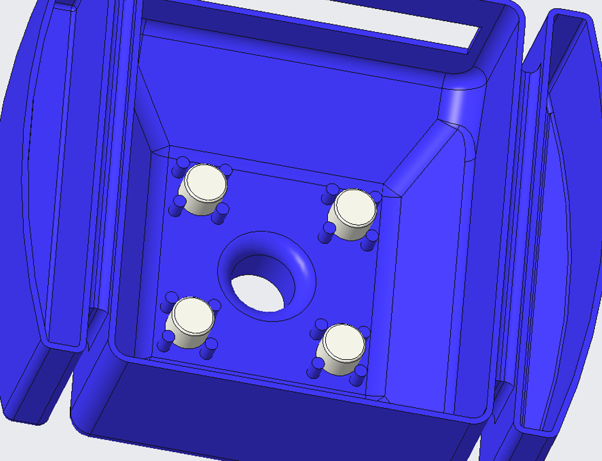

**Checking Buoy Levels**

It is important to regularly check the water level of your buoys, especially in an outdoor pool. High heat and evaporation can aid in depleting the water levels in the buoys, causing the skimmer to function at a level below optimum. To fill the buoys and ensure the skimmer is sitting at an acceptable height, refer to “Initial Setup and Use” section.

**Cleaning Skimmer**

It is beneficial to clean your skimmer at least once a season. Algae, chlorine, salt, mold, and other residues can accumulate on The Amazing Skimmer™, consequently making it less awesome. To do this, take a damp cloth or sponge and wipe the outside of the skimmer. Once the outside is clean, refer to the “Assembly” section to take apart your skimmer and clean the inside of each part. All purpose cleaning chemicals can be used but are not necessary. Bleach is not recommended, as it can wear on the plastic parts and weaken them.

**Safety Information**

THIS PRODUCT IS NOT A TOY. SERIOUS INJURY CAN OCCUR IF NOT USED AS SPECIFICED IN THE ENTIRETY OF THIS USER MANUAL.

Please turn off the pump before attempting to clean, change the chlorine tablets, or remove the skimmer from the pool. Failure to follow this safety precaution could lead to a void warranty, serious injury, or broken equipment.

The skimmer is safe to use while swimming in the pool. However, if possible, do not touch the skimmer while the pump is on and you are in the pool. The strong suction of the skimmer can pull hair into the debris trap, causing possible injury.

It is safe to swim near the Amazing Skimmer™ if there are chlorine tablets in the tray and the pump is on. However, DO NOT swim near the skimmer if chlorine tablets are in the tray and the vacuum is off. The chlorine will be extremely localized and could be a health risk.

**Warranty Information**

The Amazing Skimmer™ is backed by a 90 Day Money-Back Guarantee. If you are not 100% satisfied with the product, contact your nearest retailer or refer to “Contact Page” to receive your money back.

For one (1) year after purchase date of your Amazing Skimmer™, Awesome Pools© will replace any parts for free (just pay shipping and handling). Simply contact our Service Center for assistance if you experience any issues with the skimmer or anything breaks. After one (1) year after the purchase date of your Amazing Skimmer™ has passed, replacement parts can be purchased via our Service Center. For parts and prices, please refer to the “Service Center” section of this manual.

Awesome Pools© is NOT responsible for any damage that may be caused to the pool, pump, or any related pool equipment. Complaints of such nature will be dismissed by our Service Center. Use at your own risk.

Modifying or changing the design of the Amazing Skimmer™ IN ANY WAY will result in a void in your warranty and will automatically make the operator entirely liable if any malfunction may result.

**Service Center**

During print of this User Manual (2019) the following information is correct. However, please refer to our website for our latest email, phone number, and mailing address.

**Website:**

<https://webpages.uncc.edu/cbutzmon/1202%20Project/Home.html>

**Phone Number:**

704-AWE-SOME

**Address:**

9201 University City Blvd.

Charlotte, NC 28223

Our operators work hard 24/7 to provide you with the best possible customer satisfaction.

**Carlos Butz Monroy**

IT

[cbutzmon@uncc.edu](mailto:cbutzmon@uncc.edu)

**Tanner Gleaton**

CAD Design

[tgleato1@uncc.edu](mailto:tgleato1@uncc.edu)

**Jonathan Salo**

IT

[jsalo@uncc.edu](mailto:jsalo@uncc.edu)

**Darrick Romana**

Intern and Human Relations

[dromana@uncc.edu](mailto:dromana@uncc.edu)

**Replacement Parts**

When ordering replacement parts, please refer to the diagram below to help us identify the parts you need.

Prices are for one (1) part



(1) Removable Tray – $5

(1) Skimmer Body - $10

(2) Float Lids - $3

(2) Water Adjustment Caps - $2