# Team 30 Toiletry Case User’s Manual

**Parts:**

* Main Casing (1)

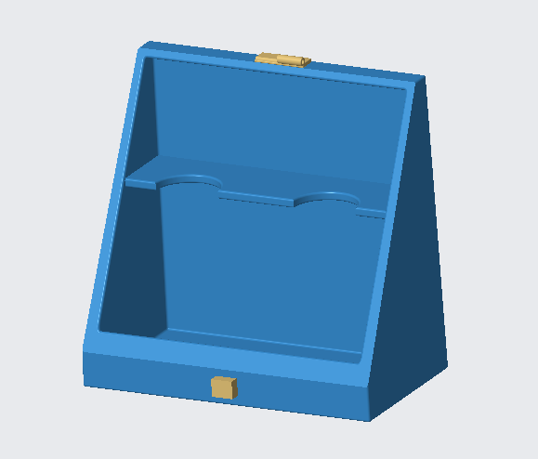

* Lid (2)

**No assembly required**

**Use and Maintenance:**

A variety of different toiletries and bathroom accessories can be stored. Stands for toothbrushes, razors and other utensils have been built-in to prevent the spread of germs through contact with dirty countertops.

For Best Results:

* Clean hinges often to prevent debris build up once every 2-3 month
* Clean the seal between the casing and lid once every 2-3 months

**Warranty Information**

We understand that traveling can be confusing and stressful, losing a bag at the airport only makes these stresses worse. Contact our ***Service Center*** for any information regarding replacement cases (Contents of case will not be replaced upon disappearance).

* Damaged Cases: Any case that has been damaged prior to customer delivery will be replaced free of charge - *Contact Service Center*
* Unsatisfactory Product: Any customer that is not satisfied with our product, or who believes that our product does not perform as advertised shall receive a full refund - *Contact Service Center*

**Service Center**

For any questions regarding instructions, shipping, maintenance, replacements, refunds, or any other questions, please contact our service center:

[Ryan Kirkland,

Phone: 704-291-1448 |

Email: rkirkla3@uncc.edu |

Address: 9201 University City Blvd, Charlotte, NC, 28223

[Paul Tello,

Phone: 704-963-6747 |

Email: jtello@uncc.edu |

Address: 9201 University City Blvd, Charlotte, NC, 28223

[Matthew Shaffer,

Phone: 757-407-5995 |

Email: mshaffe6@uncc.edu |

Address: 9201 University City Blvd, Charlotte, NC, 28223

[Carl Humphreys,

Phone: 336-908-4658 |

Email: chumph23@uncc.edu |

Address: 9201 University City Blvd, Charlotte, NC, 28223