The Easy Case 1.0

from

Easy Travel Inc.

Product User Manual

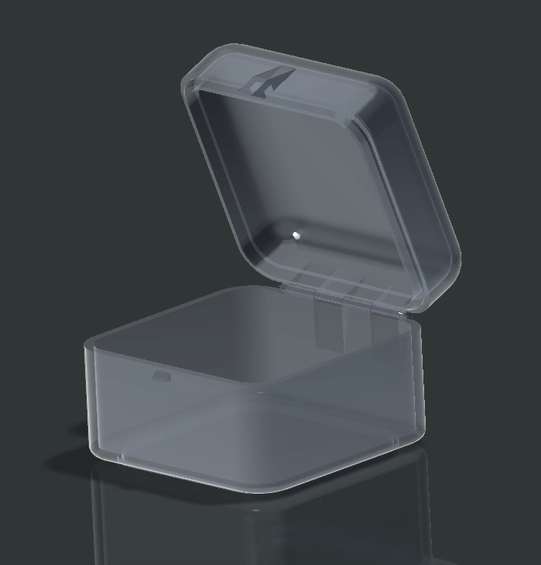

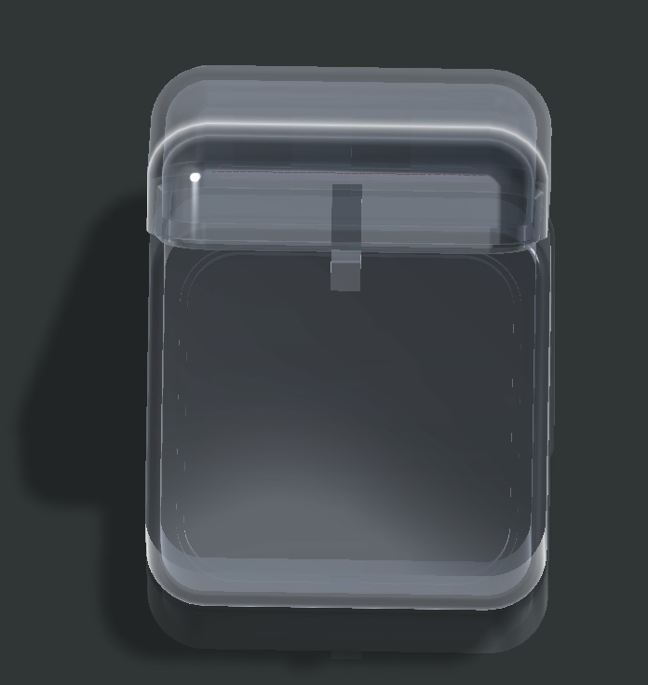

PLEASE READ THE FOLLOWING MANUAL BEFORE OPERATING THE EASY CASE 1.0

The Easy Case 1.0 by Easy Travel Inc.

**Table of Contents**

**Assembly 3**

**Unboxing and Use 4**

**Maintenance 4**

**Safety Information 4**

**Warranty Information 5**

**Service Center 6**

# Assembly

The Easy Case 1.0 is made of 3 simply designed components. This includes: the Base Container (where the toiletries are placed), the Top lid (which closes to secure your belongings inside) and lastly, the Hinge Pin (for the hinge on the back) in order to store you toiletries.

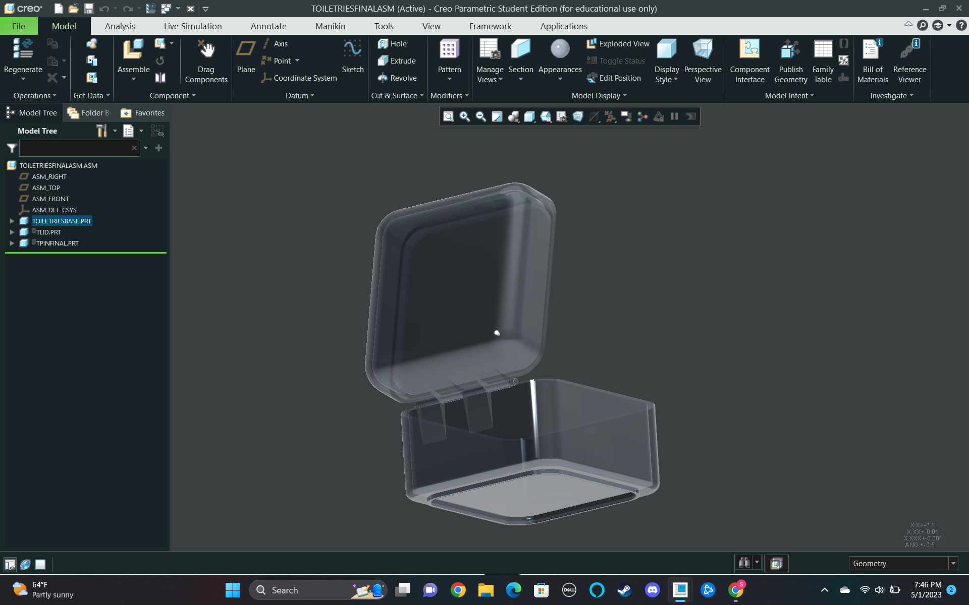

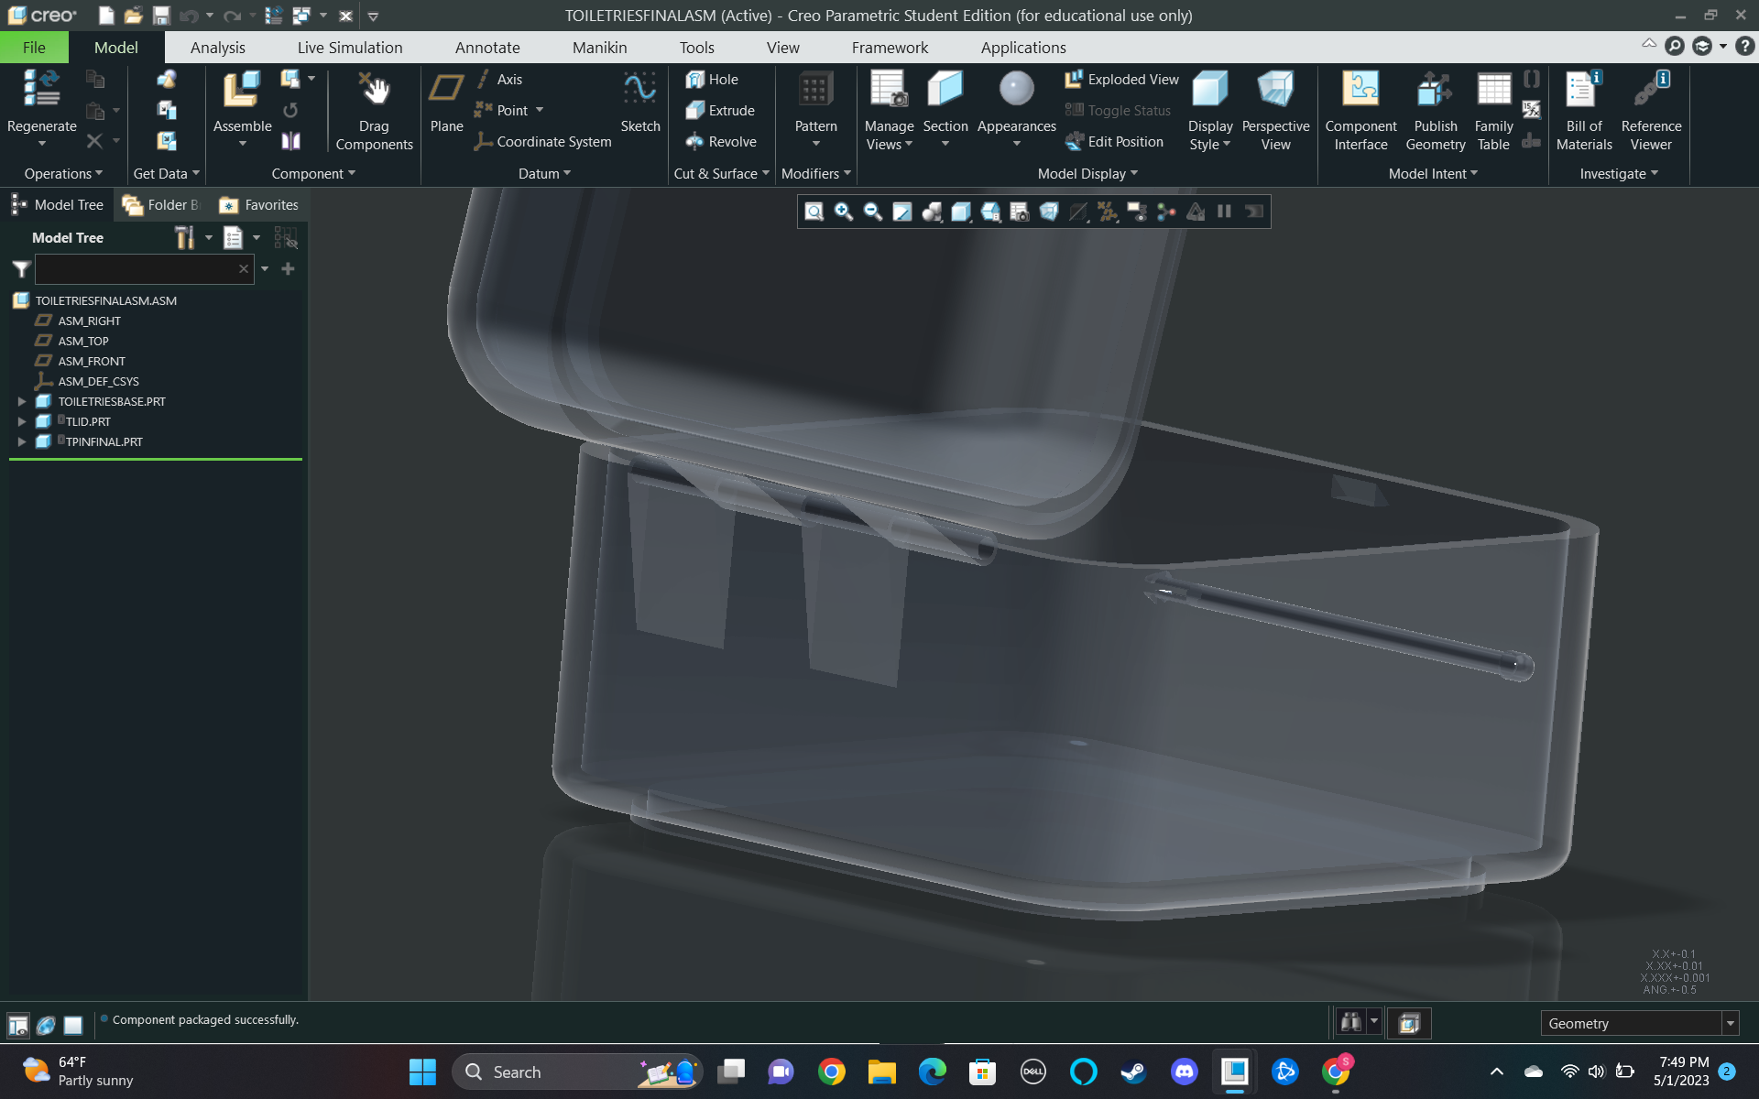

The Easy Case 1.0 includes: 1 Base Container, 1 Top Lid, and 1 Hinge Pin. All pieces come assembled for your convenience.

# Unboxing and Use

Before using your new Easy Case 1.0, be sure to inspect that your Ease Case is in good condition and that there are no cracks and/or other damages. Also be sure to check the hinge is working and functioning properly.

In addition, before using your Easy Case 1.0 make sure that you thoroughly wash the case with soap and warm water to ensure cleanliness prior to filling it with your toiletries. We are not responsible for any injuries or illnesses that are related to the product if you did not clean the Easy Case 1.0

The Easy Case 1.0 is a great solution for traveling with your tolietries/personal belongings. The Easy Case does not protect your personal belongings against water and other airborne pathogens. The Manufacturer's recommendation is to dry off any items damp before placing it in the Easy Case 1.0..

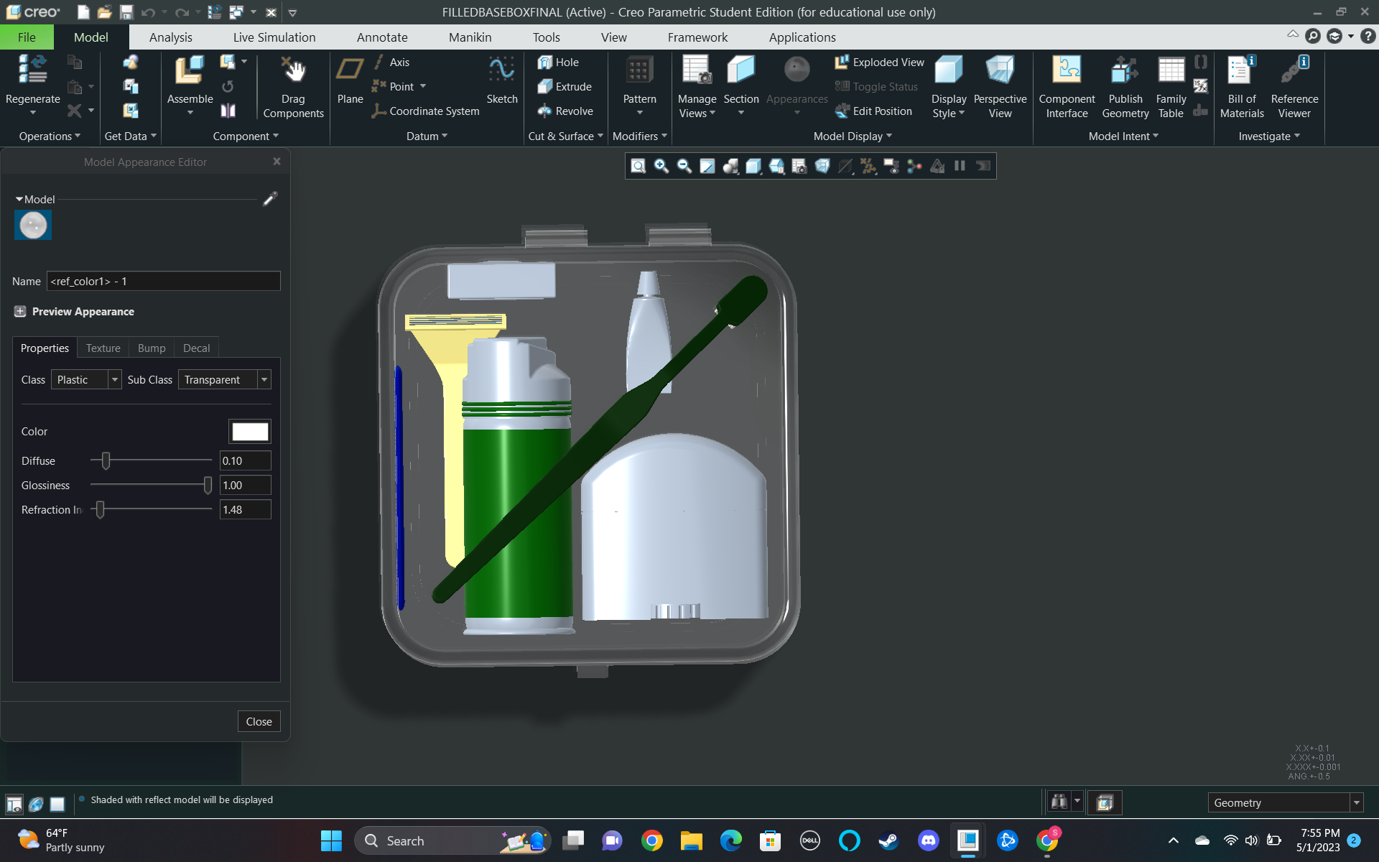

# 

# Maintenance

Maintenance of the Easy Case 1.0 is just as easy as washing. Be sure to wash the case after every use to ensure the cleanliness of the product

# Safety Information

THIS PRODUCT IS NOT A TOY. SERIOUS INJURY CAN OCCUR IF NOT USED AS SPECIFIED IN THE ENTIRETY OF THIS USER MANUAL.

# Warranty Information

The Easy Case 1.0 comes with a 30 Day Warranty (unless an additional warranty is purchased). If you are not 100% satisfied with our amazing product, if the case happens to have an unforeseen defects, or issue please refer to the “Service Center” page of the user manual to use your warranty.

For up to six (6) months after purchase of your Easy Case 1.0, we will replace any parts for free (just pay shipping and handling). Simply contact the Service Center for help if you experience any difficulties with the case. After six months (6) months after the date of purchase of the Easy Case 1.0, replacement parts can be purchased from our website. See the “Replacement Parts” section of the user manual for replacement parts and prices.

We are NOT responsible for any damage caused to the toiletries that you decide to place in the case. These types of complaints will be promptly disregarded by our Service Center.

Modifying or changing the design of the Easy Case 1.0 AT ALL will result in the void of your warranty and will automatically make you responsible for any damages that may occur.

# Service Center

During the development of this Product User Manual (2023) the information is correct. For the most up to date information please refer to our website

**Website:**

<https://webpages.charlotte.edu/dmansou1/finalproject.html>

**Phone Number:**

(704) TRA-VEL1

**Address:**

9201 University City Blvd.

Charlotte, NC 28223

Our Service Center is open 24/7 to provide the best possible customer support..

**Quentin Lamm**

CAD Engineer

[qlamm@uncc.ed](mailto:qlamm@uncc.ed)

**Dean Mansour**

Web Engineer and Technical Support

[dmansou1@uncc.edu](mailto:dmansou1@uncc.edu)

**Shiv Patel**

CAD Engineer

[spate295@uncc.edu](mailto:spate295@uncc.edu)

**Replacement Parts**

When ordering replacement parts, please refer to the diagram below to help us identify the parts you need.

Prices are for one (1) part

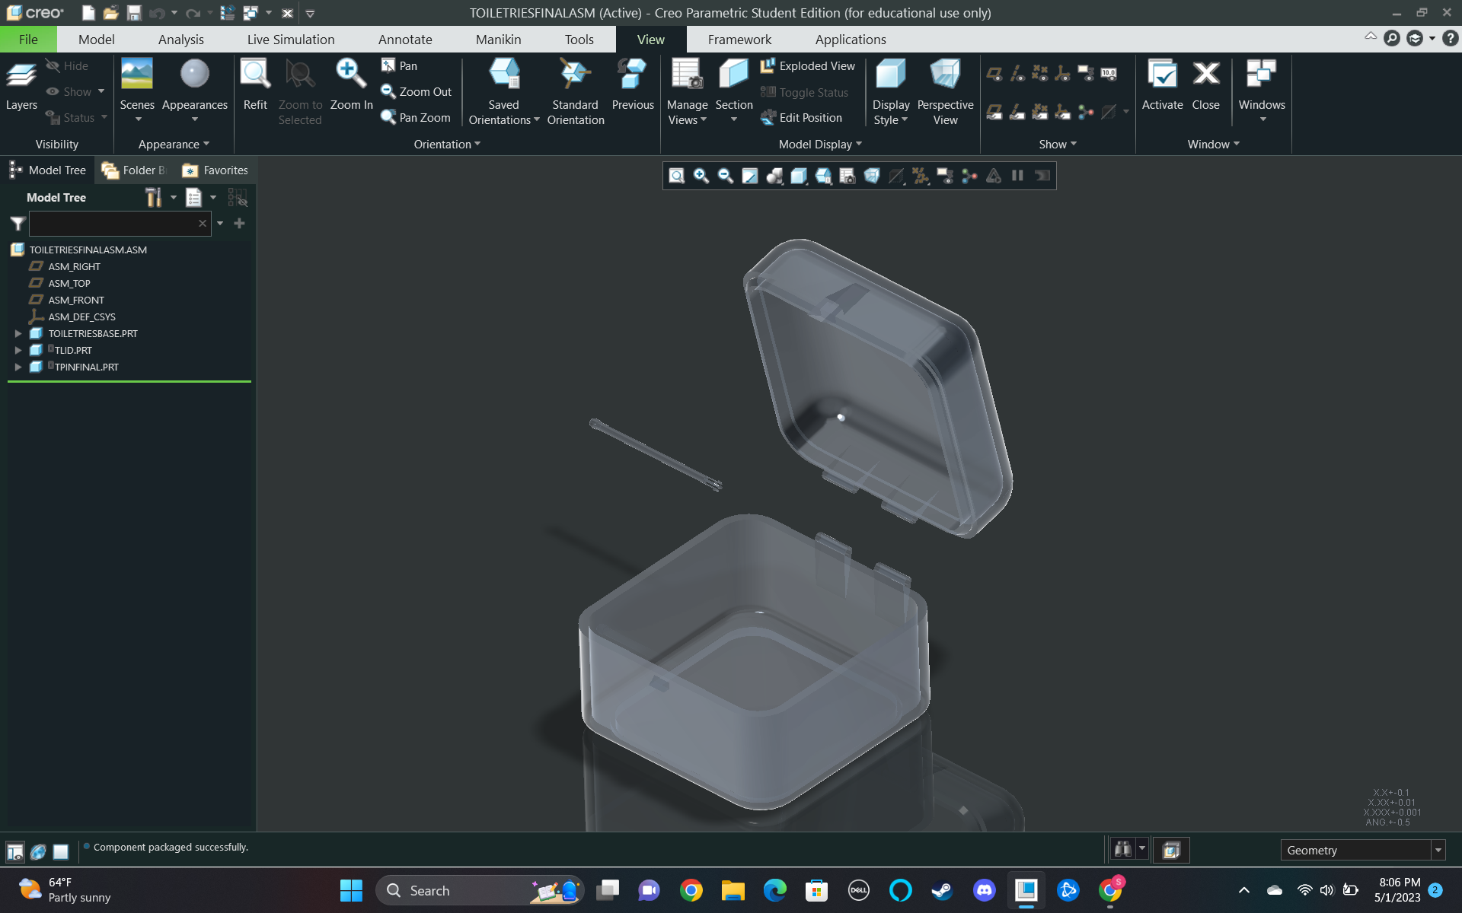

(3) Top Lid

(2) Hinge Pin

(1) Base Container

(1) Base Container– $13

(2) Connector Pin - $5

(3)Top Lid - $12