**MEGR 2156 Components: Highest fidelity solid models and refinement of solid models and equations**

* **Problem statement for the assignment**
* Ideally my product will give people an accessible and comfortable work station. It will give them the peace of mind to have this work station readily available at their need without taking up a significant amount of space in their baggage. For the average person their laptop is essentially their life on one device. Important documents are stored on here, emails, memos, pictures, and research. As many would love to just forget about work, many cannot just do that. They need their laptop to work while away. People travel either for business or vacation every day and most people indefinitely bring their laptop with them.

My method for this product is to produce it out of light weight material that is easy to clean, safe for the environment, and low cost. My ideas for this product will include several features such as rubber grips on the surface, Velcro straps, side bins, wrist rests and a soft bottom layer for comfort. Traveling shouldn’t restrict anyone’s ability to work, instead it should provide free time they can use to be productive. The decision matrix helped me choose design #2 from assignment 3 to be the best choice to achieve what I want from this product. Assignment 4 helped me best decide what features would be most beneficial and practical for my product.

* **Assumptions about the problem**
  + People lose essential supplies when working on the computer.
  + Laptops and tablets do not sit comfortably on your lap.
  + When traveling the user may not have enough room to comfortably set out their laptop in front of them
* **Pugh/Decision Matrix**

|  |  |  |  |  |  |  |  |  |
| --- | --- | --- | --- | --- | --- | --- | --- | --- |
| **Rank** | **Percentage** | **Criteria** | **Design 1 Grade** | **Design 1 Value** | **Design 2 Grade** | **Design 2 Value** | **Design 3 Grade** | **Design 3 Value** |
| **6** | **.10** | **Purpose** | **4** | **.4** | **3** | **.3** | **3** | **.3** |
| **4** | **.15** | **Storage** | **3** | **.45** | **1** | **.15** | **5** | **.75** |
| **5** | **.25** | **Size** | **4** | **1** | **4** | **1** | **4** | **1** |
| **2** | **.15** | **Design** | **2** | **.3** | **3** | **.45** | **3** | **.45** |
| **3** | **.15** | **Appearance** | **3** | **.45** | **5** | **.75** | **2** | **.3** |
| **1** | **.20** | **Ease** | **5** | **1** | **4** | **.8** | **3** | **.6** |
| **Total:** | **1.0** | **Total:** |  | **3.60** |  | **3.45** |  | **3.40** |

From the previous decision matrix, we can choose which design is right to proceed with. Design 1 received the highest score. The solutions below are for Design 1 and its components. Design 1 received the rating it did based on my criteria. For purpose it was rated how well it could hold a laptop and store supplies. The Storage was directly tied with bins designated for storage and how much it could hold at once. The size was given on the dimensions of the product which in this decision matrix they were all the same. Design was rated on how neatly and convenient the features were placed and would be able to be used by the user. Appearance was given by the eye appeal of the product design. Ease was determined by the ability to quickly use the product.

* **Solutions**

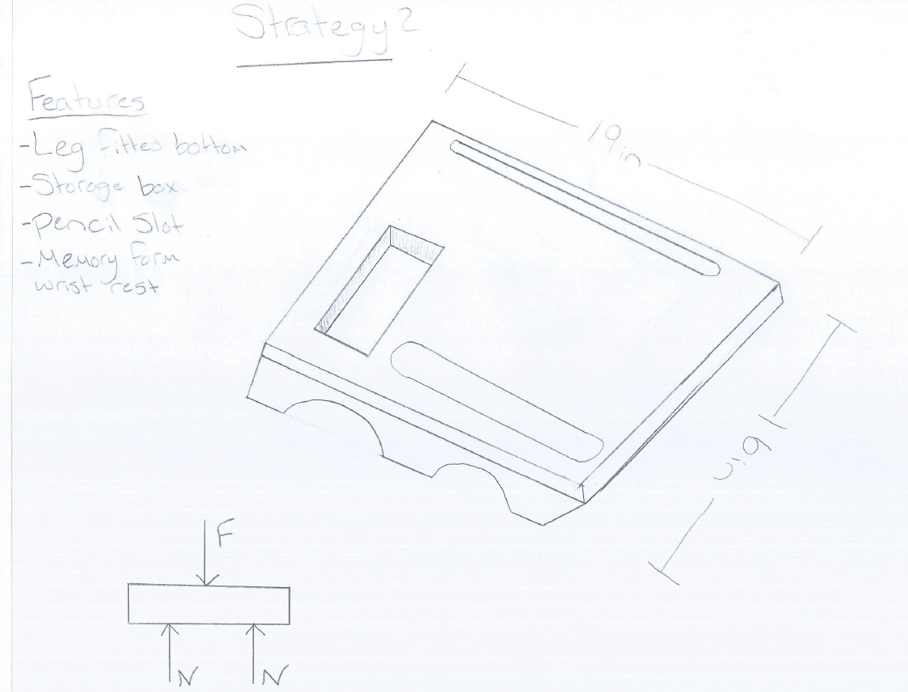 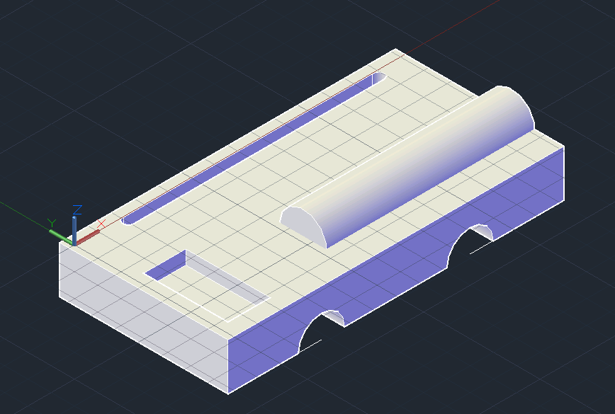

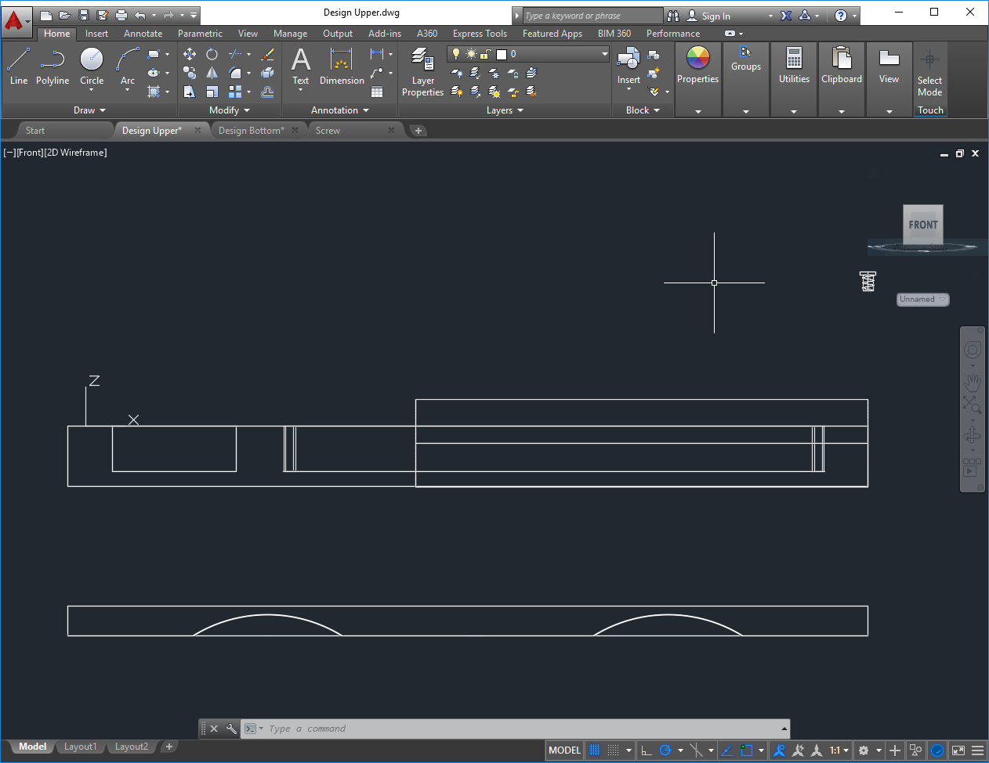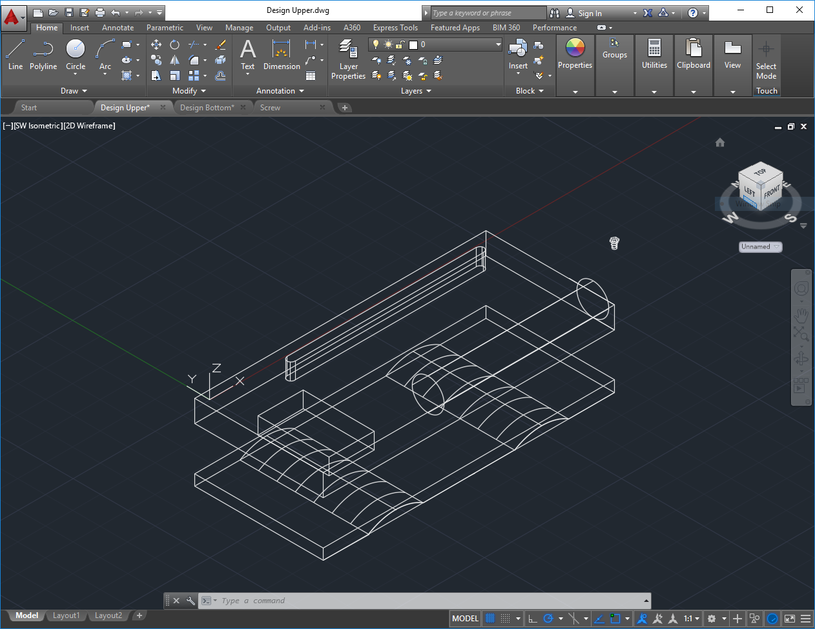

This product was intended to be one solid piece of material but based on the requirements of this assignment I will separate the product into three parts. This product has no motion to show. The detailed AutoCAD drawings are posted above and will be readily downloadable from my website, but there is no need for motion capture. I will join the components and place the bolts in the necessary position.

Material Selection and Stress Analysis

The screw below shows the type of screw/bolt I could use to connect the bottom portion to the top surface of my product. This screw would be made from steel and be a ¼ screw/bolt. From the stress tests there is only normal stress that will affect this product. There is no shear stress or bearing stress. The average weight of a laptop and tablet are about 5 pounds. The Surface area of the product can be calculate easily using the dimensions shown in the sketches above (Length:19in. Width:16in. Height 1.5in). The safety factor that is common for bolts is 8.5, which is a lot for this product, but we will use it. The surface and bottom components do not need safety factors for this product.

Factors of Safety - FOS - are a part of engineering design and can for structural engineering typically be expressed as

FOS = Ffail / Fallow

where

FOS = Factor of Safety

Ffail = failure load (N, lbf)

Fallow   = allowable load (N, lbf)

## Minimum Equations:

* Normal stress σ = Fn/A
* Bearing stress σb = F/Ab
* Shear stress 𝛕 = V/A
* Hooke’s Law  σ = E𝝴
* SF = Failure stress/Allowable stress

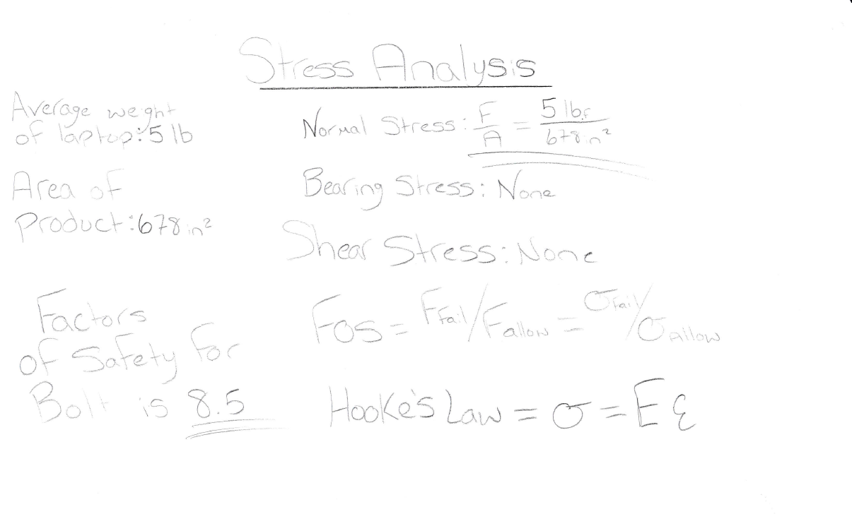

**Bottom**

|  |  |  |  |  |  |
| --- | --- | --- | --- | --- | --- |
| FR | Dp | A | R | R | C |
| Comfort | The bottom to be comfortable sit on users lap | Use soft cloth around bottom component | Bottom component is too hard for a comfortable fit | https://www.explainthatstuff.com/memoryfoammattresses.html | Use memory foam or bean bag like material around component |
| Size | The height of the bottom not to big too large | The bottom to be small enough to support but not too large that it stands out | The bottom is obnoxious to user | https://www.sciencedirect.com/science/article/pii/S0148619511000166 | Limit size to half or smaller than top component |
| Fitting | The arches to fit around legs tightly | Legs aren’t squeezed and discomfort to legs isn’t caused | Legs could be too tighly gripped by bottom | https://medium.com/evergreen-business-weekly/product-market-fit-what-it-really-means-how-to-measure-it-and-where-to-find-it-70e746be907b | Create arches that are able to be used no matter the leg size |

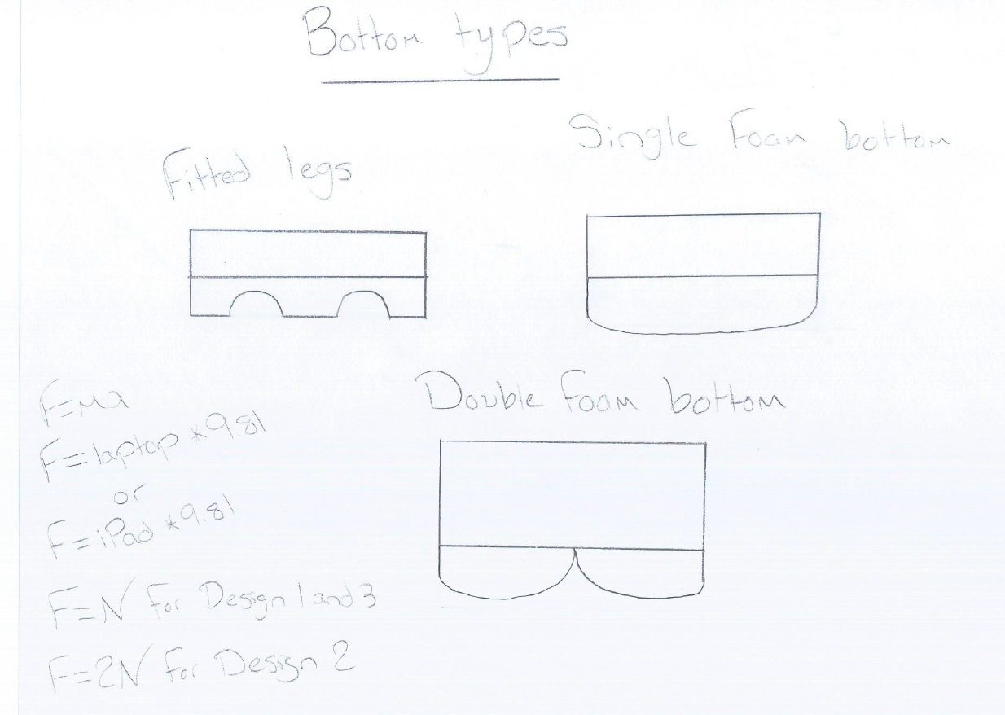 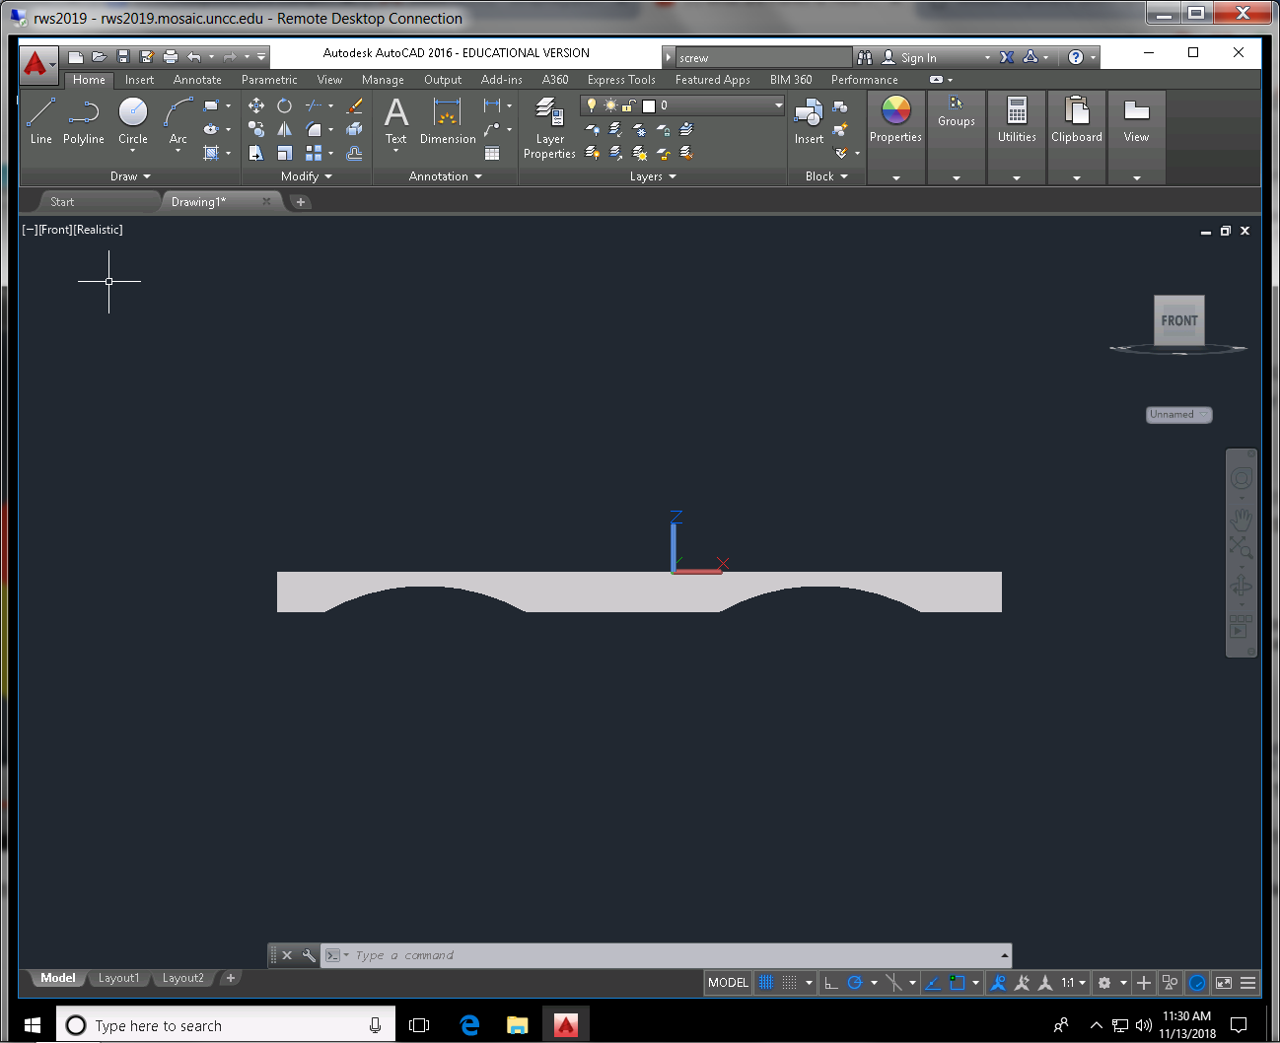

**Bolt**

|  |  |  |  |  |  |
| --- | --- | --- | --- | --- | --- |
| FR | Dp | A | R | R | C |
| Size | Correct size for Design | Big enough to perform its need | Too Big and will affect design of product | https://www.parktool.com/blog/repair-help/basic-thread-concepts | Use Machinist Handbook for size |
| Material | Choose appropriate material | Choose right material that will withstand Stress | Material isn’t strong enough and will fail | https://www.thomasnet.com/articles/hardware/fastener-materials | Use Machinist Handbook for material and right stress and safety factors |
| Placement | Place Strategically | Place out of the way, Not noticeable | Obvious to buyer and non-appealing look | https://www.climbing.com/people/to-bolt-or-not-to-bolt/ | Place underneath product, out of way |

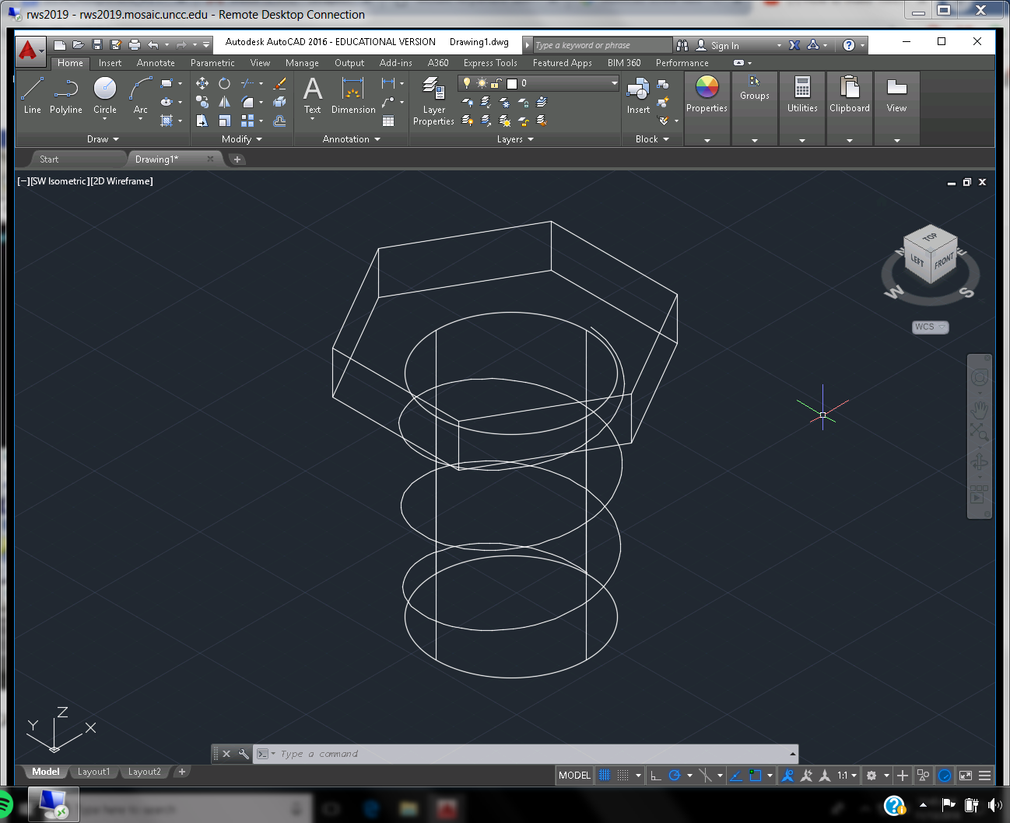

**Surface**

|  |  |  |  |  |  |
| --- | --- | --- | --- | --- | --- |
| FR | Dp | A | R | R | C |
| Clean | Keep clean surface | We want the surface to stay clean for a neat workspace | Surface gets dusty easily and spills stain surface | https://www.nedcc.org/free-resources/preservation-leaflets/7.-conservation-procedures/7.2-surface-cleaning-of-paper | Surface finish material so it is easily cleaned |
| Hard | Surface hard enough to not be damaged easily | Surface can’t be damaged if dropped or etc | Surface has dents and bumps for damage | https://www.sciencedirect.com/science/article/pii/S1000936111601350 | Surface has protective plastic hardened layer on it |
| Eco-Freidnly | Material surface is made from is recyclable | Material is not wasteful and can be reused | Material is wasteful | https://www.smartcitiesdive.com/news/most-eco-friendly-building-materials-world-bamboo-cork-sheep-wool-reclaimed-metal-wood/526982/ | Proper Material selection for surface |

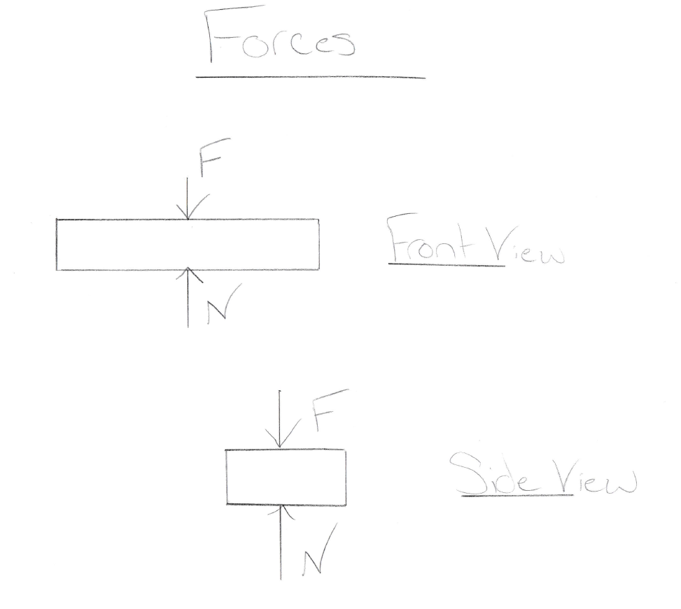 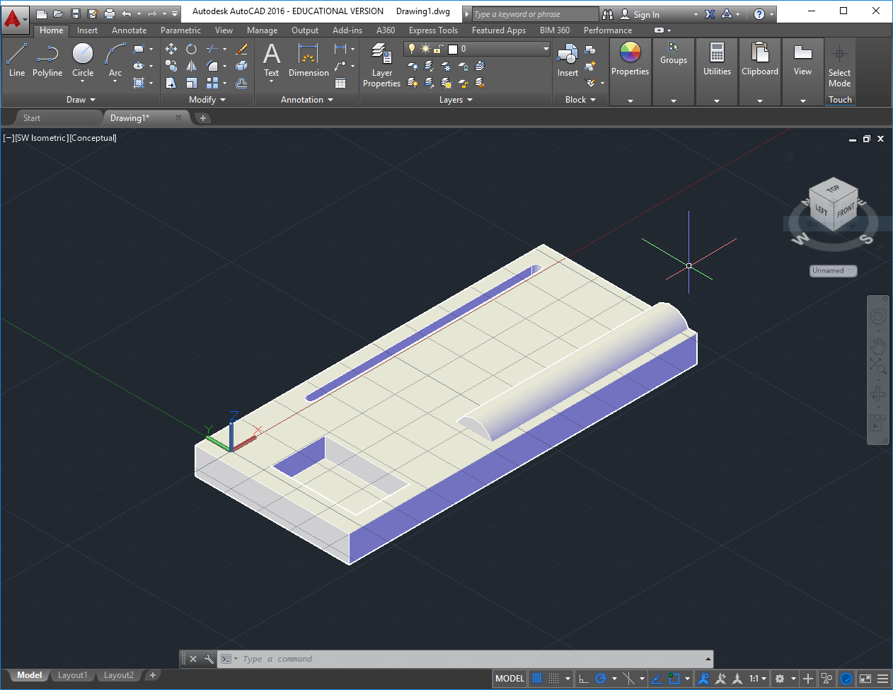

* + - Parametric Modeling Technique is a good concept for Modeling when having to change while in mid design. This technique helps ensure that requirements and guidelines are met. This method of modeling can be beneficial in feedback as well. This technique is also best when subjecting uncertain situations. This method relies on mathematical equations which reduce the chance for human bias. We will be using this technique to model our final products to ensure we need and have exactly what our product want.

<https://galorath.com/company/books/what-is-parametric-modeling/>

* **Gantt Chart**



* + - Updated Problem Statement 2018/11/03 from 3:00PM-4:00PM
    - Created FRDPARRC for Modules 2018/11/03 from 6:45AM-8:00AM
    - Created New Decision Matrix, 2018/11/07 from 2:45 PM to 4:00 PM
    - AutoCad Modules were created 2018/11/08 from 3:00PM to 4:00PM
    - Filled out decision matrix, 2018/11/08 from 4:30PM to 5:00PM
    - Updated Gant chart for assignments 2018/11/11 from 3:00 PM to 3:30PM
    - Commented on Advisees, 2018/11/11 from 5:00PM to 5:15PM
    - Filled out assignment template 2018/11/13 from 10:00AM to 1:00PM
* **Lessons Learned**
  + Gannt Chart helps plan a lot more than I thought
  + The materials and small components matter
  + The final stages are the hardest to change the design in
  + Safety Factors are important to help prevent the unexpected
* **Comments to each advisee**
  + Jackson Reckord
    - Website looking organized and clean
    - Clear and understandable information
    - Solutions thought out
  + Ryan Harbert
    - Flow of website is good
    - Design coming along well
    - Components are chosen well