**MEGR 2156 Components: Highest fidelity solid models and refinement of solid models and equations**

* **Problem statement for the assignment**
* Ideally my product will give people an accessible and comfortable work station. It will give them the peace of mind to have this work station readily available at their need without taking up a significant amount of space in their baggage. For the average person their laptop is essentially their life on one device. Important documents are stored on here, emails, memos, pictures, and research. As many would love to just forget about work, many cannot just do that. They need their laptop to work while away. People travel either for business or vacation every day and most people indefinitely bring their laptop with them.

My method for this product is to produce it out of light weight material that is easy to clean, safe for the environment, and low cost. My ideas for this product will include several features such as rubber grips on the surface, Velcro straps, side bins, wrist rests and a soft bottom layer for comfort. Traveling shouldn’t restrict anyone’s ability to work, instead it should provide free time they can use to be productive. The decision matrix helped me choose design #2 from assignment 3 to be the best choice to achieve what I want from this product. Assignment 4 helped me best decide what features would be most beneficial and practical for my product.

Assignment 5 allowed me to break my product into three induvial parts. The surface the bottom and a bolt. As for assignment 6, it will give me a chance to create detailed engineering drawings for machinists. This is an important step because this is where the physical prototypes come in. I’ll be able to get hands on experience with this product to improve it even more.

* **Assumptions about the problem**
  + People lose essential supplies when working on the computer.
  + Laptops and tablets do not sit comfortably on your lap.
  + When traveling the user may not have enough room to comfortably set out their laptop in front of them
* **Pugh/Decision Matrix**

|  |  |  |  |  |  |  |  |  |
| --- | --- | --- | --- | --- | --- | --- | --- | --- |
| **Rank** | **Percentage** | **Criteria** | **Design 1 Grade** | **Design 1 Value** | **Design 2 Grade** | **Design 2 Value** | **Design 3 Grade** | **Design 3 Value** |
| **6** | **.10** | **Purpose** | **4** | **.4** | **3** | **.3** | **3** | **.3** |
| **4** | **.15** | **Storage** | **3** | **.45** | **1** | **.15** | **5** | **.75** |
| **5** | **.25** | **Size** | **4** | **1** | **4** | **1** | **4** | **1** |
| **2** | **.15** | **Design** | **2** | **.3** | **3** | **.45** | **3** | **.45** |
| **3** | **.15** | **Appearance** | **3** | **.45** | **5** | **.75** | **2** | **.3** |
| **1** | **.20** | **Ease** | **5** | **1** | **4** | **.8** | **3** | **.6** |
| **Total:** | **1.0** | **Total:** |  | **3.60** |  | **3.45** |  | **3.40** |

From the previous decision matrix, we can choose which design is right to proceed with. Design 1 received the highest score. The solutions below are for Design 1 and its components. Design 1 received the rating it did based on my criteria. For purpose it was rated how well it could hold a laptop and store supplies. The Storage was directly tied with bins designated for storage and how much it could hold at once. The size was given on the dimensions of the product which in this decision matrix they were all the same. Design was rated on how neatly and convenient the features were placed and would be able to be used by the user. Appearance was given by the eye appeal of the product design. Ease was determined by the ability to quickly use the product.

**Bill of Materials**

|  |  |  |  |  |
| --- | --- | --- | --- | --- |
| Part Number | Part Name | Description | Quantity | Material |
| 001 | Versatile Surface material, shippable, | Surface Material | 1 | Low-Density Polyethylene |
| 002 | Fitted leg bottom surface material, shippable, | Bottom Material | 1 | Polystyrene or Styrofoam |
| 003 | Universal common stock bolt, shippable | Bolt | 1 | Grade 2  Low or Medium carbon Steel |

**Drawings**

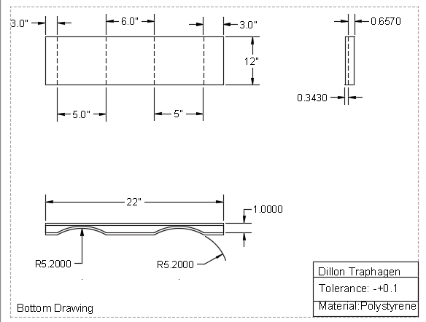

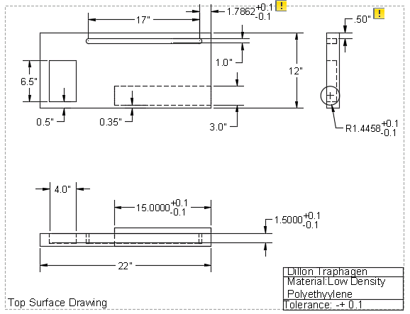

**Gantt Chart**



* + - Updated Problem Statement 2018/11/17 from 3:00PM-4:00PM
    - Create Bill of Materials 2018/11/18 from 5:15PM-6:00PM
    - Create AutoCad Multiview Drawings 2018/11/20 from 1:45PM-4:00PM
    - Finalize template 2018/11/23 from 1:00Pm-3:00PM
* **Lessons Learned**
  + Drawings need to have very specific tolerances and dimensions
  + You can not assume anything in drawings
  + Different views of the product and its dimensions are important
  + Make sure no dimensions are unknown
* **Comments to each advisee**
  + Jackson Reckord
    - Website looking organized and clean
    - Clear components used
    - Good Decision Matrix
    - Good detailed Drawings
  + Ryan Harbert
    - Product coming together very well
    - Website is easy to navigate
    - 3 Components are well illustrated
    - Good detailed Drawings