Tidy Travel Toiletry Case

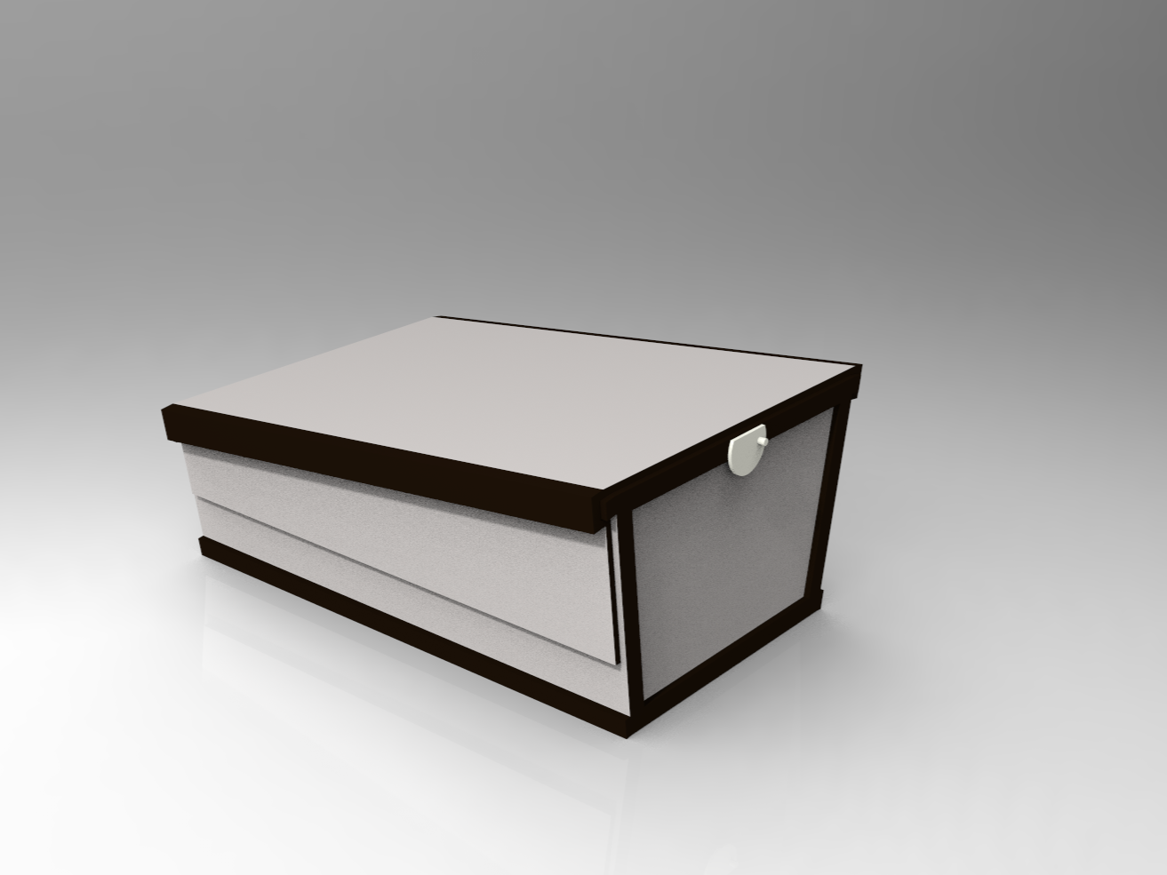

The only travel case you’ll ever need to keep your belongings clean, guaranteed!

Team 36
Ada Kersh, Austin Heft, Jose Abreu, Harmon Schlueter
Table of Contents

Parts List 3
Assembly 4
Use and Maintenance 5
Maintenance Instructions and Recommendations 5
Warranty Information 6
Service Center Information 7

Parts List
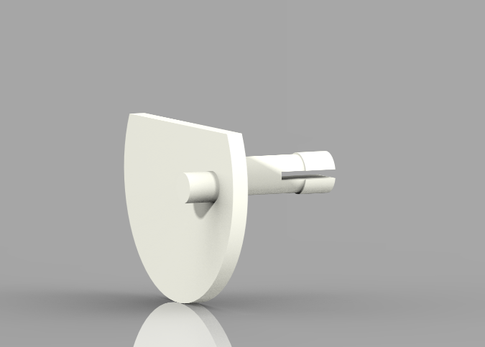  Figure 1. Locking Pin. | Figure 1 depicts the rotating locking mechanism.
Figure 2. Case and Sliding Cover. | Figure 2 depicts the toiletries case along with the sliding cover.
Figure 3. Inside View. | Figure 3 shows the main body of the case, with dedicated storage compartments for toiletries.

Assembly
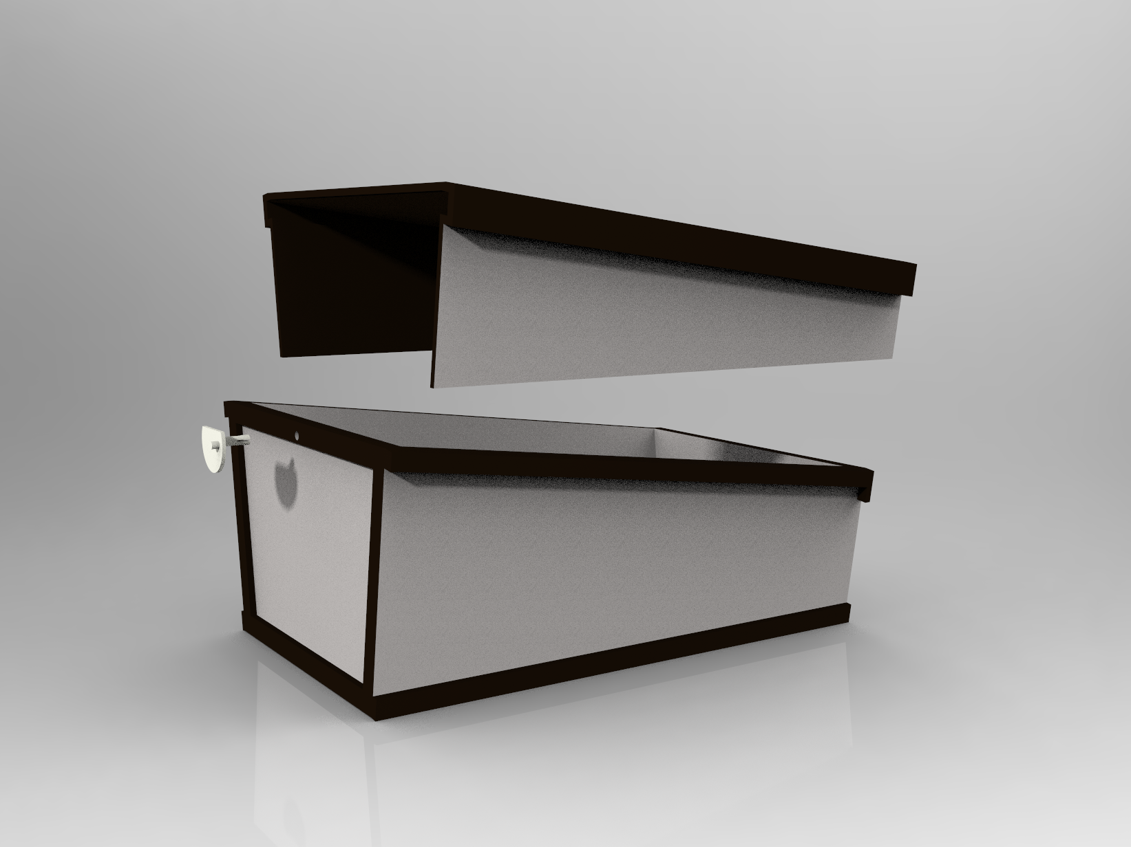
Figure 4
Assembling the Tidy Travel only requires 2 steps.
- Insert the pin of the round lock into the hole in the body of the case.
- Once the lock has been installed, the cover can slide into place using the rails at the top of the body.

Use and Maintenance
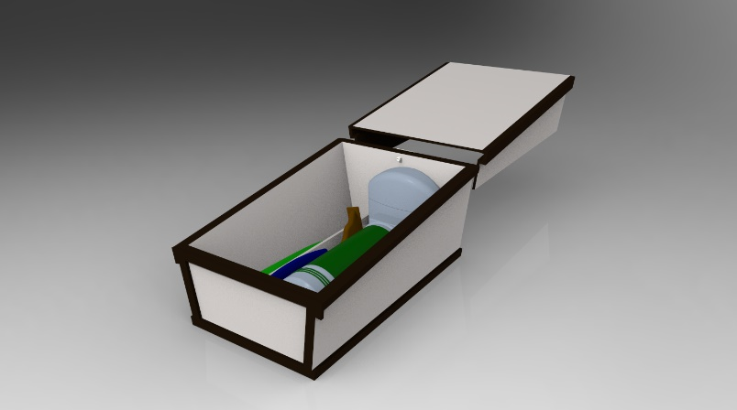
The case can be used to contain a variety of toiletries as shown in Figure 5. To close the case, the cover can slide over the body of the case to seal the toiletries in place. To keep it closed, simply rotate the lock until the flat part points down to lock the cover in place. Make sure to return the lock to the unlocked position before opening the case to prevent damage. DO NOT open the case when the lock is in the locked position or damage will occur. Once closed, the case forms a watertight seal to prevent water from getting in or leaking out to avoid spills in your luggage. The Tidy Travel is constructed from High Impact ABS plastic and should NOT be stored in temperatures above 149℉ or 65℃.
Figure 5

Maintenance Instructions and Recommendations
The Tidy Travel case is made from injection molded plastic, which means it is waterproof. This makes the case easy to clean and it is even dishwasher safe. To hand wash the Tidy Travel case, simply slide the cover off the case and remove the rotating locking mechanism (Figure 1). Then, use soap and water with a sponge or soft cloth to gently clean the inside of the case and cover. Either towel dry or let air dry. If the locking piece comes loose, it can easily be popped back into place. DO NOT try to slide the cover off the body of the case without rotating the locking mechanism to the unlocked position. DO NOT apply excessive force or pressure to the case or damage may occur. The Tidy Travel case should be stored in a location that does not exceed 149℉ or 65℃.

Warranty Information
The Tidy Travel company prides itself on high quality and standards. If your case breaks or isn’t functioning properly, please contact us immediately through any of the emails listed in the “Service Center Information” section. Our warranty allows you to return your broken case or parts for either a full refund or exchange if damage occurs within 100 days of purchase. The warranty will not cover misuse of the case; this includes intentional damage, using the case for anything other than its intended purpose, and actions against what is listed in the “Maintenance Instructions and Recommendations”. If the locking mechanism piece is lost, replacements can be purchased from the Tidy Travel website.

Service Center Information

For more information contact the Group 36 design team
Ada Kersh - hkersh@uncc.edu
Austin Heft - aheft1@uncc.edu
Jose Abreu - jabreu2@uncc.edu
Harmon Schlueter - hschluet@uncc.edu

or call
(704) 687-8349

Our office is located at Duke Centennial Hall room 323
9330 Robert D. Snyder Rd, Charlotte, NC 28223

