**Product Information:**

The PoolBoy surface skimmer is a floating surface skimmer that picks up floating and submerged debris in the upper layer of the pool. The surface skimmer comes equipped with a built in slot that holds a chlorine tablet which allows it to be dispensed at the skimmer moves throughout the pool. The body and wheels of the surface skimmer are made with polypropylene which is a durable plastic that is resistant to water and detergents. The product is designed to be durable and have a long lifetime.

**Product Specifications:**

Dimensions ( LxWxH ): 16 x 12 x 7 inches

Total cost: $175

The product comes with an optional one year warranty available for $20

We do replace individual parts

**Parts**

-Wheels and Axle

-PoolBoy Surface Skimmer Body

- Chlorine tablets (Not Included)

-Vacuum hose (Not Included)

**Assembly**

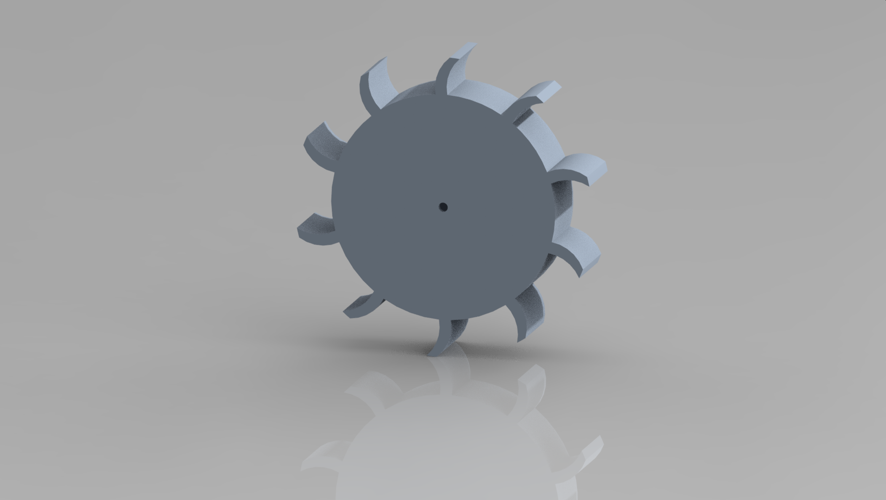

Pictured is a singular, hollow wheel. This will be attached to the other wheel by a given axle. The wheel and axle will come manufactured together. (Wheels used as flotation device)

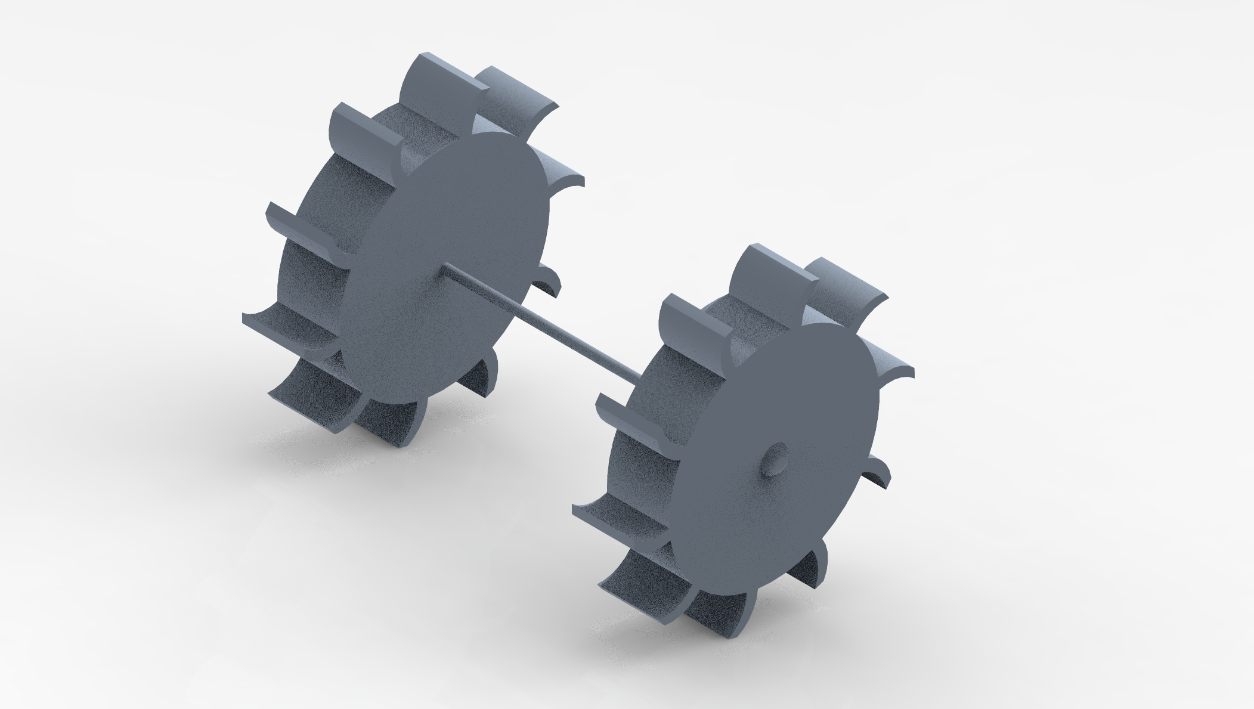

Both wheels connected by axle ( Wheel and axle can be bought for replacement parts; see contact information below)

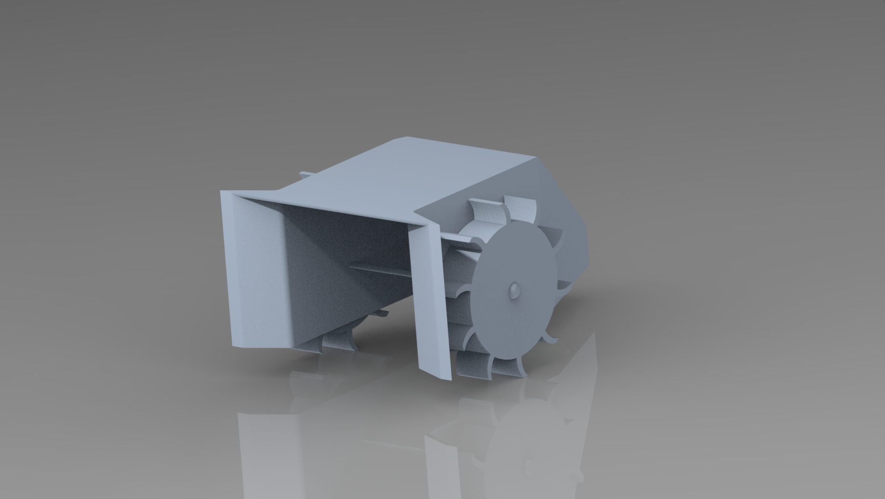

Final product assembly, body can be bought for replacement ( See contact information below)

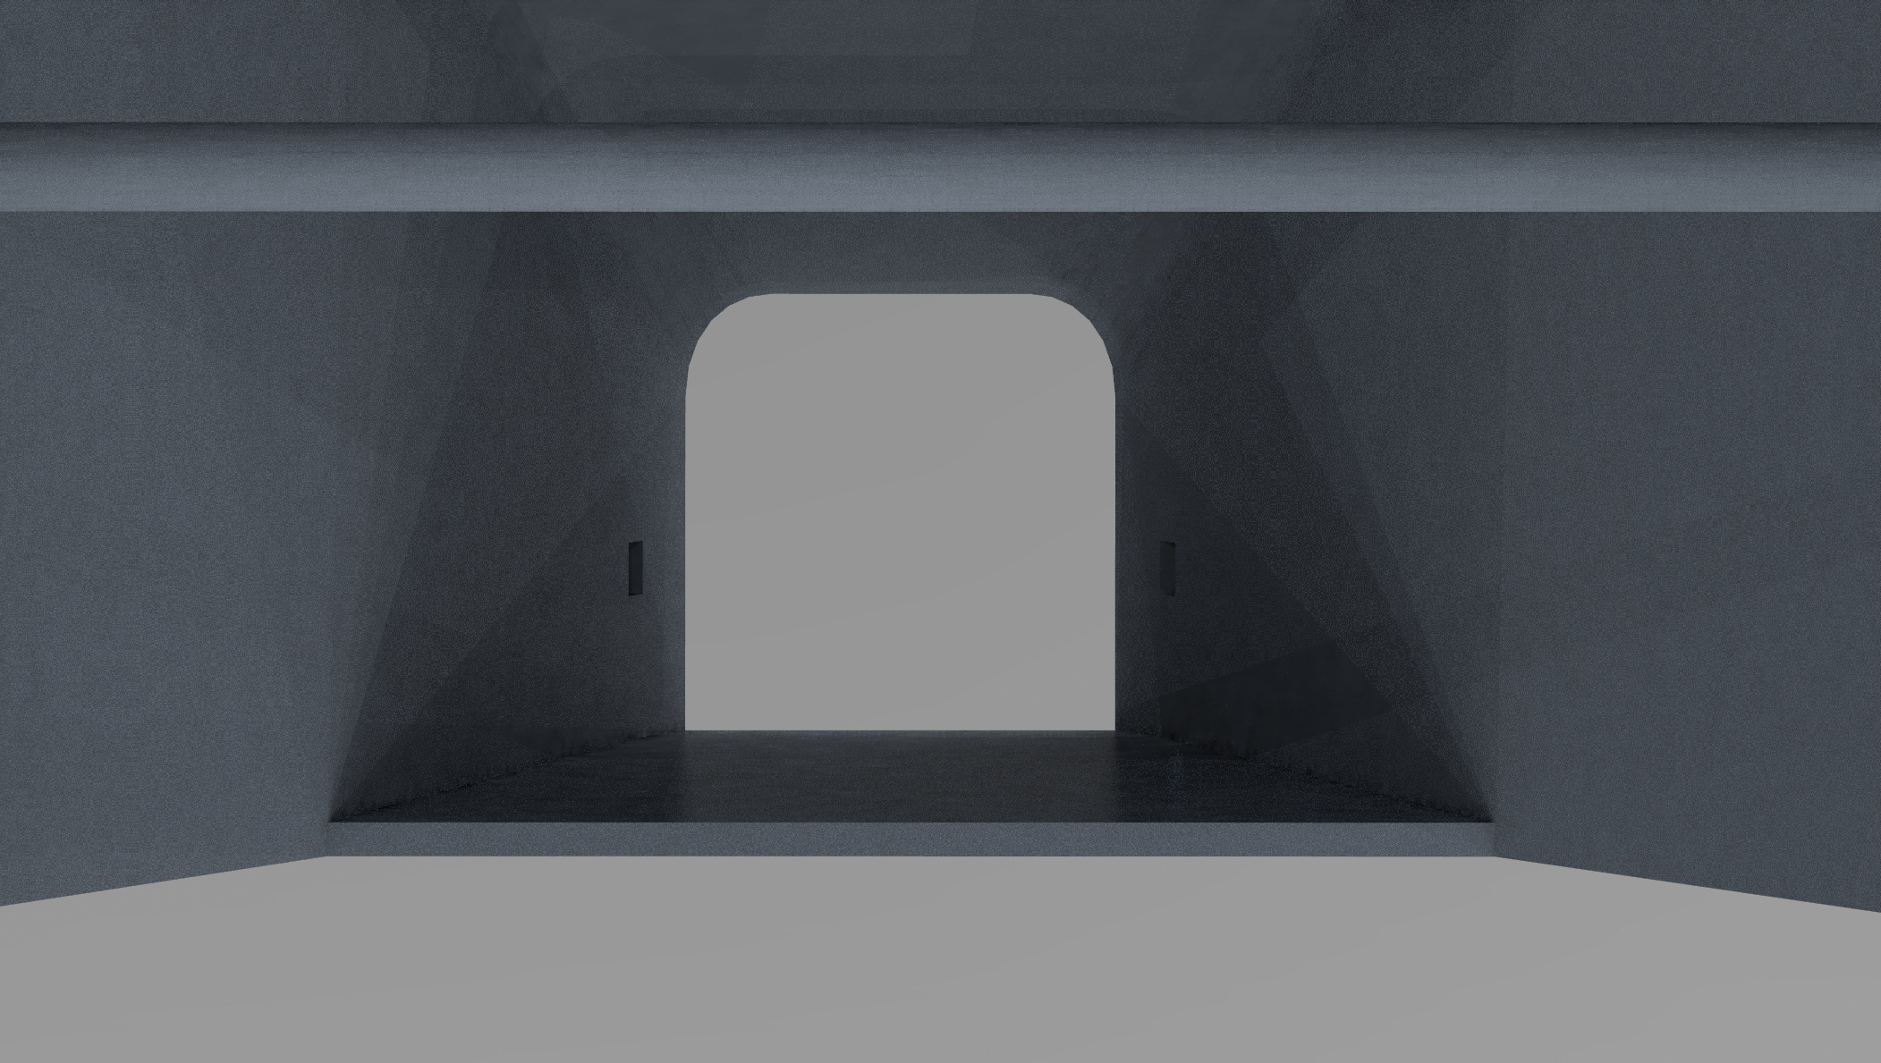

The side holes pictured on the walls of the product are used as anchor points for the vacuum hose to attach. This allows for easy attachment and removal of the hose.

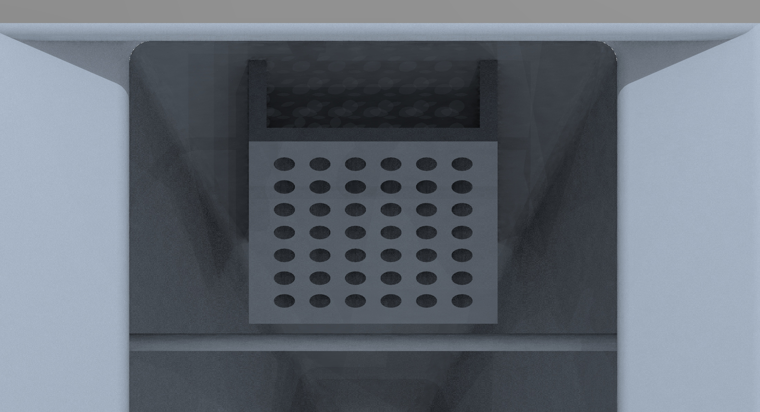

Pictured is the chlorine basket, located on the inside of the Skimmer. This makes it simple and easy to add chlorine and properly dispense as the PoolBoy Surface Skimmer travels throughout the pool surface. Basket area holds 1 in and 3 in tablets. Put in as many as needed for your pool size.

**Use and Maintenance**

-Clean and make sure parts are moving properly

-Attach hose to clip-in area

-Add chlorine tablets as needed

-Place on top of water, place evenly so the product floats correctly

Look over parts weekly, make sure hose entry point are clear, inside area is clean.

When not in use, store in a cool, dry place

Make sure to remove and clean any chlorine tablets when storing or not using

**Contact Information**

PoolBoys wants you to be able to contact us about any of your needs/comments on the

product whether it be repair, purchase, or general questions.

Email: [PoolBoysCleaningProdcuts@gmail.com](mailto:PoolBoysCleaningProdcuts@gmail.com)

Location: 7601 Charlotte Speedway St. Charlotte, NC

Phone: 1-800-PoolBoy

Personal Contacts

Joseph Burgess : [jburge26@uncc.edu](mailto:jburge26@uncc.edu)

Thomas Fudala : [tfudala1@uncc.edu](mailto:tfudala1@uncc.edu)

Riley Redmon : [rredmon@uncc.edu](mailto:rredmon@uncc.edu)

Jameson Cunningham : [jcunni29@uncc.edu](mailto:jcunni29@uncc.edu)