Pool Skimmer User Manual

Product Number: ENGR-1202M05-44

Service Center Contact:

Thomas Nemanich: [tnemanic@uncc.edu](mailto:tnemanic@uncc.edu)

Peyton Freeman: [pfreem15@uncc.edu](mailto:pfreem15@uncc.edu)

Jack Donoghue: [jdonogh15@uncc.edu](mailto:jdonogh15@uncc.edu)

Jacob Pridmore: [jpridmor@uncc.edu](mailto:jpridmor@uncc.edu)

Service Center Location:

9201 University Center Blvd.

            Charlotte, NC

             28223



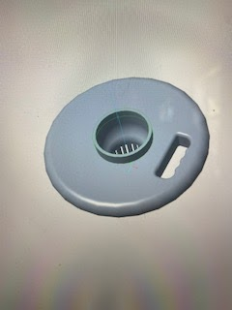

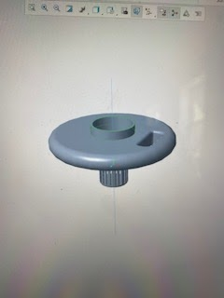

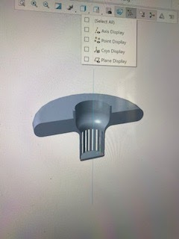

Part list:

1. Skimmer
2. End connector

Assembly Instructions:

1. Remove covering cap from top of pool
2. Remove old skimmer from recess hole
3. Place new skimmer into the hole
4. Wait for the skimmer to sink into position and wait 5 minutes
5. Check skimmer to see if water flows smoothly and quickly in a circular motion
6. Place cap back on recess hole

<https://www.skim-a-round.com/pages/setup>

Use and Assembly Maintenance Instructions:

1. Empty out contaminants caught in skimmer every 3 months (90 days) to prevent the skimmer from clogging
2. Please replace if any major cracks, holes or other forms of damage are present
3. Please replace entire skimmer annually

Part Maintenance Instructions and Recommendations:

1. Do not place product where it will induce impacts. This will weaken the material and cause the material to possibly crack.
2. Do not place the product in an environment with an extreme fluctuation in temperatures. This will cause the Chlorinator to expand and contract, and weaken the material, making the chlorinator prone to cracking.

Warranty Information:

Complementary 1 year parts and labor warranty. This warranty will apply to all parts and cover the entire labor for one year (365 days) after the purchase date. This warranty will come standard with purchase of the product.

Optional 2 year parts and labor warranty. This warranty will apply to all parts and cover the entire labor for two years (730 days) after the purchase date. The cost of this warranty is $19.99.

Optional 3 year parts and labor warranty. This warranty will apply to all parts and cover the entire labor for three years (1095 days) after the purchase date. The cost of this warranty is $25.99.

Competitor Warranty:

<https://www.pentair.com/en/knowledge-base/pool-spa-equipment/warranty.html>