Universal Pool Surface Skimmer

Table of Contents:

Assembly ...1-3

Maintenance ...4

Warranty Information ...5

Service Center ...6

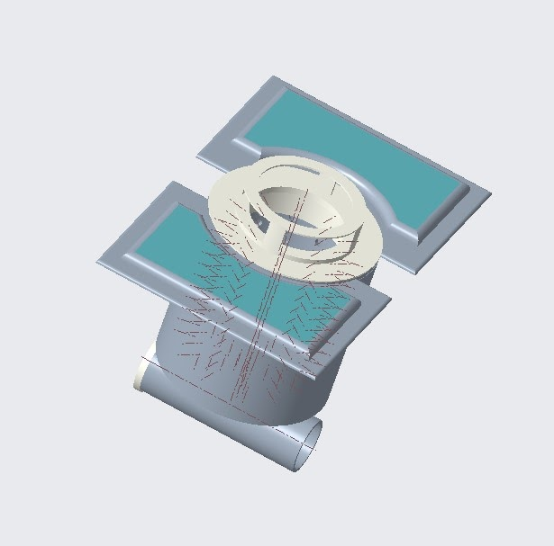

Assembly

- Basket Casing (1)

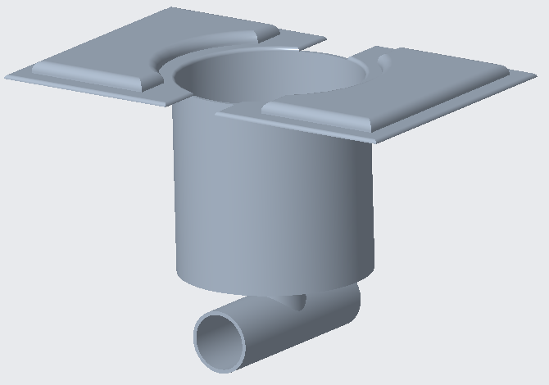

- Basket (1)
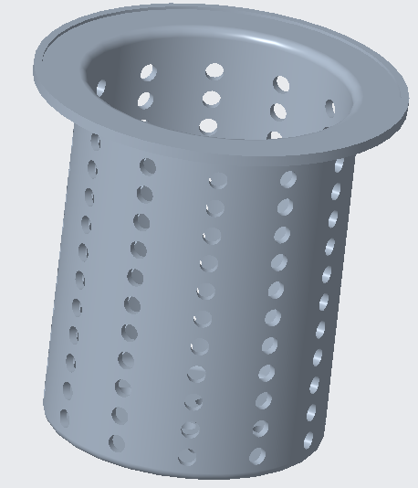

- Basket Top (1)
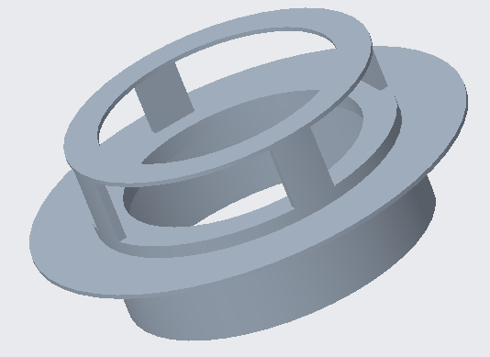

- Plug (1)

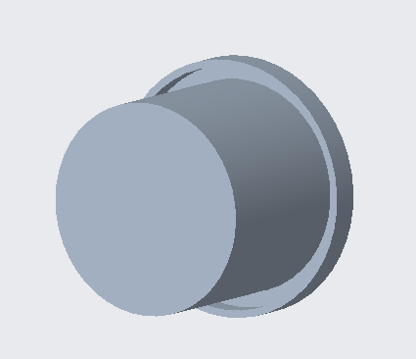
The Universal Pool Surface Skimmer Comes partially assembled in 4 main parts with no need for any tools and very little labor. If any of the main body pieces are to break, please look under warranty or service center for more information regarding replacement parts. A manual with instructions on how to receive replacement parts will be found there. The images above represent how the parts in the package will look upon arrival. The product is assembled by inserting the Basket (2) into the large, top opening in the Basket Casing (1), so that the opening of the basket is facing up. Next, the Basket Top (3) is placed on top of the Basket Casing (1) to enclose the Basket (2). If the user DOES NOT plan to use this along with a bottom skimmer, then insert the Plug (4) into one side of the tubing on the bottom of the skimmer. If any of the parts are cracked or scuffed upon arrival, we ask that you immediately contact us for an exchange, where we will cover any shipping costs.

Product overview
The surface skimmer sits just below water level, so that water and debris flow into it. There is a hose connected to the bottom and the sidewall skimmer to pull water thru to create suction. Also, the holes in the basket are tapered to increase water velocity.

Maintenance
The Universal Pool Skimmer requires minimal maintenance. Should the basket fill with debris, the top is to be removed then the basket is to be taken out of the casing. With the basket removed, dump contents into a waste bin or compost. Monthly, the skimmer should be disassembled and then cleaned with a hot water-bleach mixture and thoroughly rinsed before being reassembled and returned to a pool. During monthly maintenance, the skimmer is to be inspected for any cracks or defects. Should any piece of the skimmer show deficiencies, contact the Warranty and Claims department listed below for replacement parts.

Warranty Information

When you purchase the Universal Pool Skimmer, you will be asked about the warranty and insurance. You will be given insurance that extends to 5 months for free, but if you want to pay to provide better insurance and for a longer period, you must change the insurance before buying the product from us.

The Standard Warranty includes 5 months of regular maintenance on the universal pool skimmer, and you can exchange all damaged parts of the skimmer.

The Golden Warranty, 65$, You have a full year of periodic maintenance to the universal pool skimmer, and you can replace all damaged parts of the skimmer.

The Special Warranty, 250$, lasts 5 years with periodic maintenance to the skimmer, and you can replace the damaged parts of the skimmer. Special insurance customers can change the universal pool skimmer to the new version at a nominal price.

You can return or exchange the skimmer in only one circumstance, which is that there are manufacturing defects.

Service Center

Charlotte Pool Supply aims to provide a durable, long-lasting product that will please the customer. We believe that the customer comes first and any problems with our product should be resolved immediately and with the utmost care. If at any point in time you are upset with our product or service, please contact us via email or phone.

By Email: CharlottePoolSupply@gmail.com

By Phone: 1-800-CPS-UNCC
or
919-348-0596

Ordering Replacement Parts:

For any replacement parts, please contact us via email or phone at:

By Email: CharlottePoolSupply@gmail.com

By Phone: 1-800-CPS-UNCC
or
919-348-0596
Ordering/Picking up items

If you are looking to order directly from Charlotte Pool Supply and would like to pick up your parts, you can find us at the address below:

9330 Robert D. Snyder Rd, Charlotte, NC 28262
Office Hours: 9:00am-5:00pm, Monday-Saturday.

Zaire Lawrence
Email: Zlawren1@uncc.edu
John Fraello
Email: jfraello@uncc.edu
Hassan Almegda
Email: halmegad@uncc.edu
Jonathan Mendoza
Email: Jimulmen@uncc.edu

