**Skim and Swim**

**Table of Contents:**

**Assembly …. 1**

**Use & Maintenance …. 2**

**Warranty …. 3**

**Contact & Service Center Information …. 4**

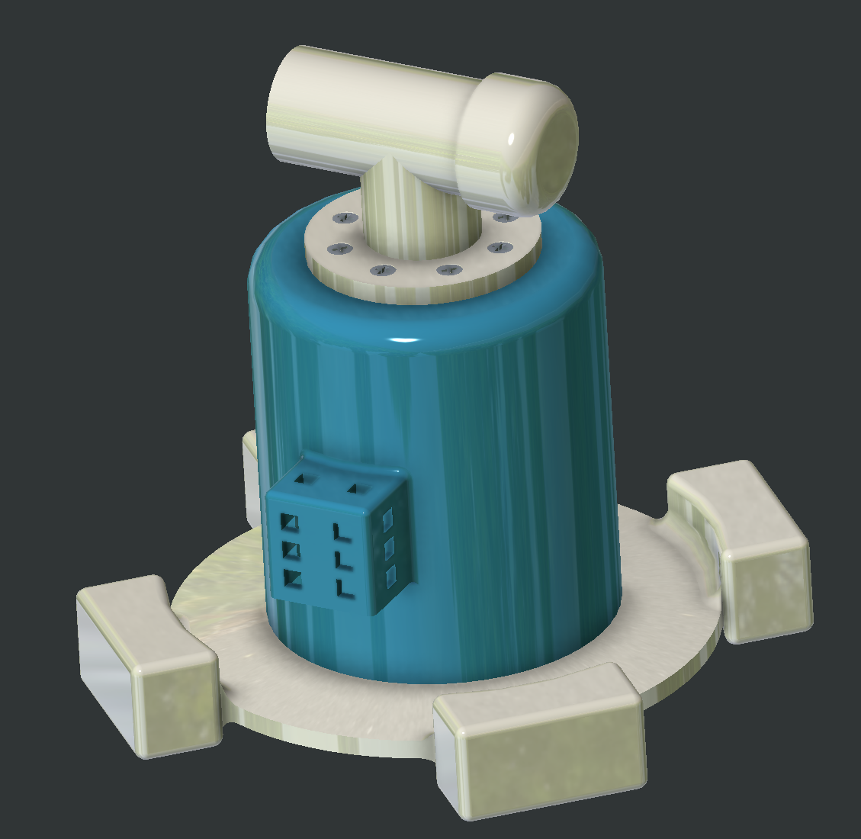

**Assembly**

The Skim and Swim comes completely preassembled with no need for tools or labor. If you wish to attach the secondary hose, simply remove the cover (see figure on page 2) and attach the secondary hose (sold separately). A screw driver is included for disassembly if required for cleaning. The chlorine tablet holder is placed on the side with ease of access. Simply place 1” tablet (sold separately) into side basket (see figure on page 2). Chlorine tablets are available through us but any 1” tablet will work with the product. If any part of the product breaks, please see the warranty or service center for information on how to order replacement parts. The Skim and Swim comes in packaging as seen above, if for any reason it does not arrive as shown, please reship to JJH Pool Supply and notify us as soon as possible and we will cover the shipping costs. – JJH Pool Supply

**Use & Maintenance**

The Skim and Swim is simple and easy to use. Place the Skim and Swim anywhere in your pool and connect the vacuum hose (sold separately) to the port onto the bottom T-pipe. Install 1” chlorine tablets (sold separately) into the chlorine tablet basket that is located on the side of the base. Sit back and let the Skim and Swim clean your pool of debris as it floats. For cleaning, remove skimmer from pool and disconnect vacuum line, remove debris from inside basket, and place skimmer back into pool and reconnect the vacuum line. If debris has made it past the lid, remove the top 8 machine screws with included screw driver from the lid and clean out base. For chlorine tablet basket, simply wash out residual chlorine and install new tablet. For maintenance, please look over the Warranty page for repair information and below is a list of replacement parts and their prices.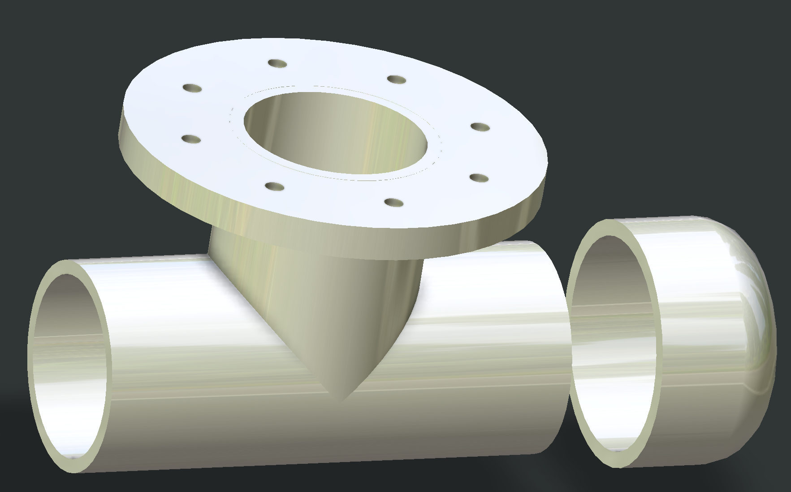

Chlorine Basket Holder Vacuum Line with cap

* Replacement Parts:
  + Skimmer body: $33.99
  + Skimmer lid with floats: $43.99
  + Skimmer vacuum valve: $11.99
  + Skimmer vacuum valve cap: $6.99
  + 8-32 machine screws (16 required): $0.50 each
  + 1” chlorine tablets (50 pack): $14.99
* Ordering: To place an order please contact us via email or phone number during regular business hours. If ordering after regular business hours, please contact the company email and we will respond first thing the next morning. THANK YOU FOR YOUR BUSINESS

**Warranty**

Each purchase of Skim and Swim from JJH Pool Supplies comes with a lifetime warranty. The warranty is voided if **1) the skimmer has had parts installed that are not supplied by JJH Pool Supplies, 2) the skimmer is damaged by improper use, 3) individual components are damaged from improper use**. Warranty for this and all JJH Pool Supplies products are addressed on a case-by-case basis and you may be denied warranty coverage for reasons that are not stated above.

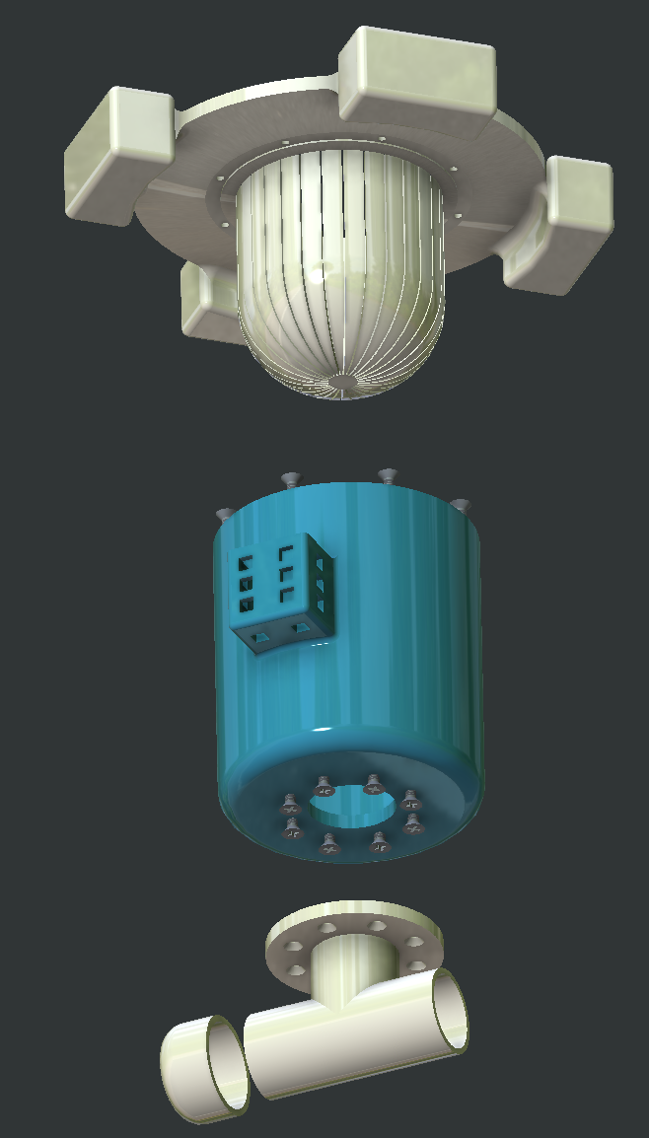

**Contact & Service Center Information**

At JHH Pool Supply, your satisfaction is our top priority. If you have any questions about our pool products or services, feel free to get in touch with us. Our dedicated team of experts is here to assist you and provide the best solutions for all your pool needs. You can reach us through phone or email during our business hours. We are always happy to help and look forward to hearing from you. Don't hesitate to contact JHH Pool Supply for any inquiries or assistance with your pool maintenance and equipment requirements.

Phone: 1-800-JHH-POOL

Email: jhhpoolsSupplies@gmail.com

Business Hours: Monday to Friday, 9:00 AM - 5:00 PM

**Service Center Location:**

9330 Robert D. Snyder Rd, Charlotte, NC 28223

DUKE 259

**Team Contact:**

Lead Product Designer; Jacob Kingsbury: jkingsb1@uncc.edu

Web Page Designer; Jairo Morales: jmoral28@uncc.edu

Warranty and HR Manager; Henry Kelleher: hkellehe@uncc.edu