***The Vault***

by

Travel Containers Inc

**User Manual**

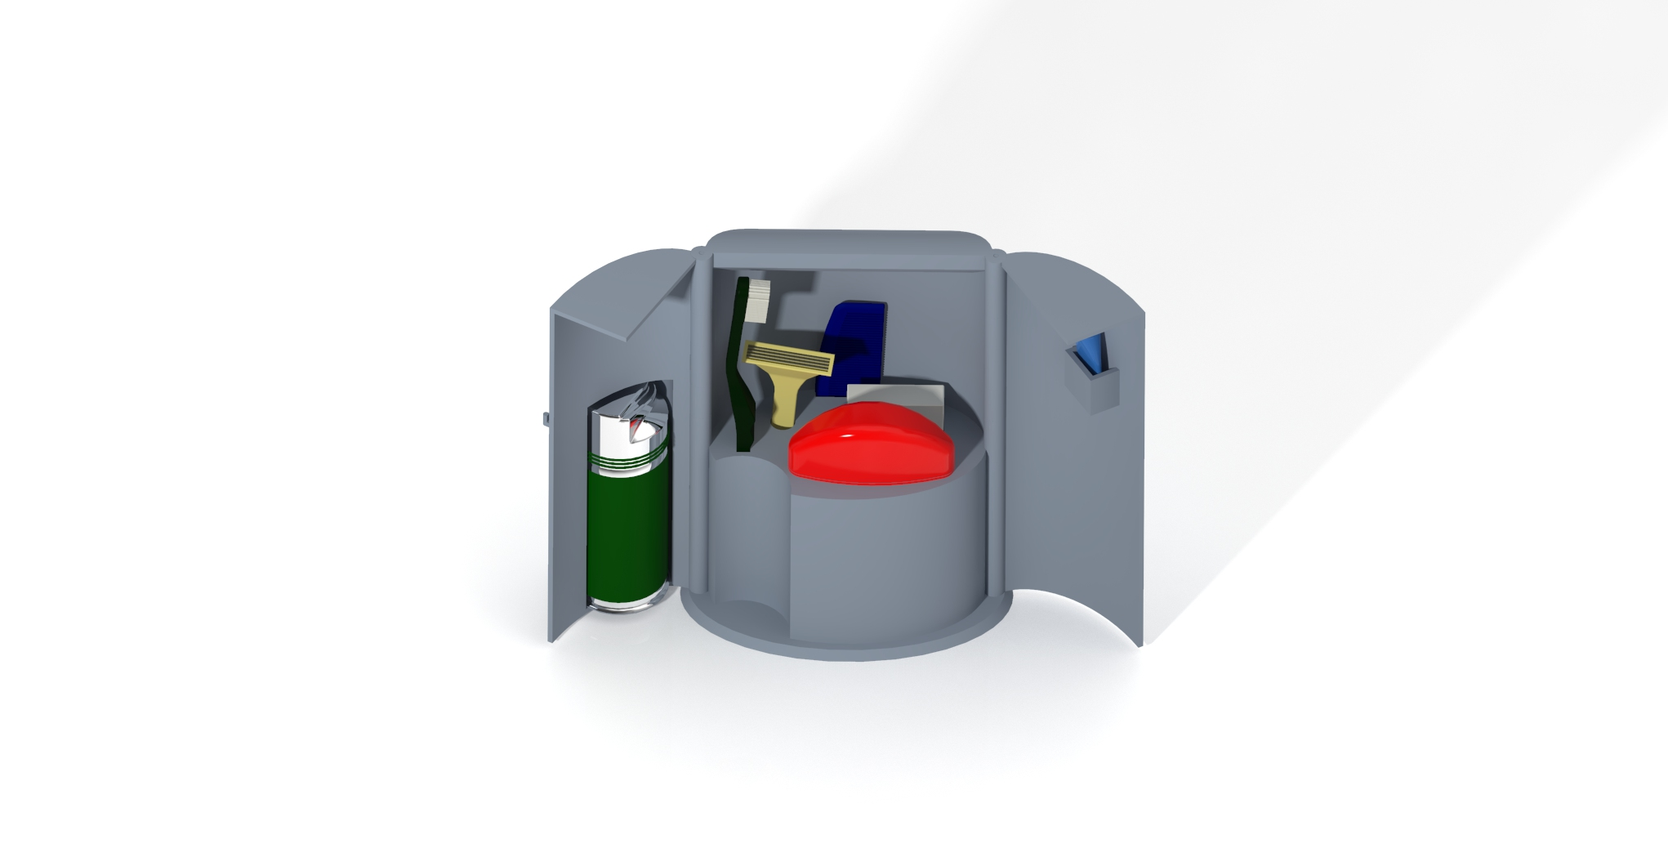

Please refer to this manual for directions on how to operate *The Vault*.

***The Vault* User Manual**

**Table of Contents**

Safety Warnings…………………………………………………………………………………2

Assembly…………………………………………………………………………………………3

How to Use………………………………………………………………………………………6

Care and Maintenance………………………………………………………………………….8

Warranty…………………………………………………………………………………….……9

Service Center…………………………………………………………………………………10

**Safety Warnings**

[](https://www.bing.com/images/search?q=Warning%20Triangle&FORM=IQFRBA&id=592DC0FD79EEAD41B5932C032A6723672AF13773)

**Warning: Choking Hazard**

The pins that hold the doors connected to the base of *The Vault*, could be a choking and eye hazard when putting together. Please keep out of reach of children during assembly.



**Warning: Pinch point**

Keep hands clear of any pinch points when closing the doors.

**Assembly**

**Note: *The Vault* comes fully assembled from the factory. You should not need to assemble or disassemble *The Vault*. The following instructions are for your reference only**

Parts Included:

1. *The Vault* Base
2. Left door with shaving cream holder
3. Right door with toothpaste holder
4. Pins (2)
5. Lock (attached to right door)

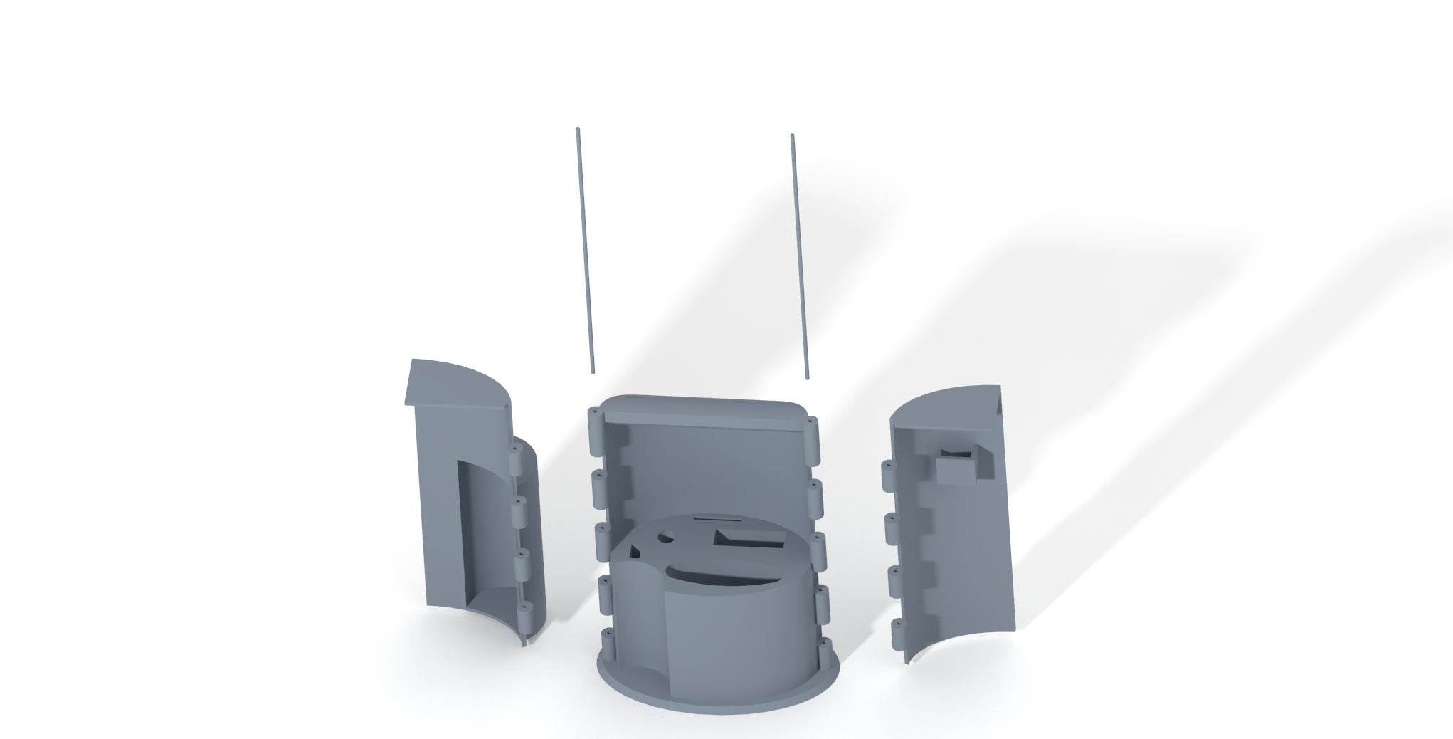

Assembly Steps:

1. Place the Base in an upright position with the opening facing you (as pictured above).
2. Align the hinge of the left door with the hinge on the left side of the base.
3. Slide one of the hinge pins through the top of the holes on the base and door. (DO NOT HAMMER, make sure the pin enters the hinges smoothly and is secured all the way down.) Push the pin through until it meets the bottom of the base or is flush with the top.
4. Repeat steps 2 and 3 for the right side door
5. Once both doors are properly attached to the hinges, close the two doors towards the center of the base.
6. Turn the front latch down to secure the doors shut.
7. To open *The Vault*, simply lift the latch and open the doors.

Door Open Position:

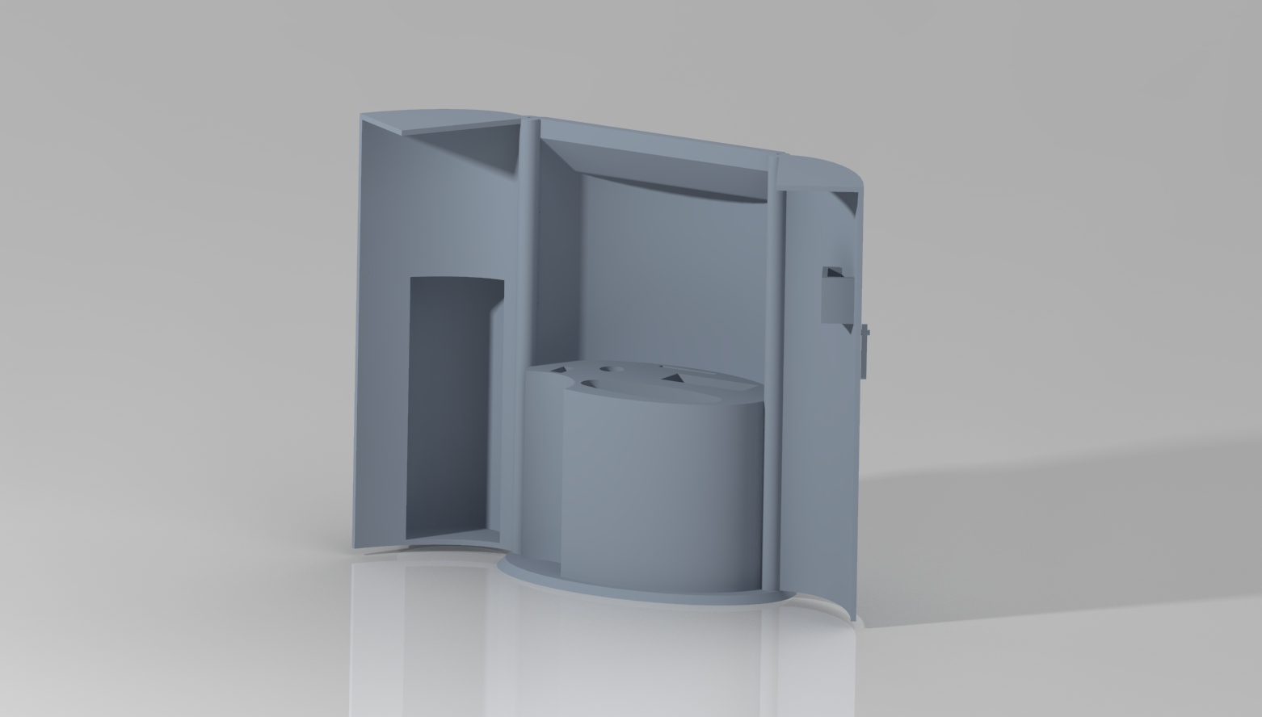

Door Closed Unlocked Positions:

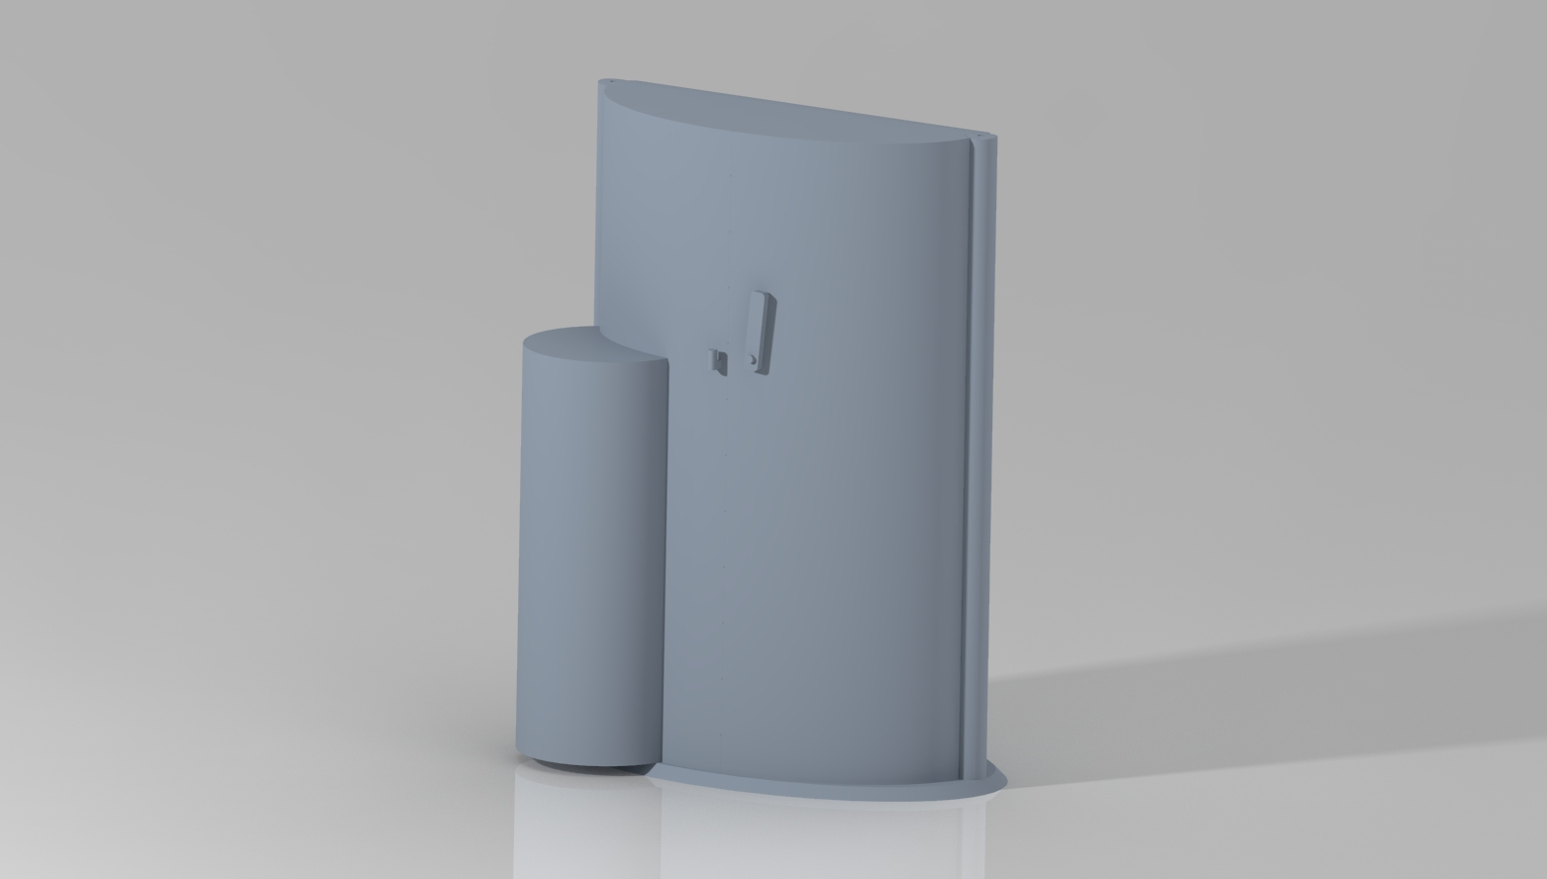

Door Closed Locked Positions:

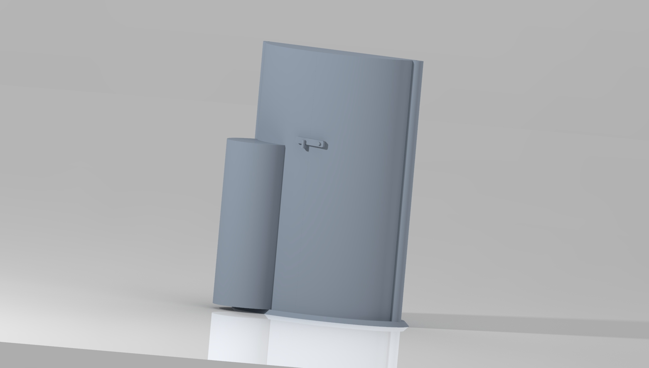

**How to Use**

*The Vault* is specifically designed to house 7 different toiletry items:

1. Shaving Cream
2. Toothbrush
3. Toothpaste
4. Razor
5. Comb
6. Deodorant
7. Floss

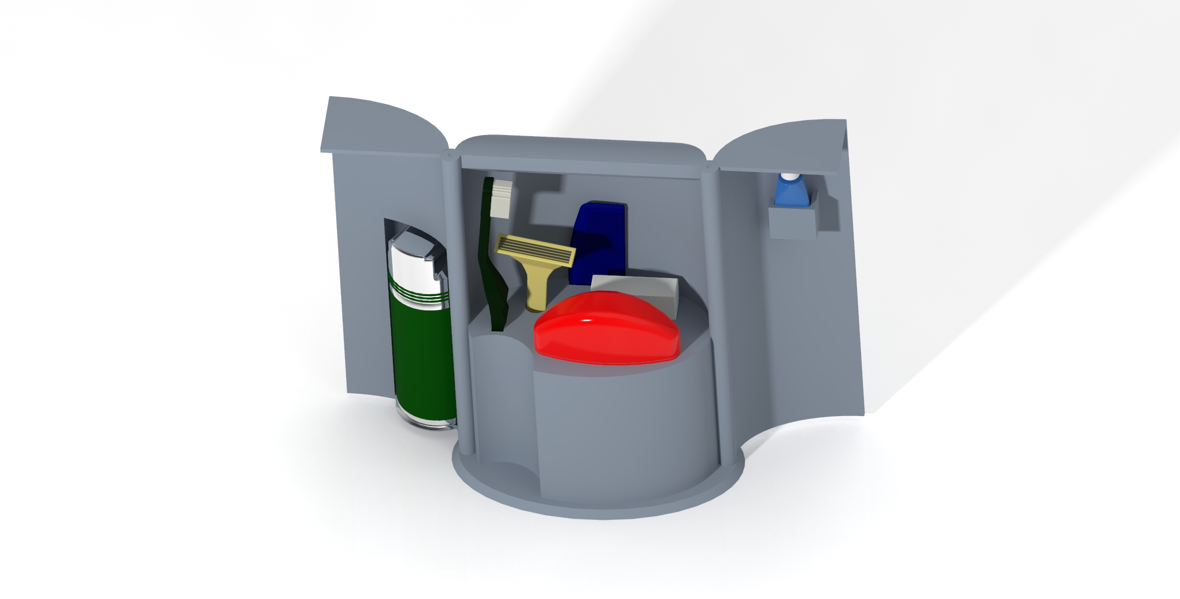

The following diagram shows where each item is stored.

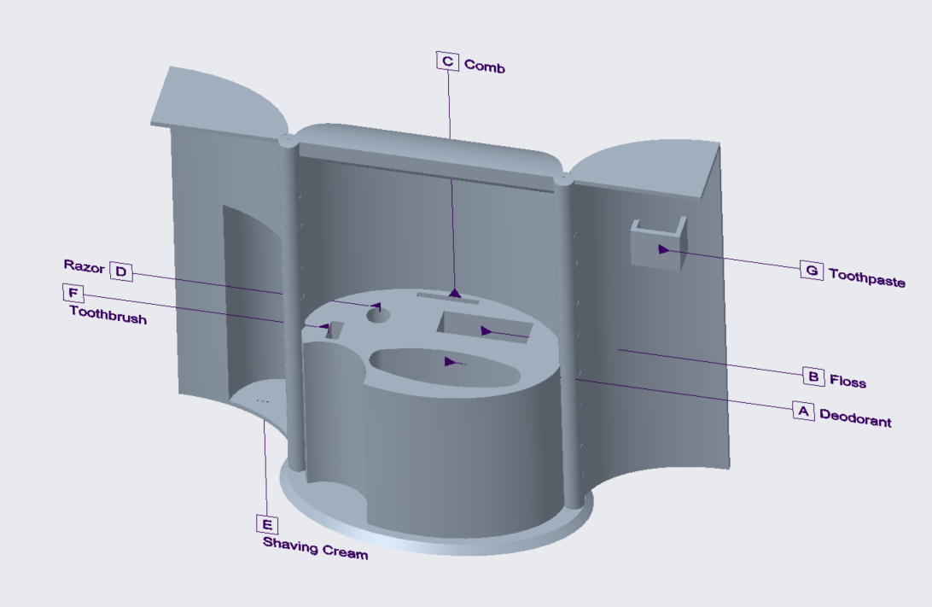

**Directions for use**

1. When fully assembled, open *The Vault* by lifting the latch from closed position to open.
2. Open *The Vault’s* doors.
3. Keep *The Vault* right side up, as turning *The Vault* upside down may cause possessions inside *The Vault* to fall out.
4. Place possessions inside *The Vault’s* premade sections.
5. Close *The Vault’s* doors and latch the doors closed for secure containment during travel.
6. Upon arrival at destination, place the vault with the large flat base down on the counter.
7. Unlock the doors and open.
8. Your *Vault* is now ready to serve as a stand to keep your items away from “unclean” public counters.
9. When leaving, return all items to their proper place, close the doors, lock, and pack in luggage.

**Care and Maintenance**

*The Vault* is not a toy. Only use *The Vault* for its designed purpose. Do not throw.

**Cleaning**

*The Vault* is made of high quality, durable plastic; therefore it is dishwasher safe.

1. Remove all items from *The Vault*.
2. Ensure the doors are open.
3. Place upside down in the top rack of the dishwasher, so that the holes are facing down for water to drain from.
4. Load the rest of your dishwasher.
5. Run the dishwasher according to the manufacturer's instructions.
6. After the cycle, remove *The Vault* from the dishwasher and wipe off any remaining moisture.

**Warranty**

*The Vault* is backed by a 90-day limited warranty.

If the product is defective upon arrival, please send it back and you will receive a new one.

If, under normal use, your *Vault* fails or breaks within 90 days of purchasing, please email us (see service center) and you will receive a full replacement.

**The warranty does not cover damage caused by abuse, negligence, or misuse.**

**Please read the entire user manual to fully understand how to utilize and care for *The Vault.* Failure to do so, may result in the invalidation of your warranty.**

**Service Center**

Website:

<https://webpages.charlotte.edu/kvanhor7/the_vault.html>

Phone Number:

704-00-VAULT (82858)

Address:

9201 University City Blvd

Charlotte, NC 28223

Our Team:

**Kyle VanHorn**

[kvanhor7@uncc.edu](mailto:kvanhor7@uncc.edu)

**Adam Antolick**

[aantolic@uncc.edu](mailto:aantolic@uncc.edu)

**Nazim Sait**

[nsait3@uncc.edu](mailto:nsait3@uncc.edu)

**Colton Powell**

[powel67@uncc.edu](mailto:powel67@uncc.edu)