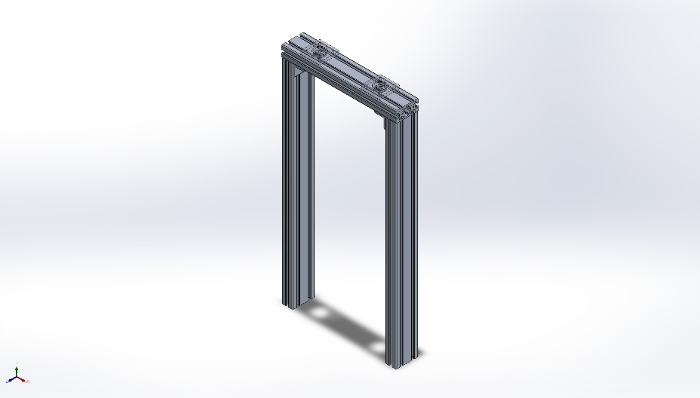
  Simulation of V2_Tensile_tester_assemlby
  Date: Wednesday, April 22, 2026
  Designer: Solidworks
  Study name: Static 3 from [Static 2 from [Static 1]]
  Analysis type: Static
  Table of Contents
  Description 1
  Assumptions 2
  Model Information 3
  Study Properties 6
  Units 6
  Material Properties 7
  Loads and Fixtures 8
  Connector Definitions 9
  Interaction Information 9
  Mesh information 10
  Sensor Details 11
  Resultant Forces 12
  Beams 12
  Study Results 13
  Conclusion 15

Description
No Data

Assumptions

Model Information

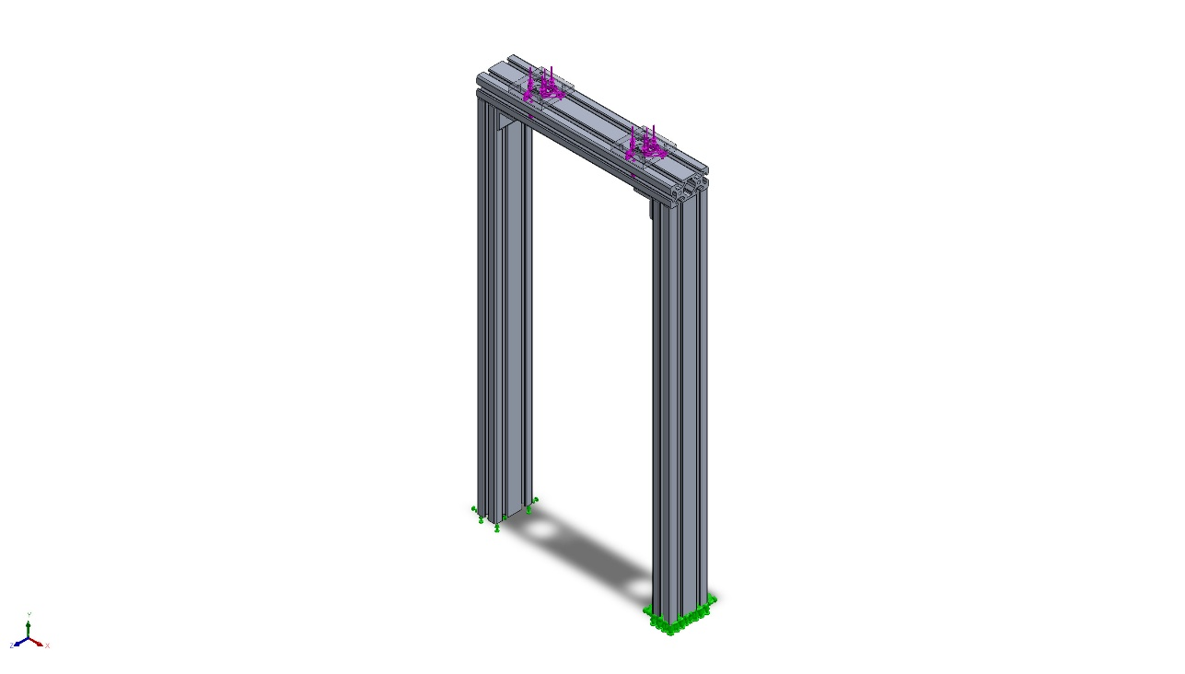
Model name: V2_Tensile_tester_assemlby
Current Configuration: Default
Solid Bodies
Document Name and Reference | Treated As | Volumetric Properties | Document Path/Date Modified
Cut-Extrude4  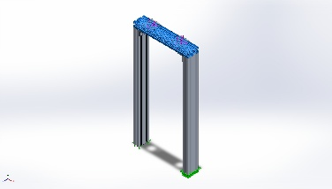 | Solid Body | Mass:1.63416 kg  Volume:0.000605264 m^3  Density:2,699.91 kg/m^3  Weight:16.0147 N | C:\Schoolwork UNCC\Semester Work\4Spring 2026\Design Projects Lab I MEGR-2156\A11\16.14in_cut3.SLDPRT  Apr 22 18:47:18 2026
Cut-Extrude1  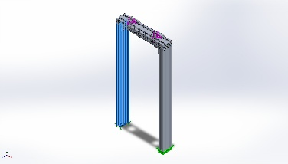 | Solid Body | Mass:3.19256 kg  Volume:0.00118243 m^3  Density:2,700 kg/m^3  Weight:31.2871 N | C:\Schoolwork UNCC\Semester Work\4Spring 2026\Design Projects Lab I MEGR-2156\A11\2.5ft_cut1.SLDPRT  Apr 22 18:47:18 2026
Cut-Extrude2  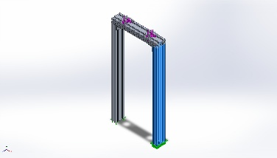 | Solid Body | Mass:3.19256 kg  Volume:0.00118243 m^3  Density:2,700 kg/m^3  Weight:31.2871 N | C:\Schoolwork UNCC\Semester Work\4Spring 2026\Design Projects Lab I MEGR-2156\A11\2.5ft_cut2.SLDPRT  Apr 22 18:47:18 2026
Cut-Extrude3  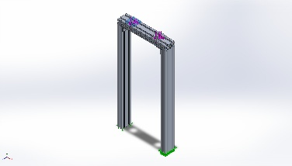 | Solid Body | Mass:0.103139 kg  Volume:3.81995e-05 m^3  Density:2,700 kg/m^3  Weight:1.01076 N | C:\Schoolwork UNCC\Semester Work\4Spring 2026\Design Projects Lab I MEGR-2156\A11\Motor Mount.SLDPRT  Apr 22 18:47:18 2026
Cut-Extrude3  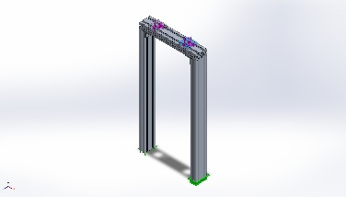 | Solid Body | Mass:0.103139 kg  Volume:3.81995e-05 m^3  Density:2,700 kg/m^3  Weight:1.01076 N | C:\Schoolwork UNCC\Semester Work\4Spring 2026\Design Projects Lab I MEGR-2156\A11\Motor Mount.SLDPRT  Apr 22 18:47:18 2026
Fillet2  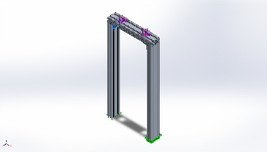 | Solid Body | Mass:0.0869092 kg  Volume:3.21886e-05 m^3  Density:2,700 kg/m^3  Weight:0.85171 N | C:\Schoolwork UNCC\Semester Work\4Spring 2026\Design Projects Lab I MEGR-2156\A11\grainger-5JRU7\Part8.SLDPRT  Apr 22 18:41:13 2026
Fillet2  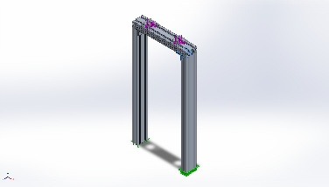 | Solid Body | Mass:0.0869092 kg  Volume:3.21886e-05 m^3  Density:2,700 kg/m^3  Weight:0.85171 N | C:\Schoolwork UNCC\Semester Work\4Spring 2026\Design Projects Lab I MEGR-2156\A11\grainger-5JRU7\Part8.SLDPRT  Apr 22 18:41:13 2026

Study Properties
Study name | Static 3 from [Static 2 from [Static 1]]
Analysis type | Static
Mesh type | Solid Mesh
Thermal Effect: | On
Thermal option | Include temperature loads
Zero strain temperature | 298 Kelvin
Include fluid pressure effects from SOLIDWORKS Flow Simulation | Off
Solver type | Automatic
Inplane Effect: | Off
Soft Spring: | Off
Inertial Relief: | Off
Incompatible bonding options | Automatic
Large displacement | Off
Compute free body forces | On
Friction | Off
Use Adaptive Method: | Off
Result folder | SOLIDWORKS document (C:\Schoolwork UNCC\Semester Work\4Spring 2026\Design Projects Lab I MEGR-2156\A11)

Units
Unit system: | SI (MKS)
Length/Displacement | mm
Temperature | Kelvin
Angular velocity | Rad/sec
Pressure/Stress | N/m^2

Material Properties
Model Reference | Properties | Components
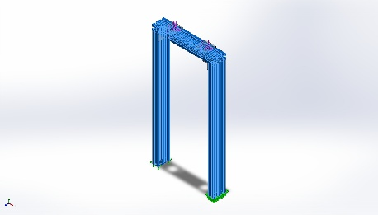 |  | SolidBody 1(Cut-Extrude4)(16.14in_cut3-1),  SolidBody 1(Cut-Extrude1)(2.5ft_cut1-1),  SolidBody 1(Cut-Extrude2)(2.5ft_cut2-1)
  Name: | 6063-T5
  Model type: | Linear Elastic Isotropic
  Default failure criterion: | Unknown
  Yield strength: | 1.45e+08 N/m^2
  Tensile strength: | 1.85e+08 N/m^2
  Elastic modulus: | 6.9e+10 N/m^2
  Poisson's ratio: | 0.33
  Mass density: | 2,700 kg/m^3
  Shear modulus: | 2.58e+10 N/m^2
  Thermal expansion coefficient: | 2.34e-05 /Kelvin
Curve Data:N/A
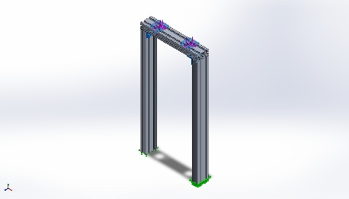 |  | SolidBody 1(Cut-Extrude3)(Motor Mount-1),  SolidBody 1(Cut-Extrude3)(Motor Mount-2),  SolidBody 1(Fillet2)(Part8-1),  SolidBody 1(Fillet2)(Part8-2)
  Name: | 1060 Alloy
  Model type: | Linear Elastic Isotropic
  Default failure criterion: | Unknown
  Yield strength: | 2.75742e+07 N/m^2
  Tensile strength: | 6.89356e+07 N/m^2
  Elastic modulus: | 6.9e+10 N/m^2
  Poisson's ratio: | 0.33
  Mass density: | 2,700 kg/m^3
  Shear modulus: | 2.7e+10 N/m^2
  Thermal expansion coefficient: | 2.4e-05 /Kelvin
Curve Data:N/A

Loads and Fixtures
Fixture name | Fixture Image | Fixture Details
Fixed-1 | 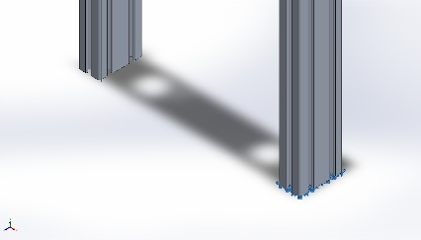
  Entities: | 2 face(s)
  Type: | Fixed Geometry
Resultant Forces
Components | X | Y | Z | Resultant
Reaction force(N) | -0.0638309 | 3,999.99 | 4.47929 | 3,999.99
Reaction Moment(N.m) | 0 | 0 | 0 | 0

Load name | Load Image | Load Details
Force-1 | 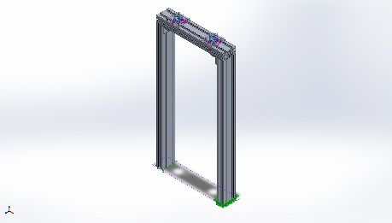
  Entities: | 4 face(s), 1 plane(s)
  Reference: | Top Plane
  Type: | Apply force
  Values: | ---, ---, -1,000 N
Torque-1 | 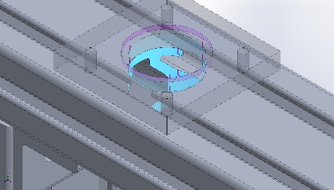
  Entities: | 2 face(s)
  Reference: | Face< 1 >
  Type: | Apply torque
  Value: | 5.408 N.m
Torque-2 | 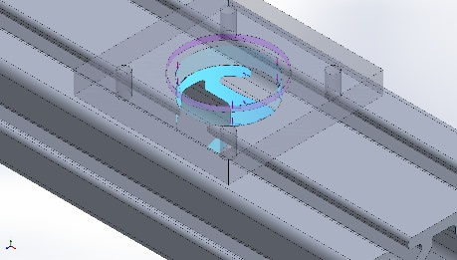
  Entities: | 2 face(s)
  Reference: | Face< 1 >
  Type: | Apply torque
  Value: | 5.408 N.m

Connector Definitions
No Data

Interaction Information

Interaction | Interaction Image | Interaction Properties
Global Interaction | 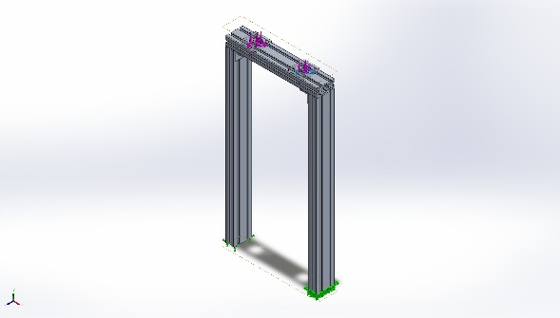
  Type: | Bonded
  Components: | 1 component(s)
  Options: | Independent mesh

Mesh information
Mesh type | Solid Mesh
Mesher Used: | Blended curvature-based mesh
Jacobian points for High quality mesh | 16 Points
Maximum element size | 1.2988 in
Minimum element size | 0.0649401 in
Mesh Quality | High
Remesh failed parts independently | Off
Reuse mesh for identical parts in an assembly (Blended curvature-based mesher only) | Off

Mesh information - Details
Total Nodes | 3951515
Total Elements | 2521841
Maximum Aspect Ratio | 10.154
% of elements with Aspect Ratio < 3 | 97.4
Percentage of elements with Aspect Ratio > 10 | 3.97e-05
Percentage of distorted elements | 0
Time to complete mesh(hh;mm;ss): | 00:00:42
Computer name: | LUKE_LAPTOP

Mesh Quality Plots
Name | Type | Min | Max
Quality1 | Mesh | - | -
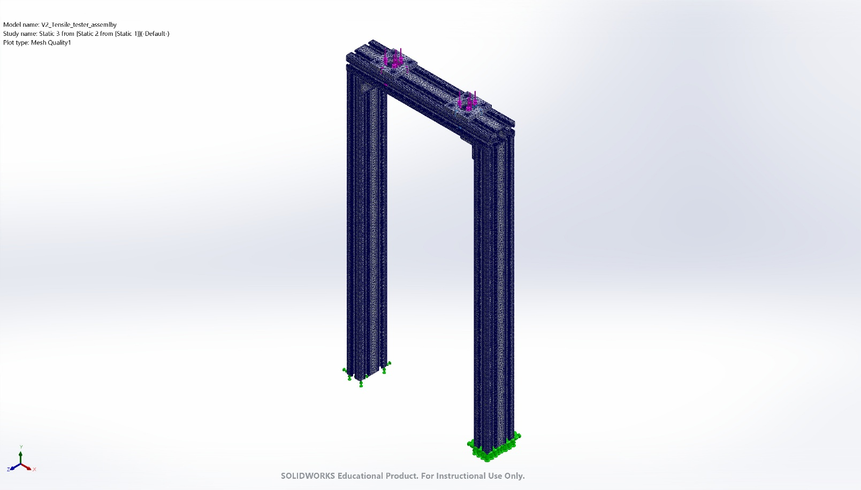
V2_Tensile_tester_assemlby-Static 3 from [Static 2 from [Static 1]]-Quality-Quality1

Sensor Details
No Data

Resultant Forces

Reaction forces
Selection set | Units | Sum X | Sum Y | Sum Z | Resultant
Entire Model | N | -0.0638309 | 3,999.99 | 4.47929 | 3,999.99

Reaction Moments
Selection set | Units | Sum X | Sum Y | Sum Z | Resultant
Entire Model | N.m | 0 | 0 | 0 | 0

Free body forces
Selection set | Units | Sum X | Sum Y | Sum Z | Resultant
Entire Model | N | -0.205332 | 0.447755 | -0.471826 | 0.682103

Free body moments
Selection set | Units | Sum X | Sum Y | Sum Z | Resultant
Entire Model | N.m | 0 | 0 | 0 | 1e-33

Beams
No Data

Study Results

Name | Type | Min | Max
Stress1 | VON: von Mises Stress | 2.526e+02N/m^2  Node: 478 | 3.680e+07N/m^2  Node: 633373
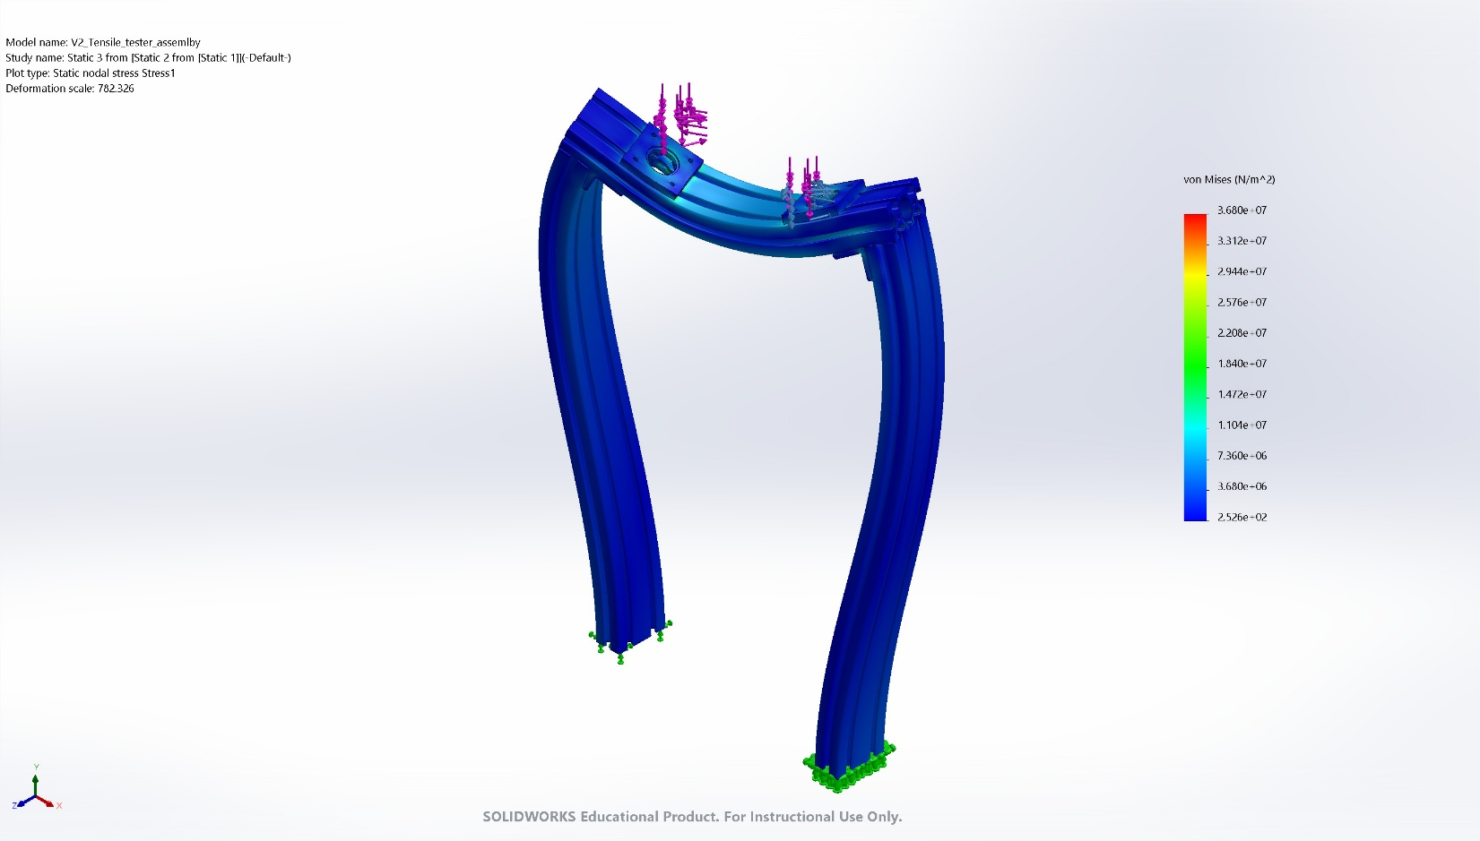
V2_Tensile_tester_assemlby-Static 3 from [Static 2 from [Static 1]]-Stress-Stress1

Name | Type | Min | Max
Displacement1 | URES: Resultant Displacement | 0.000e+00mm  Node: 776162 | 1.156e-01mm  Node: 2673588
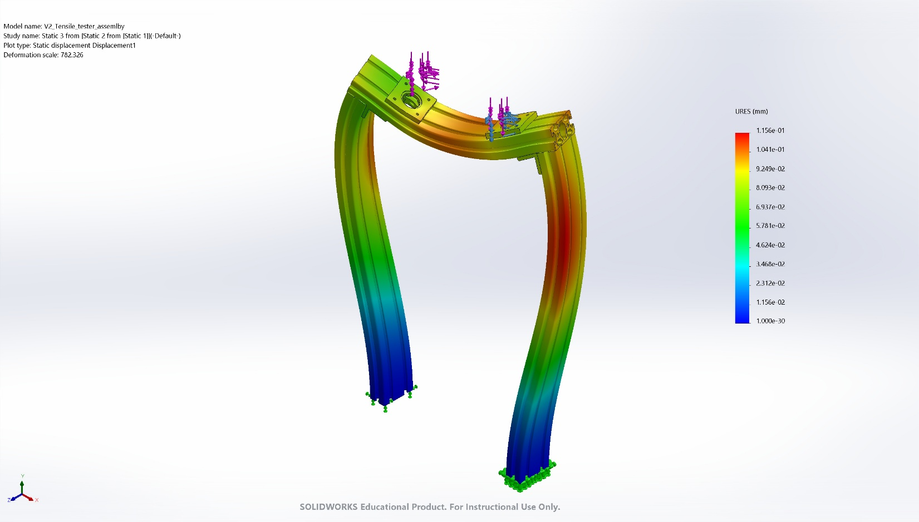
V2_Tensile_tester_assemlby-Static 3 from [Static 2 from [Static 1]]-Displacement-Displacement1

Name | Type | Min | Max
Factor of Safety1 | Automatic | 1.362e+00  Node: 3950109 | 4.000e+00  Node: 1
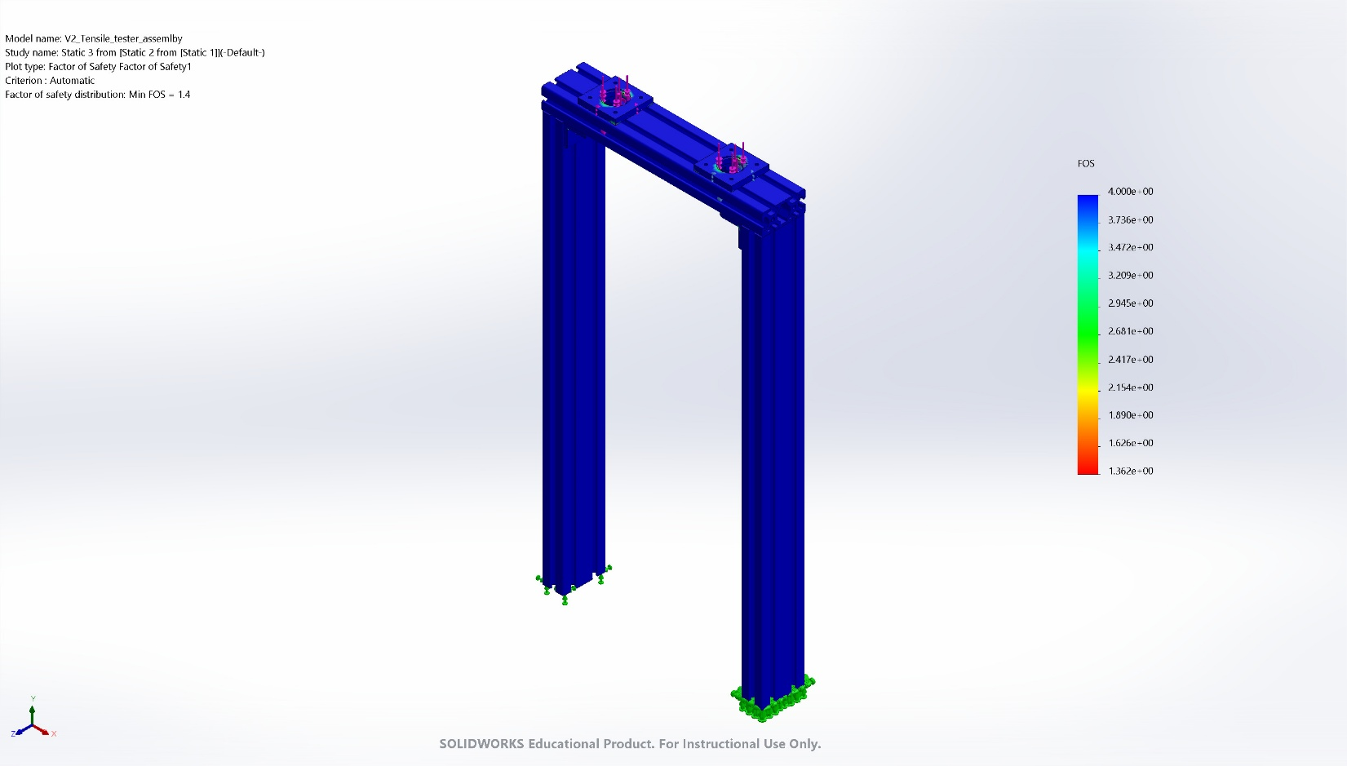
V2_Tensile_tester_assemlby-Static 3 from [Static 2 from [Static 1]]-Factor of Safety-Factor of Safety1

Conclusion

