

The verticase

Designed by: William Elder, Matt Herian, Jordan Madren, and Dontae Green



UNC Charlotte

9201 University City Boulevard

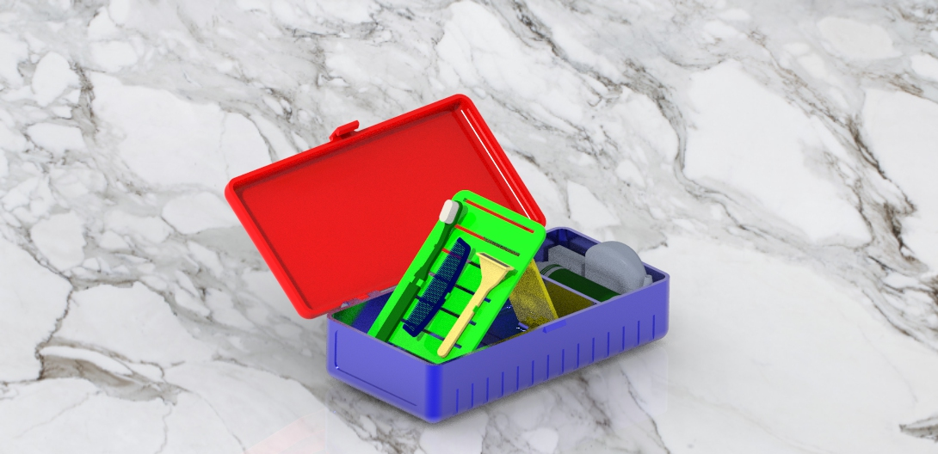

the verticase

Table of Contents

* Parts List-…………………………………….pg. 3
* Assembly Instructions-………………..pg. 4&5
* Usage and Maintenance-…………....pg. 6
* Maintenance Recommendations-..pg. 7
* Warranty Information-…………………pg. 8
* Service Center-…………………………….pg. 9

Parts List

Shown below are images providing description of the individual parts the Verticase is comprised of.

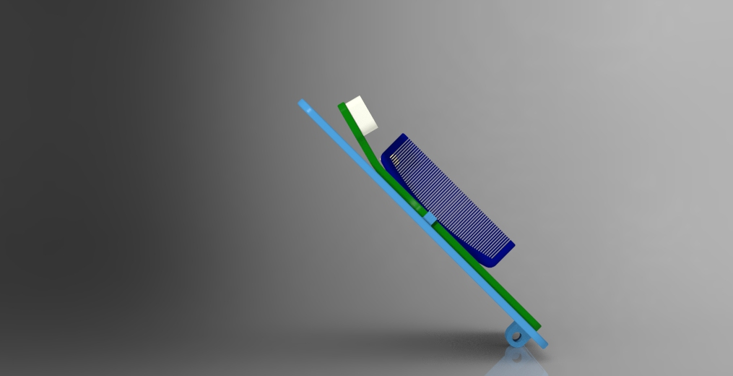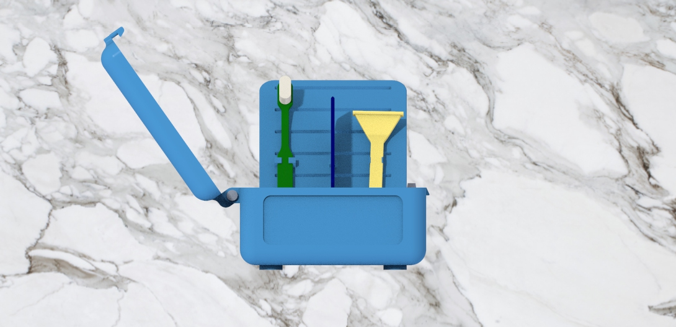

Shown here is a pin connecting the lid to the body

Shown here is the lid for the Verticase

This is the stabilizer and its hinge hole

Here, is a view of a hinge which allows the stand to be collapsable

Shown here is closer look at the stand and stabilizer along with their individual features

Shown here are the clips that will secure items such as a toothbrush, razor, or comb

Shown here is the stand for the Verticase

Shown here is the body of the Verticase

Assembly Instructions

* Firstly, place the case lid on top of the case body
* Next, align the hinges of the case lid with the hinges on the case body
* Then, insert one of three provided pins through all hinge holes that are now aligned
* Check to see if the lid will open apart from the body
* Next, place the stabilizing piece into the body of the case and align its hinge hole with the hole closest to the divider
* Insert the second of the three pins supplied to connect the stabilizer to the body of the case
* Next, place the stand on top of the stabilizer and align its hinge hole with the remaining hinge hole in the body of the case.
* Insert the last of the pins provided to connect the stand to the body.
* Your Verticase is now fully assembled and it is advised at this point to test if all hinges are functioning properly. If they are not, please contact one of our customer service representatives for assistance.

Visual Assembly



Here the top has been aligned with the body and the pin has been inserted through the hinges

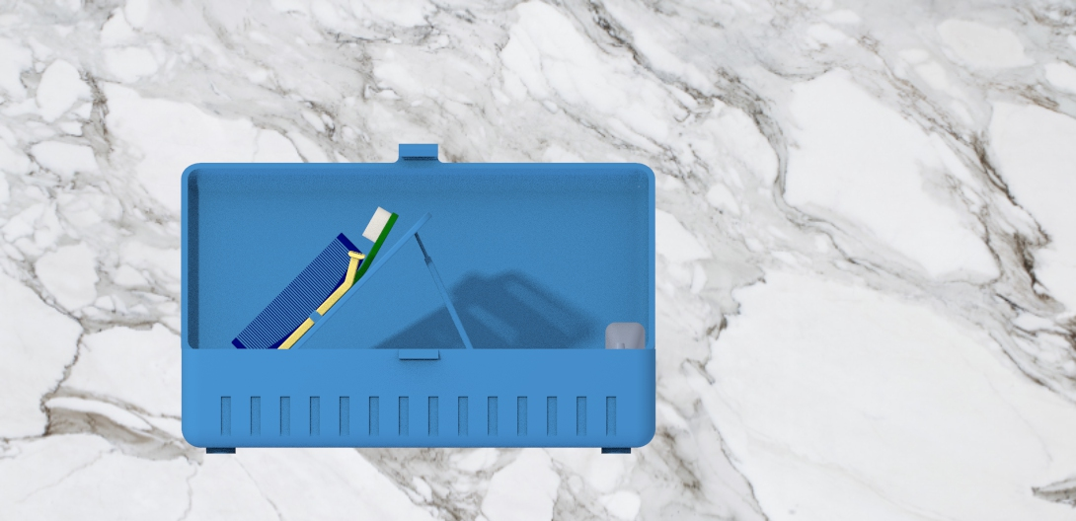

Here the stand is resting against the stabilizer

Use and Maintenance

* Once assembled, you should find within the case a divider for a separate compartment, the stand with three sets of clips, and the stabilizing piece.
* 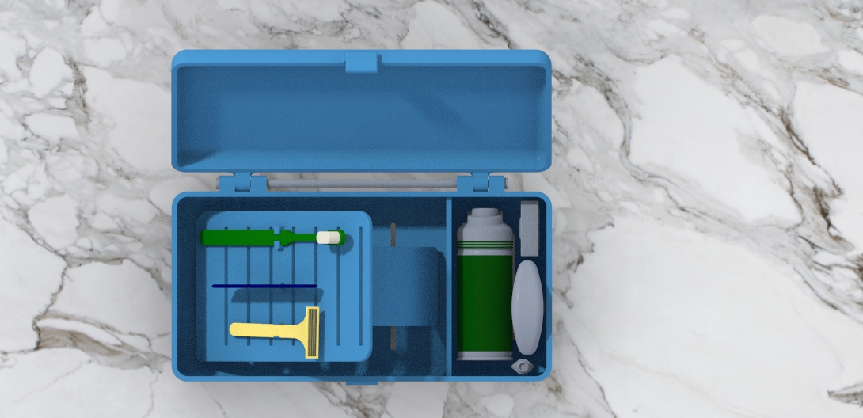To raise the stand, simply lift it, raise the stabilizer, and rest the stand against it.
* These clips were designed to hold in place a toothbrush, razor, or perhaps a comb.
* We hope that you find our product simple, but of great convenience

Part Maintenance

To ensure the longevity of your Verticase, it is recommended that routine maintenance and cleaning is conducted. To thoroughly clean The Verticase, disassemble the case by removing the pins from their respective hinges and take out the remaining stabilizer along with the stand from the body. Then, use a dish soap with water to wipe down the inside of the top, body, stand, and stabilizer of the case. While disassembled, check the hinges of the top, body, stand, and stabilizer to ensure there has not been any residue trapped between them. If there is, to clean them use a cue-tip with some isopropyl alcohol and rub the cue-tip along the inside of the hinge holes.

Warranty Information

The Verticase is protected under warranty up to a year after purchase.

Warranty will not be upheld under the following circumstances:

* Failure to provide proof of purchase
* The product was purchased and used outside the warranty coverage timespan
* Faulty use of individual parts
* Recognizable modifications to the product
* Exposure to extreme environmental conditions
* 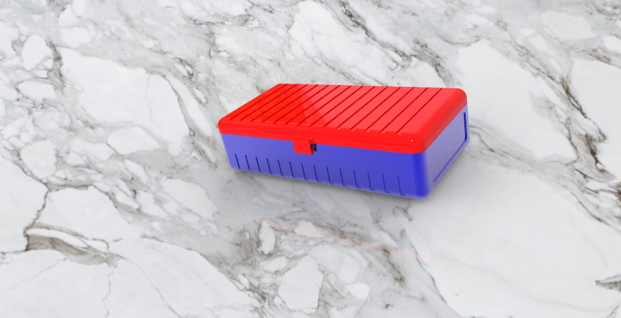Attempted use of the product outside its intended functionality

Service Center

We, the creators of the Verticase, hope to provide convenience and simplicity to the consumer and listed below are a few resources that can provide some assistance and answer some frequently asked questions about our product.

**Website**

<https://webpages.charlotte.edu/lgreen81/FinalProject.html>

**Engineer Contact Information**

**Jordan Madren Dontae Green**

Email: [jmadren@uncc.edu](mailto:jmadren@uncc.edu) Email: [Lgreen81@uncc.edu](mailto:Lgreen81@uncc.edu)

**Matt Herian William Elder**

Email: [mherian@uncc.edu](mailto:mherian@uncc.edu) Email: [welder3@uncc.edu](mailto:welder3@uncc.edu)

**Address**

9201 University City Boulevard

Charlotte, NC 28223