RoundTrip
by
Roam Ready ©

User Manual
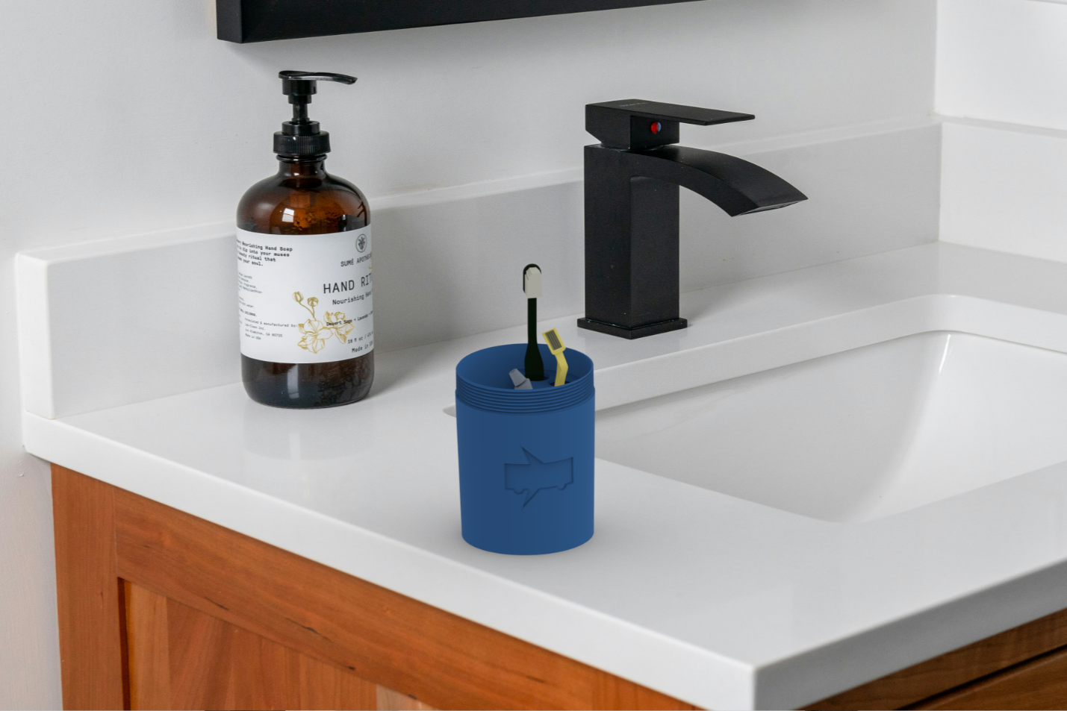

RoundTrip

Table of Contents

Assembly 3
Use 6
Maintenance 9
Warranty 10
Service Center 11

Assembly
The Assembly process for our RoundTrip model is very easy and accessible for users of all reaches.
- Our product is made up of two sub-sections, the base with the holder for all of your transportation-safe travel needs, and the lid to hold it all together. It’s that simple! There is more on each section in the following pages.


Base
- The base, or the intended bottom of the product, has 3 different sections of various sizes for all your toiletry needs, a 4-inch total diameter bottom, and a 5-inch height.
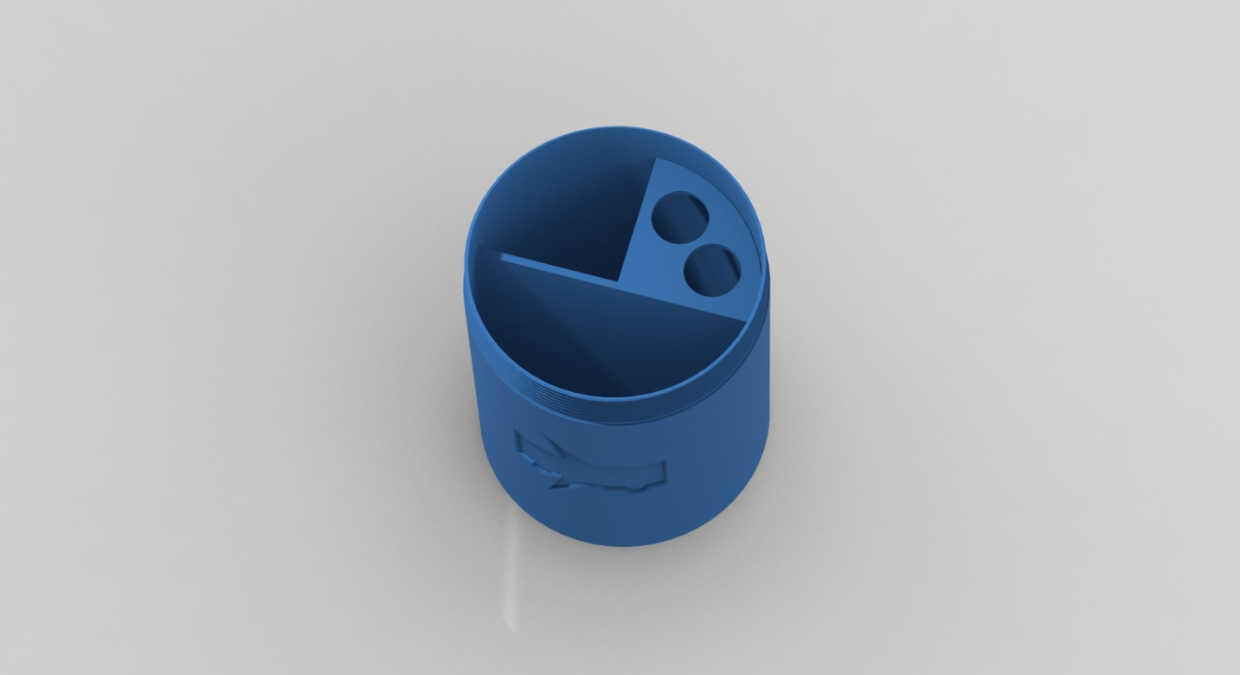

The two open sections are designed for any toiletry items of various shapes to fit into, allowing for the storage of different size deodorants, floss, etc.
The other quadrant with two engineered holes of ¾ inch diameter are designed to fit travel sized razors and toothbrushes, or anything desired. Items with larger handles may not fit through these holes but could easily be set in either of the other quadrants.

Lid
- The lid is a simple, hollowed out cylindrical-shaped cup with a 4-inch length and a 4-inch diameter.


Additionally, when RoundTrip is in use and the lid is removed, the lid may be used to hold additional items or as a rinse cup after brushing your teeth.

Each section has grooves; outside for the base, inside for the lid, in order for them to seamlessly assemble.

Use
Using RoundTrip is a very simple process, and it can fit and stand up on its own anywhere.
To use RoundTrip, simply place your desired items in either of the holder sections in the base and place the lid over it. After this, connect the grooves on both parts and twist the lid until it’s secured onto the base.
The combined length of the RoundTrip model is 9 inches, so any of your travel toothbrushes and razors should safely fit in it.
Our use recommendations for items and placement are illustrated at the top of the following page:

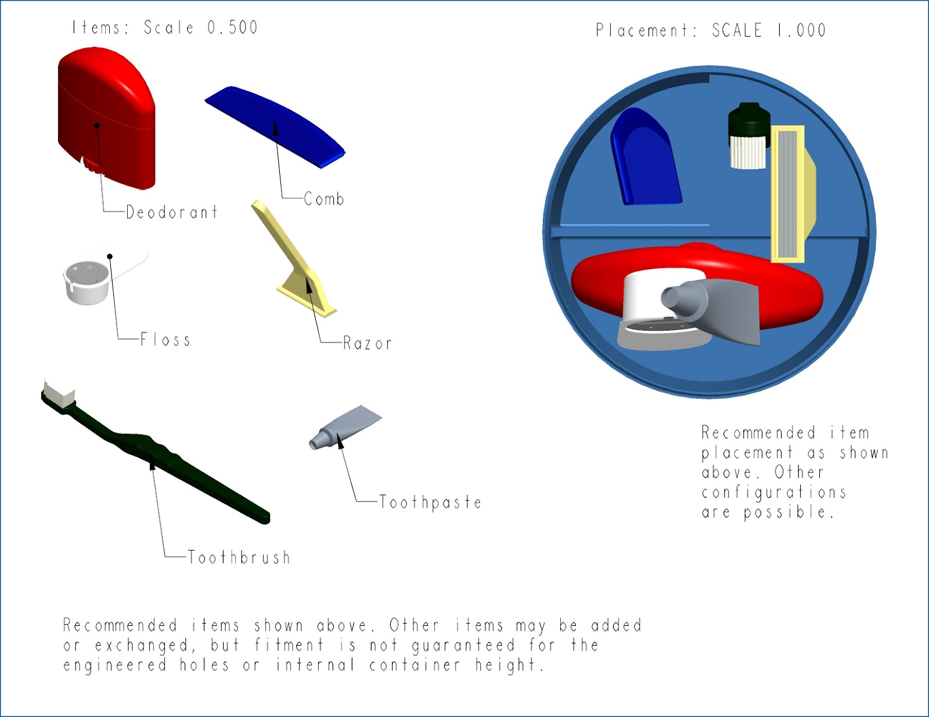

As seen with the picture below, RoundTrip can stand up on its own due to its vertical design and fits in right with a sink environment.
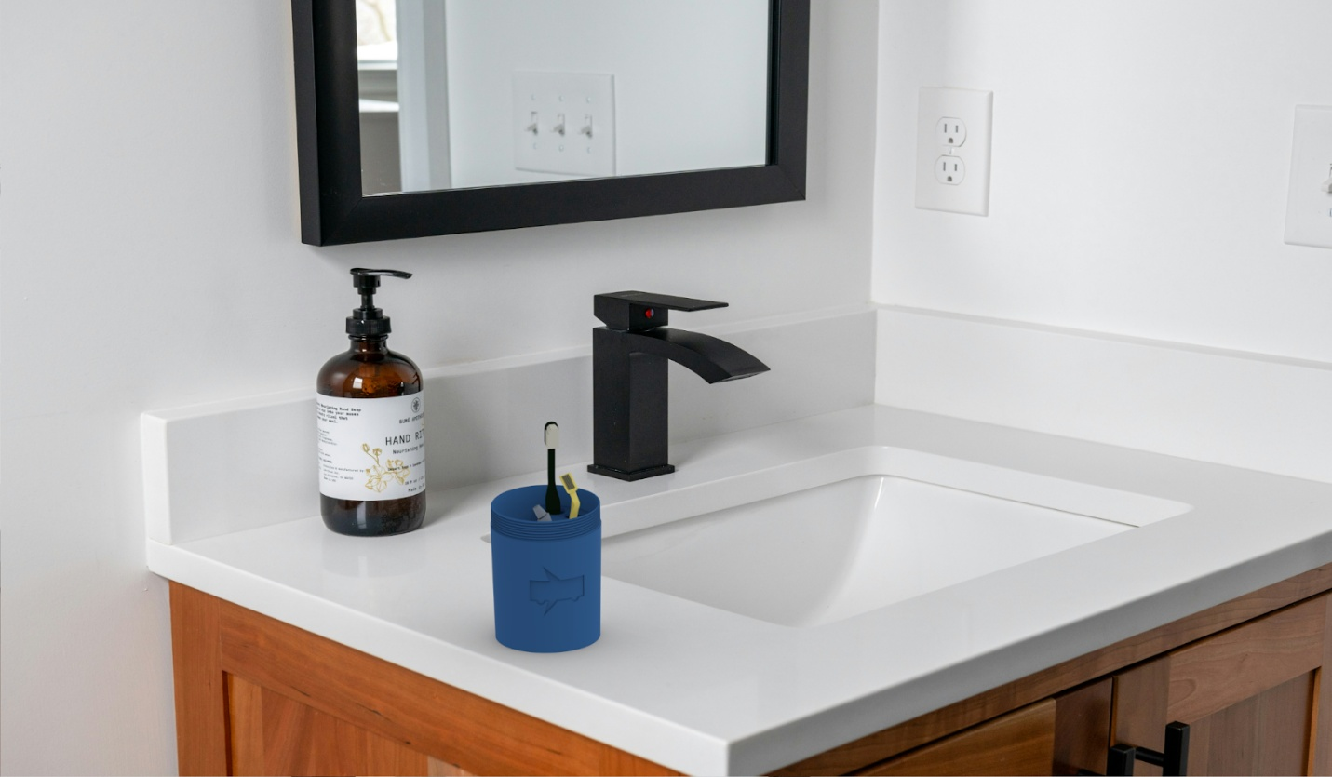
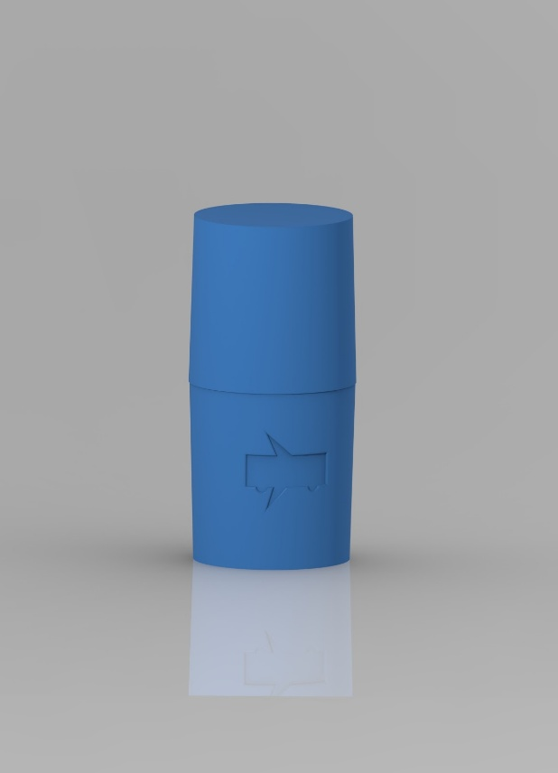
When the lid is securely tightened, RoundTrip fits within a 4” x 4” x 9” space, and its cylindrical shape allows it to easily fit within any bag or even some large cup holders.
When traveling light or compact is your goal, RoundTrip will easily take your toiletries both ways!

Maintenance
Maintenance for RoamReady may include washing and drying of the inside part holders in the case of anything getting trapped in it.
We generally recommend the use of cold or lukewarm water to rinse and clean the product due to the possibility of heat affecting the integrity of the material.
In terms of washing methods, we generally recommend hand washing, however, the use of a dishwasher can also be a possibility, just make sure to use low pressure and a generally low temperature, as this could damage the product.
We recommend cleaning before and after use/storage for the cleanest results, and let components air dry completely before storage.

*Roam Ready is not responsible for damage inflicted due to unrecommended cleaning techniques.
Warranty
In an effort to provide the greatest possible customer satisfaction, we offer a 5-year warranty. We feel this is necessary to accommodate all users from frequent travelers to occasional vacationers, no matter how often they use our product.
Under warranty, you can return the damaged case to be recycled and choose either a full refund or replacement. To be eligible, you must send photo evidence to our service center that shows no intentional or excessive damage.
Cases returned without being verified first through our service center will not be covered under warranty and will be considered for recycling only.
Any damage that shows signs of intent or fraud will immediately void the warranty.
Beyond the warranty, you can still be eligible for a replacement but not a refund. The eligibility requirements are the same as under warranty.

Service Center
All information is up to date as of 5/25/2025, for the most up to date information please refer to our website.
Website:
https://webpages.charlotte.edu/ldevrie2/FreshmanDesign
Phone Number:
+1 (800) ROAM NOW
Address:
9201 University City Blvd.
Charlotte, NC 28223-0001

Luke DeVries
ldevrie2@charlotte.edu
Joel Lopez
jlopez70@charlotte.edu
Lucas McKinnon
lmckinn9@charlotte.edu
Luca Multari
lmultari@charlotte.edu

