Task Allocation in Real Team and Multi Robots
Research Report in the First stage

Qiong Cheng, Safdar Abedi
and Xiaolin Hu*

qiong5cheng@yahoo.com, sabedi2@student.gsu.edu, xhu@cs.gsu.edu
Department of Computer Science
Georgia State University,
Atlanta, GA 30303 USA

Abstract
In the study of software metrics, in my mind are the thoughts of models to predict and evaluation the performance of software process management. In the meantime, task allocation is an unavoidable research topic at the first level. The topic has also been proposed and done in the area of multi robots. The paper will discuss a simulation approach in an environment of center-based control.

1. INTRODUCTION

There are lots of researchers and scientists who focus on the software process improvement. They proposed lots of models such as the waterfall model, the V model, evolutionary process models such as the spiral model and more recently, models for object-oriented development such as the Rational Unified Process. But there are relatively less professional people who study how to provide quantitatively decision-making tools for predicting the efficiency of task allocation in a real team. So it will combine the process model with the task assignment models.

The research will consist of the following goals:

To build process model and simulation
To build task allocation model and simulation
To build model which combine process model with task assignment model, which will be closer to real life.

Considering that how to assign a task is an unavoidable aspect of process management, we set the first research focus on the task allocation. The research topic is similar to the question in multi-robot research community, “which robot should execute which task?”

Both are big topics, a significant body of work has been done on it. Some scientists even borrow some knowledge from biology and the natural life, for example the task allocation in the swarm of the ants. The importance of task allocation grows with the complexity, in size and capability, of the system under study. Even in the simplest case of homogeneous team or robots with fixed, identical roles, intelligent allocation of tasks is required for good system performance, if only to minimize physical interference.

As for the performance prediction and evaluation, a variety of approaches have been proposed. Most of them are evaluated experimentally. The formal analysis is the indispensable approach in them, for example, the stochastic process algebra, Petri nets, and even their extension PEPA (Performance Evaluation Process Algebra) nets. However, they are rarely subjected to the simulation based on discrete event specification. There is no visualized and quantitative tool for predicting the efficiency of task allocation. So our aim in the long run is to provide a tool of process and task management, but the aim in the short run is just to build different task allocation model and compare their performances.

The rest of this paper is organized as follows. In the next section we give a formal statement of the general problem of task allocation in an organization with the center-based control. In Section 3, we will bring forth a simulation solution. In Section 4, the rest of challenges will be discussed. We will conclude in Section 5 with a summary and a brief discussion of extensions and future efforts.

2. PROBLEM STATEMENT
In the first stage of our research, we will focus on task allocation in a relatively simple organization structure with center-based control. In this organization, there is a hierarchy structure for the control of priorities. For example, each macro cell is a department of the higher level, which overlays a cluster of seven micro cells. A central micro cell will be surrounded by six peripheral cells (Figure 1).
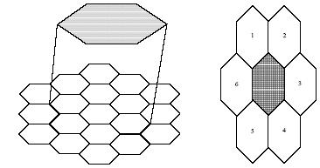
Figure 1.

In the simplified research problem, the problem is how to predict the efficiency of the team under central control.

3. SIMULATION SOLUTION
There are varieties of approach to the central control system. Here for the future continual study on it, we bring forth the simulation, based on discrete event specification.

A. Simulation Goals
- To simulate the structure of one organization
- To simulate the execution of the task flow
- To evaluate the performance of different operation flow (--)

B. State Design in the Simulation
There is a hierarchical design structure. Here we just focus on one level, which consists of TeamLeader Class and TeamMember Class(Figure 2.). For simplification, we assume the homogeneous system.
ExtTran
IntTran
Passive
Receiving
AssignSub
Finish Task
GetAllRes
WaitReturn
Report
TeamLeader
Passive
Handling, t
Output

Receiving

ExtTran
IntTran
TeamMember1
Passive
Handling, t
Output

Receiving

ExtTran
IntTran
TeamMember2
High-Level
High_Level
TeamLeader
Figure 2.

C. Simulation Model
We design the simulation model(Figure 3. ) and code for it.
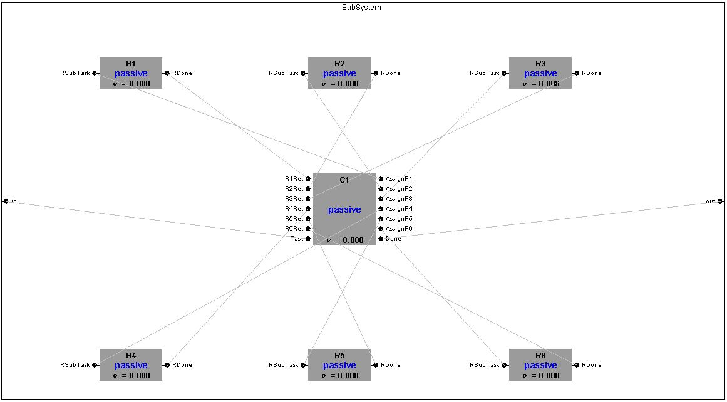

Figure 3.

By the simulation experiment, we observe the frequency of task assignment. But because of the assumption of the same priority and ability of every TeamMember, it is far away the real-life team.

4. CHALLENGE FOR NEXT STAGE
- How to create and add new ViewableAtomic dynamically by message command For example, adding a member of a team
- To build the procedure flow by dragging-and-dropping of mouse and to simulate
- The research for task allocation in multi robots
- The research for evaluating process management

5. CONCLUSION

It has been a long way to make effort in the research of task allocation and process management in software engineering. We will apply the knowledge between multi robots system and software engineering to each other. At the same time, we will try to borrow some from the other disciples such as biology.

REFERENCES
[1] Stephen Gilmore, Jane Hillston, Leila Kloul, Marina Ribaudo, “PEPA nets: A structured performance modeling formalism”, Elserier Science 2003
[2] Brian P. Gerkey, Maja J Mataric, “Multi-Robot Task Allocation: Analyzing the Complexity and Optimality of Key Architectures”, in proceedings of the IEEE International Conference on Robotics and Automation(ICRA 2003)

