BLAMO! Travel Toiletry Case

From the amazing

Project Team 4!

User Manual

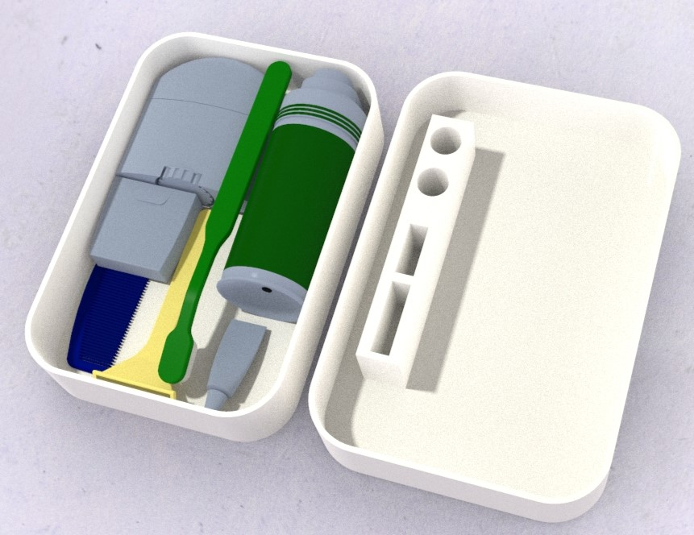

Please review the following manual carefully before operating BLAMO!

Table of Contents

Assembly………………………………………………………………………………………………………………………..3

Initial Setup and Use……………………………………………………………………………………………………….4

Maintenance…………………………………………………………………………………………………………………..5

Warranty………………………………………………………………………………………………………………………..6

Service Center Location & Phone……………………………………………………………………………………..7

Assembly

The BLAMO! Is a pre-assembled toiletries case that has been designed by experienced, and talented, engineers to meet all your desirable travel needs. Therefore, there should be no reason for its disassembly. To see how the BLAMO! Should look fresh out of the box, refer to the graphic below.

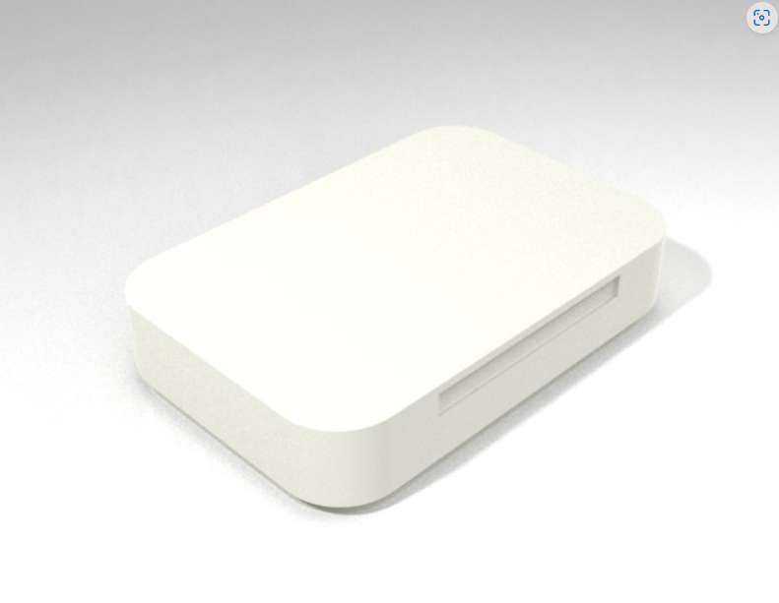

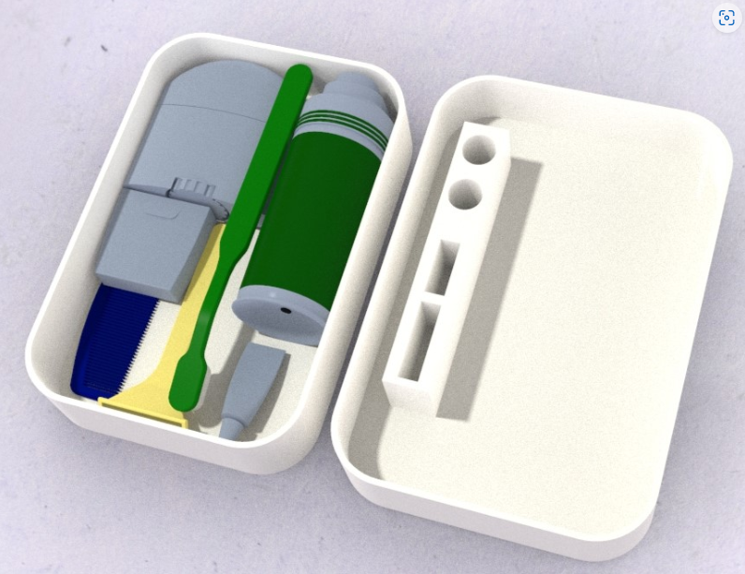

Initial Setup and Use

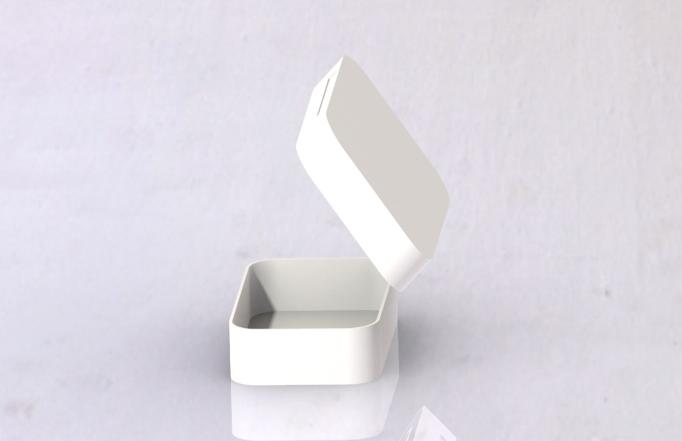The BLAMO! is pre-assembled in our factories and therefore does not require an initial setup. It was designed to hold all your basic toiletries items and can hold as much as you can fit inside all while maintaining a convenient pocket size. To open your BLAMO! Toiletry case simply pull the top cover from the bottom tray.

The case’s lid comes with slots designed to hold your toiletries items up from any contaminated surfaces. To see how this works, refer to the figure above.

Maintenance

Due to its small size, the BLAMO! requires no maintenance besides the fact that it should be cleaned for sanitary purposes. Our product was designed to handle all sorts of cleaning methods, including dishwashers. We recommend cleaning with mild soap and warm water once a month if you plan on using it daily.

Warranty

Our number one priority is to make sure that our customers are satisfied with their purchase. For this reason, BLAMO! comes with a 30-day moneyback guarantee. If you are not content with your purchase, please visit the “Meet the BLAMO! Team” page on our website to receive your money back.

Service Center Location & Phone

For all questions, comments, or concerns please contact:

Larry Pinto

[lpinto@uncc.edu](mailto:lpinto@uncc.edu)

Saul Castro

[Scastro7@uncc.edu](mailto:Scastro7@uncc.edu)

Service Center:

Website: <https://webpages.charlotte.edu/lpinto/ENGR_1202_final_project.html>

Address: 426 N Tryon St Charlotte, NC, 28202

Phone: (704)-332-2362