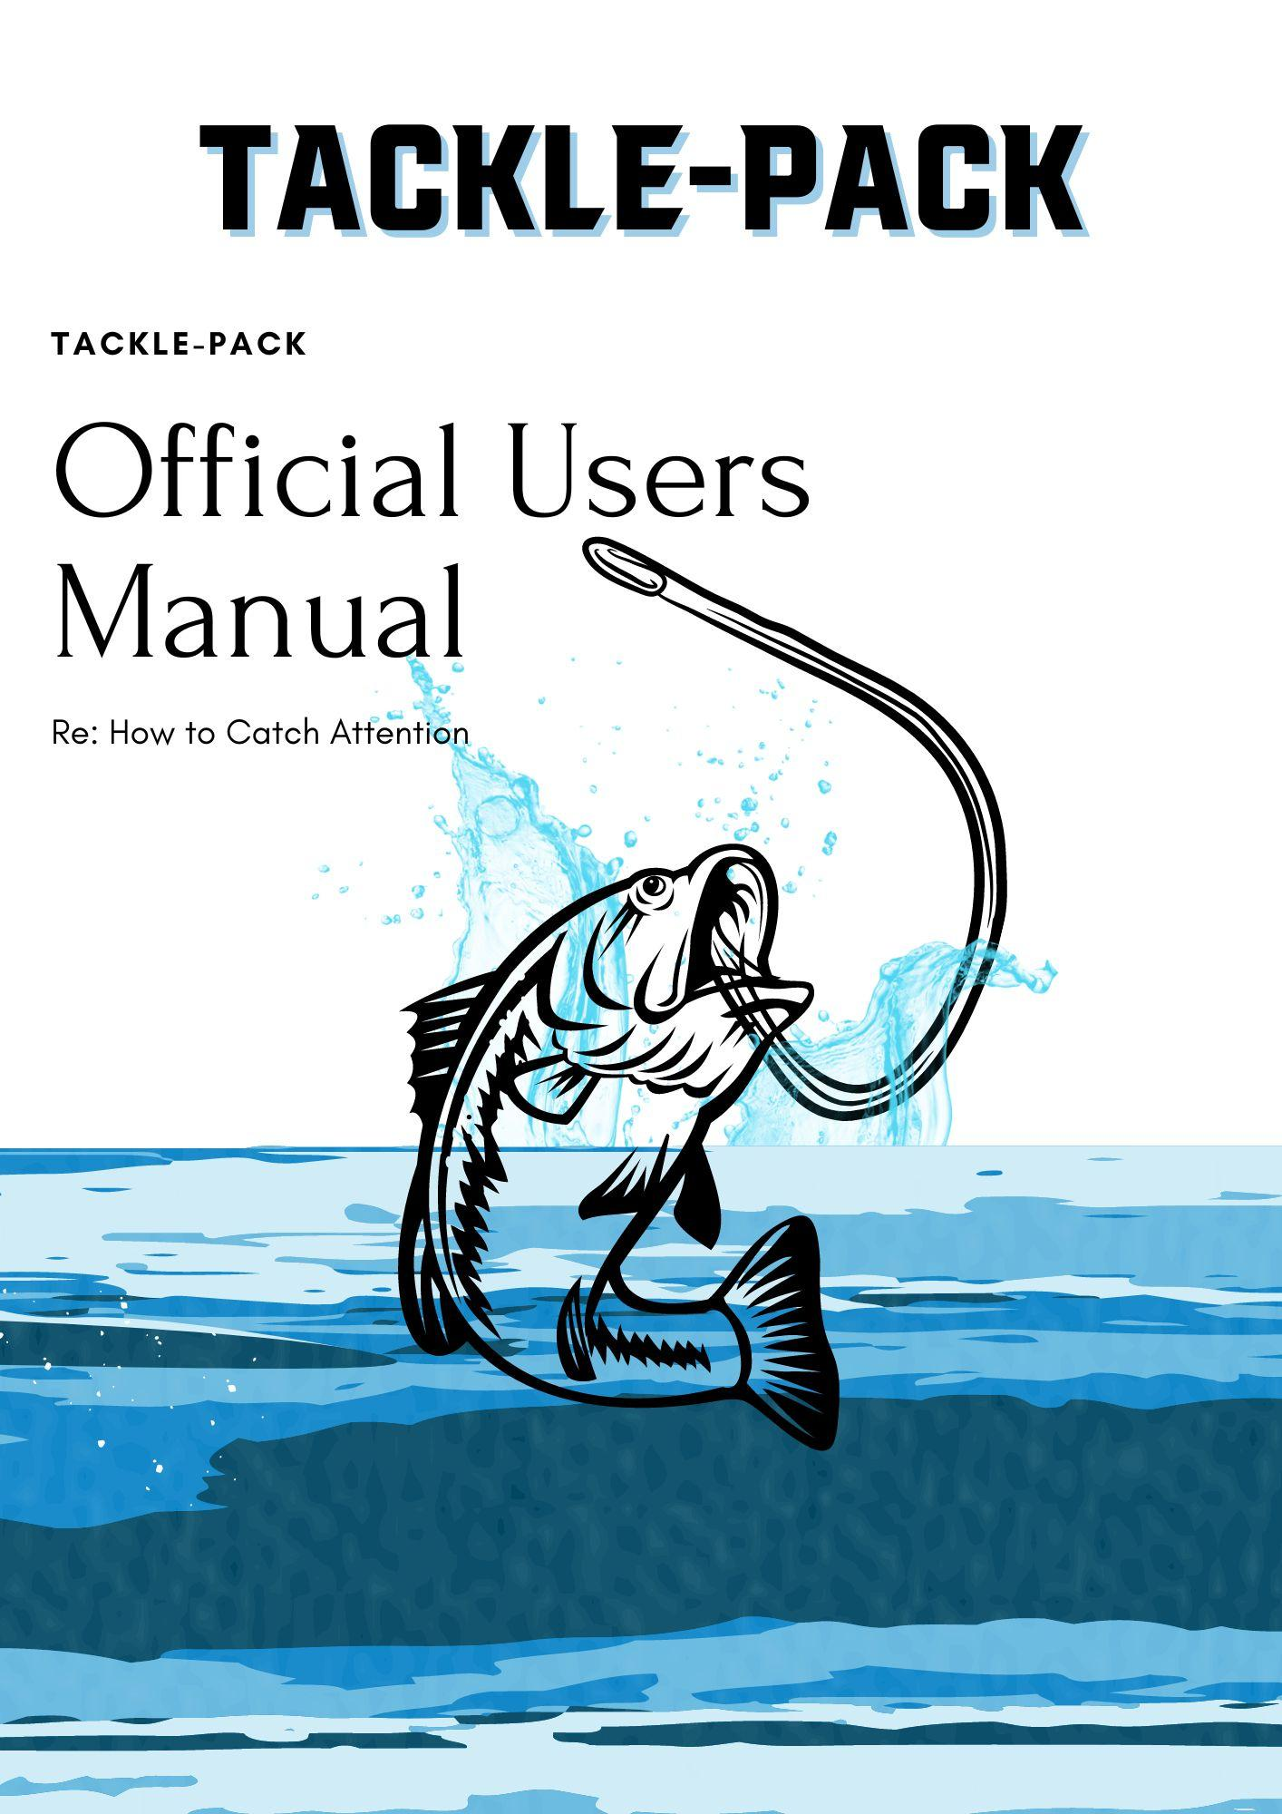
Presented by: Connor Garrison, Colt Holshouser, Samuel Kleinschuster, Tyler Schmid
PG. 3&4
Instructions for assembly
PG. 5
Instructions for use and maintenance
PG. 6
Warranty/Service Center Location and Phone information
ASSEMBLY
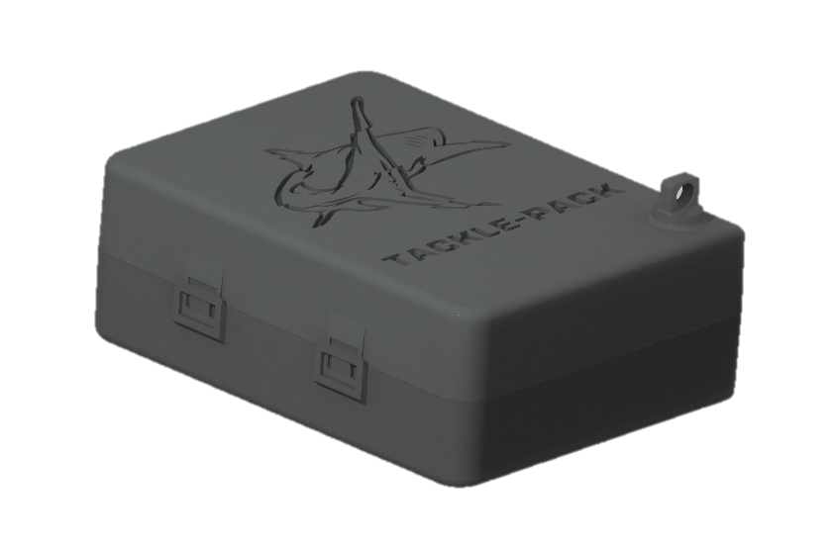
- Once the case is out of its packaging. You will see a tab on the bottom right side of the top lid of the Tackle pack (this side will have our logo). This tab has a hole for you to link it to your backpack or purse to secure it in your luggage and ensure it doesn’t fall out. Next pull on the latch on the long side of the pack, opposing the hinge. This will open the case and give you access to the many compartments and features of the Tackle Pack

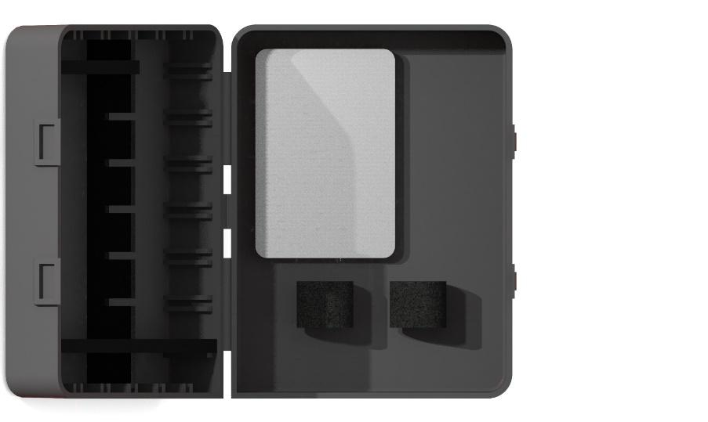
- On one side of the case, you will now find an open compartment. In this compartment you will also find small Velcro straps. These are to secure any small objects you don’t want rattling around in your luggage or backpack. This is where one can keep things like a razor, toothbrush, or travel toothpaste. To use, simply separate the straps in a “tearing” motion. This will allow you to wrap your belongings with the Velcro to hold in place. (See next page)

- Lastly on the other side you will find some notches on the sidewalls of the compartment and some dividers loose. This allows you to choose how big or small these “cubbies” are to hold all of your misc. things. To create these cubby holes, slide a divider in between the notches running down the walls of the tackle pack until they bottom out. This side is where we get our name as we were inspired by the design of a slim fit professional tackle box. The extra flexibility ensures that you, the user, have everything you need to Tackle the day!
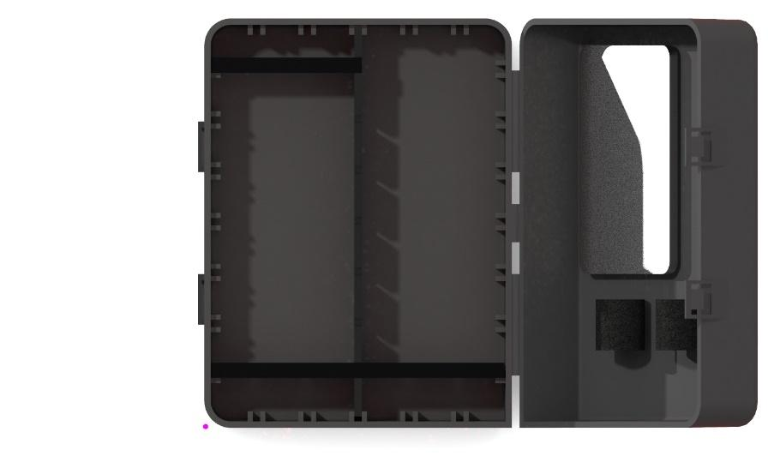
USE AND MAINTENANCE

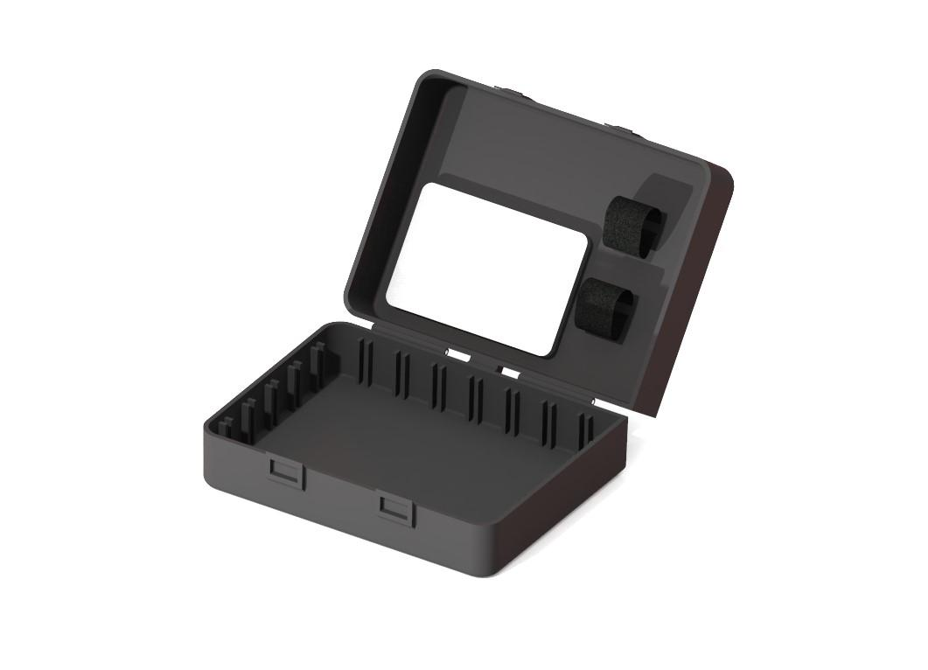
- To clean the Tackle Pack, the first step will be to open the lid and remove all contents from the Pack. Secondly you will want to remove all dividers from the “cubby” side of the Tackle pack. Then undo all Velcro straps and wipe down the inside and out of the container. Much like a Tupperware box. Lastly, reinstall your dividers in their desired configuration and insert all of your supplies. Keep in a dry place to ensure the products inside do not become wet.

WARRANTY/SERVICE CENTER LOCATION

- Who is covered
- This warranty is extended to the original purchaser or the person receiving the product as a gift only.
- What is covered and how long
- Tackle-Pack warrants all new products are free from defects in manufacturing, materials, and workmanship for a period of one year from date of purchase.
- What is not covered
- The warranty does not cover defects or malfunction caused by misuse, abuse or improper maintenance, failure to follow operating instructions, or use with our product with which it is not intended to be used.
- Service
- We will repair or replace any of our products that prove to be defective in material or workmanship during the warranty period.
- Located in Charlotte, North Carolina: 9201 University City Blvd, Charlotte, NC 28223
- Contact us
- Connor Garrison: jgarri30@uncc.edu
- Colt Holshouser: jholsho6@uncc.edu
- Samuel Kleinschuster: skleinsc@uncc.edu
- Tyler Schmid: tschmid@uncc.edu

Thank you for purchasing the Tackle Pack!

