Universal Travel Kit

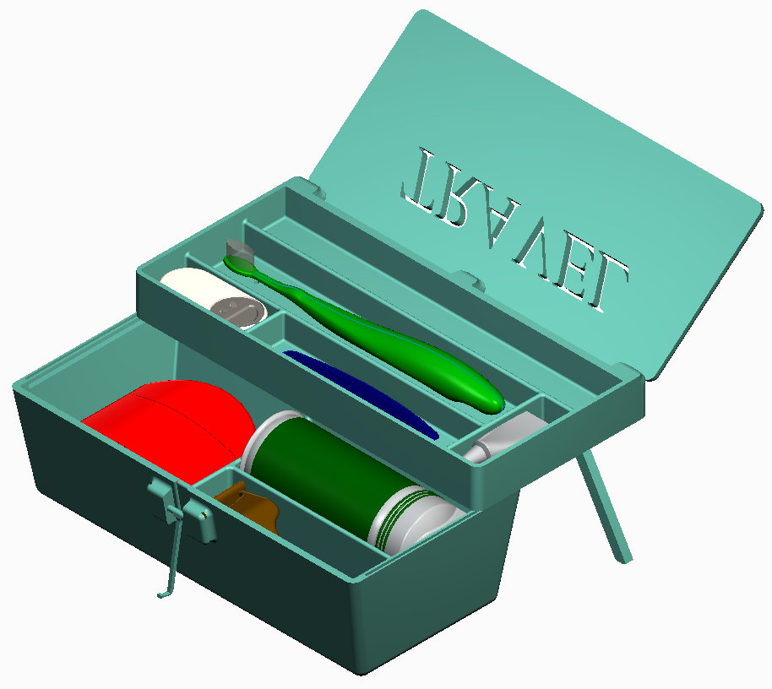

Table of Contents

Prior to Usage 3

Safety Precautions 3

Product Information 4

Warranty Information 5

Component List 5

Exploded View 6

Contact Information 7

Prior to Usage

- Remove the Universal Travel Kit (UTK) from the packaging.
- Inspect your UTK to make sure it has not been damaged/destroyed due to inadequate shipping.
- Unlock the lid/cover, slide the upper tier backwards and fold out kick stands, remove deodorant, shaving cream, floss, toothbrush, comb, toothpaste and razor.
- Sterilize the case with hot soapy water. (In case of contamination during shipping.)
- Your kit is dishwasher safe, letting air dry is recommended.
- Repackage your UTK throw it in your travel bag and you’re ready to go!

Safety Precautions

- Keep your UTK in good working condition by leaving it open to dry nightly when not in your travel bag.
- If your UTK gets broken during travel, it is recommended that you either buy a replacement kit, replacement parts or discontinue use.
- The specialty drainage holes are drilled in the two tiers of your UTK to keep the inside dry.
- Utensils are not recommended to be put away damp, but with the drainage/ventilation holes you can be worry free!
- If replacement parts are needed see the parts list below on Pages …

Product Information

Your Universal Travel Kit (UTK) is designed to be easy to use and durable for your everyday use when traveling. This is the most innovative way to package all of your hygiene needs and keep them out of the elements.

Case- made from strong plastic molded material, mold/mildew resistant. Comes in a variety of colors for the customer’s convenience.
Floss- non-flavored floss but is also available in other flavors such as spearmint, cinnamon, and peppermint.
Deodorant- men’s and women’s available.
Shaving Cream- men’s and women’s available.
Comb- travel-sized plastic comb, easy to use.
Toothbrush- plastic molded toothbrush used to reach the hard to get places in between your teeth.
Toothpaste- comes in variety of flavors, anti-cavity action plus whitening technology.

Warranty Information
Your Universal Travel Kit has a limited 60 day warranty. If anything breaks on your kit or needs replaced you can contact the company and get a replacement kit. If you are not satisfied with your product within the first 30 days you can return the kit and we will give you your money back! Shipping and Handling costs will not be included in the refund. If you have any complaints or problems with your kit please contact the quality management department at.
Webpages.uncc.edu/wmcbrid5/Final_Project.html
Component List
- Lid
- Kick Stands
- Sliding Shelf
- Lower Shelf
- Latch
- Deodorant
- Toothbrush
- Toothpaste
- Comb
- Floss
- Comb
- Razor

Exploded View

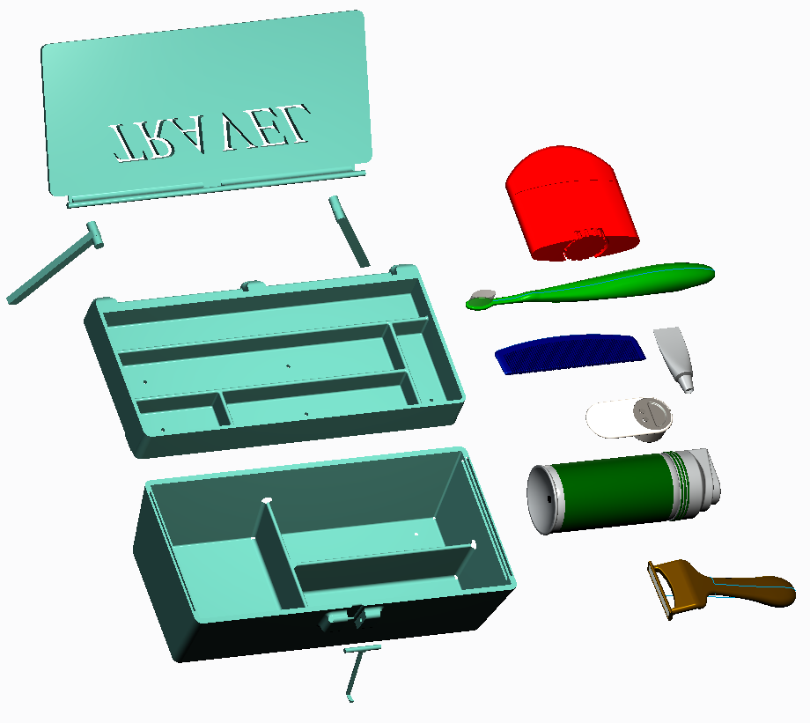
12
11
10
9
8
7
6
5
4
2
3
1
2

Contact Information
You can contact us through the following emails if you have any concerns or questions about your Travel Kit.
Dan Cornett – dcornet3@uncc.edu
Eric Reichenbach – ereichen@uncc.edu
Justin Kehm – jkehm@uncc.edu
Wyatt McBride – wmcbrid5@uncc.edu
Our location is: 9201 University City Blvd, Charlotte, NC 28223

